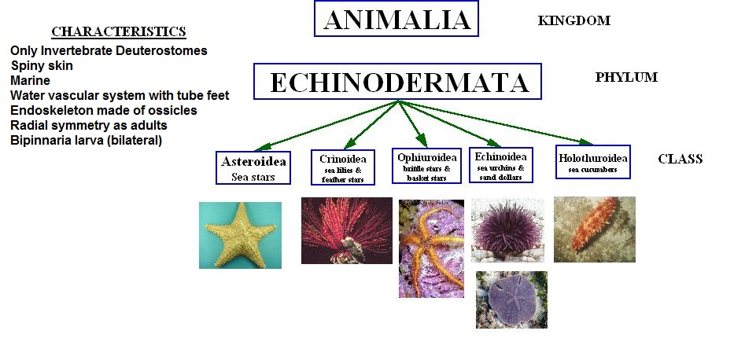
Kelly Riedel/Brookings Biology

