Cell Signaling and Homeostasis Modeling
G-protein Receptor
G-protein
Ligand
Reception

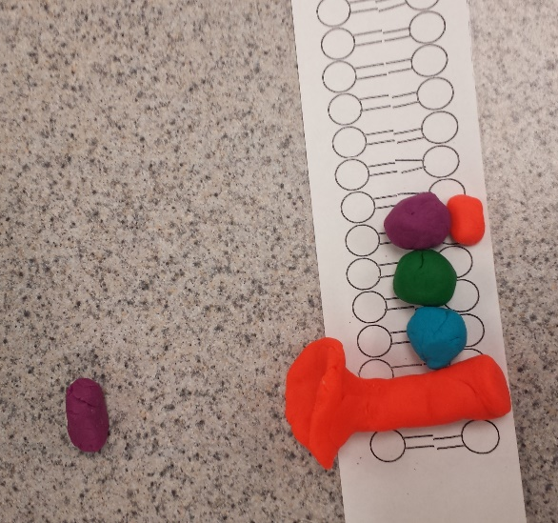

The ligand binds to the receptor site.
GDP
Membrane-bound receptor
The membrane-bound receptor has a receptor site for a small molecule, a ligand, to bind to.
The G-protein is attached to the receptor and has a guanosine diphosphate, or GDP, attached to the alpha subunit.

Transduction

The attached ligand causes the G-protein to change shape, and GTP replaces GDP.
GTP

When the ligand separates from the receptor, no more G-proteins can be activated.
The activated alpha subunit separates from the other subunits of the G-protein.

Cell Response
Examples:
- Can activate adenylyl cyclase, which activites cAMP and causes protein kinase A to inhibit glycogen synthesis or promote glycogen breakdown (this is caused by the hormone epinephrine that acts as the ligand)
- Can dilate skeletal muscle blood vessels
- Can constrict intestinal blood vessels
- Can activate apoptosis
- Yeast reproduction
The G-protein subunits recombine and attach to the membrane-bound receptor. The cycle resets.
GDP
The alpha subunit undergoes phosphorylase activity by removing a phosphate from the GTP, leaving GDP.
Phosphate

Analysis Questions
- Phosphorylation and dephosphorylation regulate signal transduction pathways by controlling whether or not the proteins sites that potentially bind the phosphates are exposed or hidden.
- Secondary messengers may be released or synthesized and broken down again in specific ion channels and some can be stored in organelles
- Secondary messengers send chemical messages that are activated by epinephrine and they are intracellular messages
- Cell signaling secretes chemical messages throughout the body to tell it to produce more substances, perform apoptosis, or perform mitosis to create a balance
- Hormones are sent by glands out through the bloodstream. They flow in the bloodstream until they reach distant cells where they can attach to receptors. The hormones have very specific shapes, and they act as ligands for membrane-bound receptors that bind to these specific ligands and change shape to initiate the signal. The hormones move randomly in the bloodstream, but because their shape is so specific, they will only bind to certain cells that have the specific receptors in their membranes.
- The body has many other systems that help maintain homeostasis. For example, the process of diffusion and osmosis (transport) in and out of cells helps maintain homeostasis by leveling the amount of water and solutes in the cell and the extracellular fluid. This does not require signaling, as these processes are passive.
- An example of a behavior mechanism is insects forming large groups when temperature fluctuates, as this decreases the surface area to volume ratio and allows less heat to be released or retained. These groups produce an interior environment very different from the outside environment, maintaining homeostasis of temperature. An example of a physiological mechanism is getting adequate rest, sunlight, and exercise for humans, as this behavior helps maintain homeostasis.

