Cell Signaling and Homeostasis Modeling

Reception
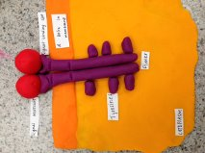
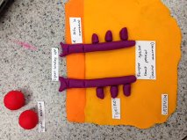
The two receptor tyrosine kinase proteins exist individually as polypeptides, each with a signal-binding site outside of the cell. The part of the protein in the membrane has an α helix. The tail inside the membrane has multiple tyrosines. Kinase is a protein that “phosphorylates,” or adds a phosphate to, another molecule. The signal molecules attach to the binding site causes two receptor polypeptides to associate closely with each other, making a dimer.

Transduction
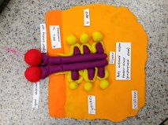
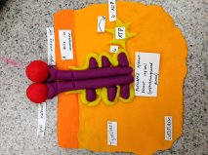
The forming of the dimer, or dimerization, activates the tyrosine-kinase region (the part inside of the cell) of each polypeptide. Every tyrosine kinase adds a phosphate from an ATP molecule to the tail, or end, of the tyrosine on the other polypeptide. The ATP that loses one of its phosphates is now ADP. The unphosphorylated dimer activated, creating the full activated receptor tyrosine-kinase, or the phosphorylated dimer.
Response
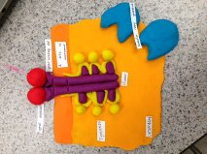
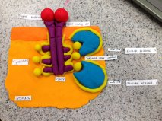
When the receptor protein is activated all the way, it is recognized by certain relay proteins inside of the cell. Every protein binds to a certain phosphorylated tyrosine, experiencing a resulting change in its structure that activates the protein connected to the tyrosine with the phosphate. Each activated protein triggers a pathway for transduction, causing a cellular response. One type of receptor tyrosine kinase is required for the survival and proliferation of migrating myoblasts during myogenesis.

Analysis
- Phosphorylation and dephosphorylation modify the function of the proteins and regulate many cellular processes (growth, cell cycle, apoptosis)
- Secondary messengers are inside the cell as signaling molecules released by the cell, triggering physiological changes; one of the first components of intracellular signal transduction cascades
- They are called secondary messengers because it is stimulated or stopped by the receptor after the first messengers bind to the receptor
- Cell signaling allows communication between groups of cells called tissues; signaling molecules relay positional information among cells in a tissue, and these pathways maintain the equilibrium
- Lipid-soluble hormones diffuse across the plasma membrane of cells and bind to the receptors inside the cells, where their signals tell the cell to synthesize more or less mRNA; this results in the amount of protein created
- Cell membranes control what substances enter or exit the cell, some substances crossing without the use of energy from the cell; diffusion allows the concentration of molecules to reach equilibrium, so that molecules can continue to move equally back and forth across the cell membrane; osmosis, the diffusion of water, allows water molecules to continue to move across the membrane evenly so that there is no net movement
- One behavioral mechanism in a desert bird is its breeding during the relatively cool spring, leaving the desert for cooler areas at higher elevations; they are active during the morning and around sunset and stay in shady, cool spots during the hot day; a physiological mechanism of desert animals is their excretion of metabolic wastes as uric acid, which is an insoluble white compound; this wastes very little water, whereas mammals excrete urea, accounting for considerable water loss

