STATION #1
USE THE POOL NOODLES TO REVIEW TRP AND LAC OPERONS.
CHECK YOUR BILL FOR ANSWERS

ANSWER THE QUESTIONS
STATION #2
ACTIVE/PASSIVE TRANSPORT
USE CARDS TO MAKE A CONCEPT MAP
CHECK ANSWERS IN YOUR BILL
ANSWER THE QUESTIONS

STATION #3
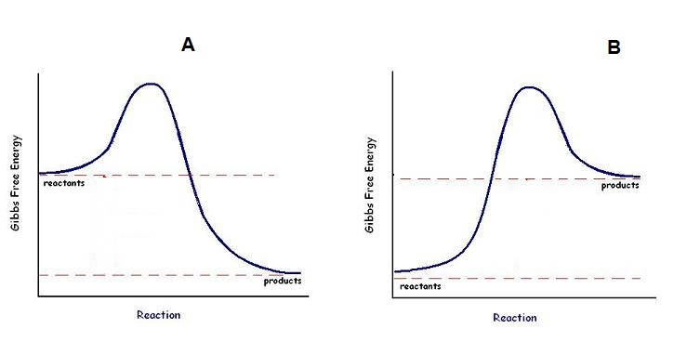
GIBBS FREE ENERGY AND
CHEMICAL REACTIONS

STATION #4
STANDARD ERROR OF THE MEAN (SEM) WHAT DOES IT MEAN?
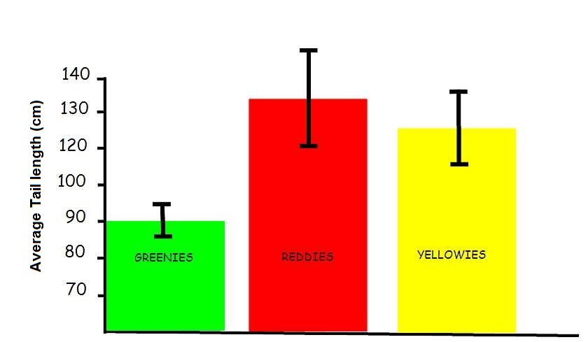

STATION #5 GRAPHING DATA
WATER POTENTIAL LAB
HYPO/HYPER/ISOTONIC

STATION #6
PEDIGREE PRACTICE
HOW ARE TRAITS INHERITED?

STATION #7
CHI SQUARE ANALYSIS
Observed Phenotypes (o) | Expected (e) | (o-e) | (o-e)² | (o-e)²  e
 |  |  | X² =
In corn, purple kernels (P) are dominant over yellow (p) and
smooth kernels (S) are dominant over shrunken (s).
AN ear of corn has 381 kernels,
purple, smooth = 216
purple, shrunken = 79
yellow, smooth = 65
yellow, shrunken = 21

STATION #8- GENETICS WHAT’S THE PATTERN MEAN?

STATION #9 -GENETICS WHAT’S THE PATTERN MEAN?
Cross I: True-breeding bronze-eyed males were crossed with true-breeding red-eyed females. All the F₁ offspring had bronze eyes. F₁ flies were crossed, and the data for the resulting F₂ flies are given in the table below.

Cross II: True-breeding normal-winged males were crossed with true-breeding stunted-winged females. All the F₁ offspring had stunted wings. F₁ flies were crossed, and the data for the resulting F₂ flies are given in the table below.

Cross III: True-breeding bronze-eyed, stunted-winged males were crossed with true-breeding red eyed, normal winged females. All the F₁ offspring had bronze eyes and stunted wings. The F₁ flies were crossed with true breeding red-eyed, normal-winged flies, and the results are shown in the

STATION #10- GENETICS WHAT’S THE PATTERN MEAN?

STATION #11
PRACTICE SOME MATH GRID INS
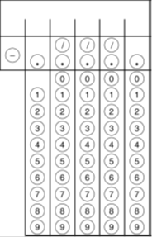

STATION #12
USE POP BEAD CHROMOSOMES TO ACT OUT MEIOSIS THEN ANSWER THE FRQ QUESTION

