AP BIO SEMESTER 2 REVIEW

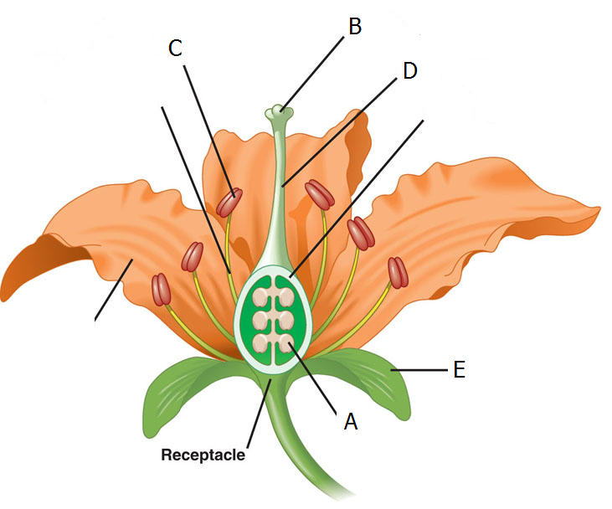
1. Which of the following is the site of pollen production?

2. If a plant has both male and female parts on the same flower it is called ____________.
3. In guinea pigs, black fur (B) is dominant to brown fur (b) . No tail (T) is dominant to having a tail (t). What fraction of the progeny of the cross BbTt X BbTt will have black fur and tails?
4. Use the nomograph provided to determine the % saturation of a water sample at 25 C that has 7 mg/L of oxygen.
5. Which of the coelom patterns shown is characteristic of humans?
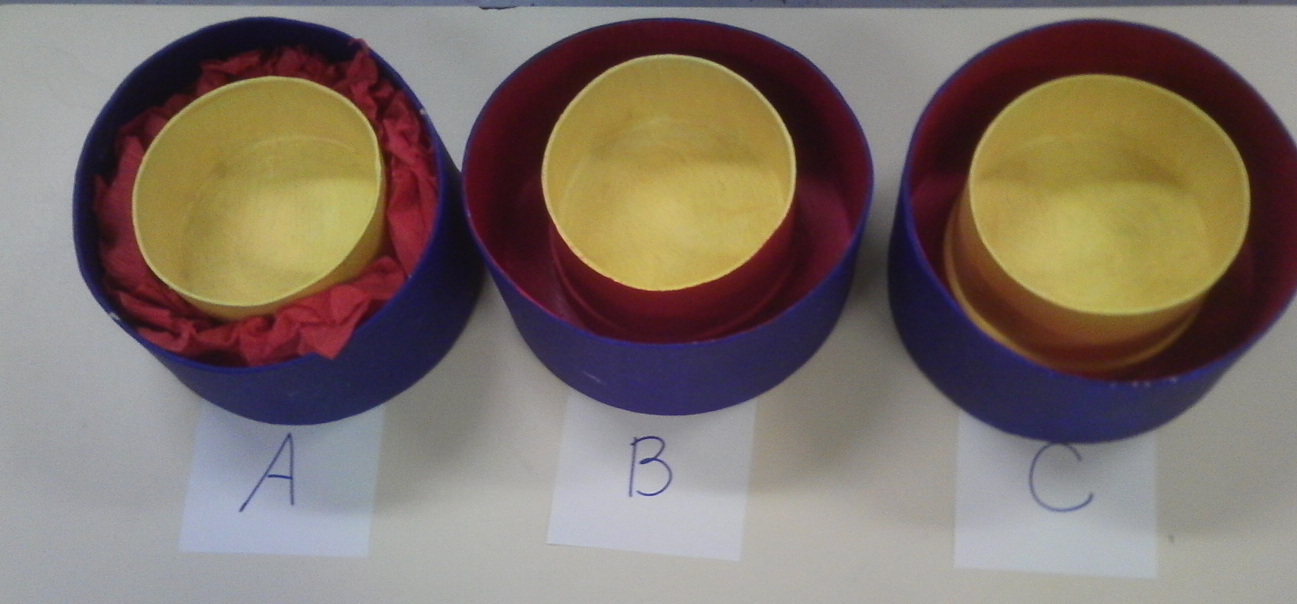
6. Name the +/O type of symbiosis in which one organism benefits and the other is neither helped nor harmed.
7. Placing this egg in distilled water would cause it to
A. undergo plasmolysis
B. swell and possibly burst
C. stay the same size
D. shrink smaller

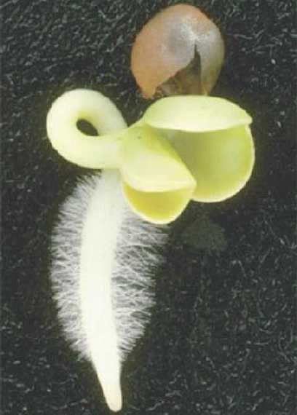
8. This type of root is called a ___________
and is typical of _____________
monocots dicots

9. Tell a molecule made by joining glucose molecules with α-1,4 linkages.

10. Disulfide bridges are examples of ______ structure in proteins.
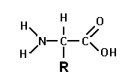
1° 2° 3° 4°

11. Tell the macromolecule that could be made from this subunit.

12. Name the molecule that receives electrons at the end of the light reaction during photosynthesis.

13. In a population of squirrels, the allele that causes bushy tails (B) is dominant and the allele for bald tails (b) is recessive. If 64% of the squirrels in a forest have a Bushy tail, what is the frequency of the dominant allele?

14. Name a body organ that develops from mesoderm.

15. The concentration of pollutants like DDT in higher concentrations in organisms at higher trophic levels in a food chain is called _______________.

16. During DNA replication the ____________ strand is synthesized continuously in the 5’ → 3’ direction.
lagging leading

17. The random inactivation of one of the X chromosomes in female cells results in a ________________.

18. In the alternation of generations life cycle plants use _______________ to produce gametes.
mitosis meiosis

19. In Linnaeus’s hierarchy, families are grouped into larger taxons called _______________

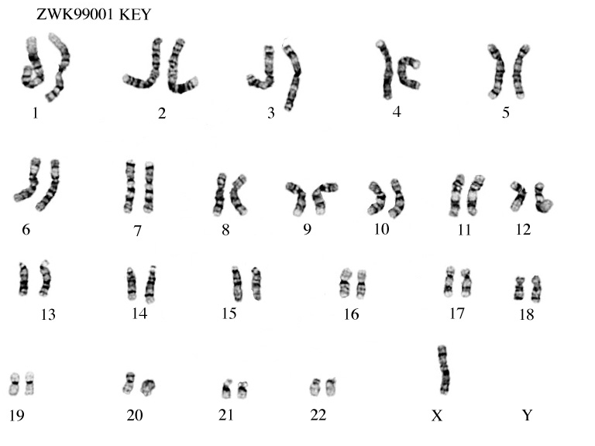
20. What genetic disorder
is shown in this karyotype?

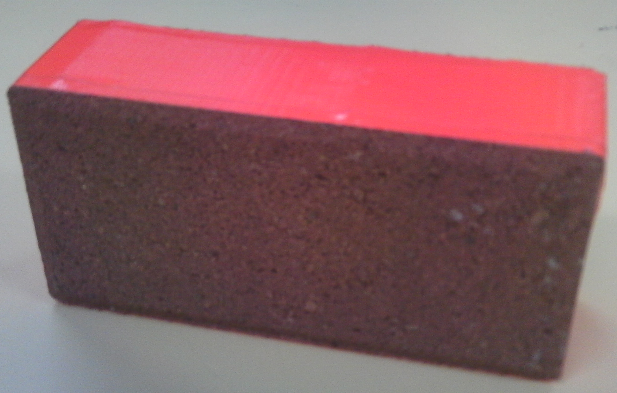

21. What is the function of the Casparian strip?

22. Which of the following levels of organization includes all of the others?
(A) Population
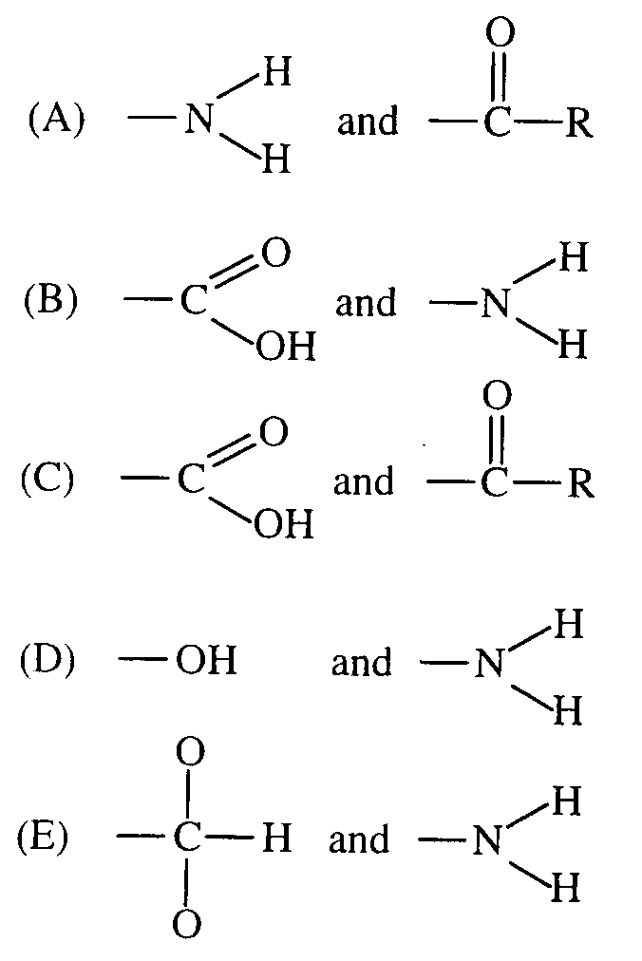
(B) Ecosystem
(C) Community
(D) Organism
(E) Habitat

23. Which of these functional groups is found in amino acids ?

24. Which of these molecules is the main component in cell membranes?
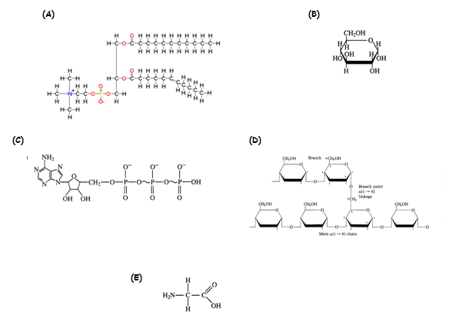

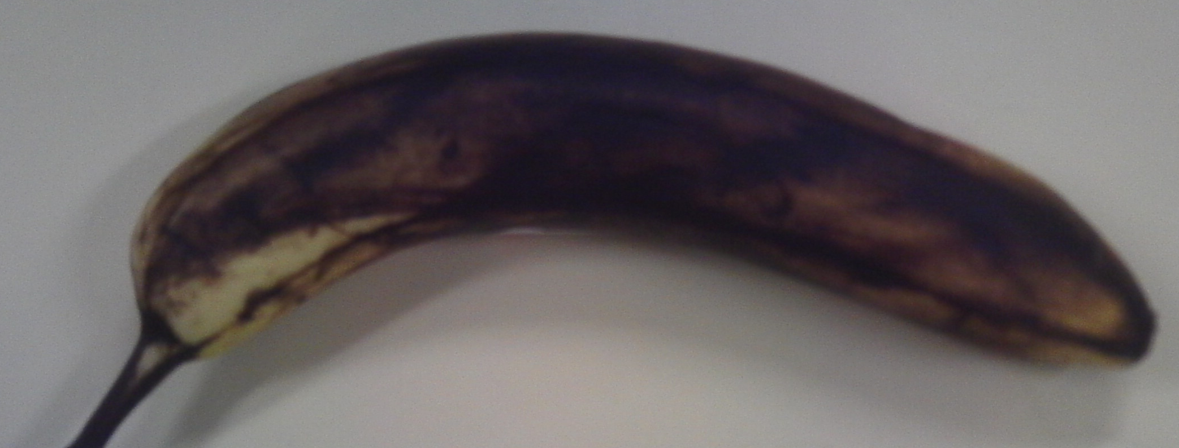

25. Which gaseous plant hormone is responsible for turning this banana brown?

