DNA sequence
T T C A C G C G G A A A
1. Tell the sequence of the complementary DNA strand.

2. Name this process of making a DNA copy.

3. Show the mRNA message this piece of DNA would produce.

4. Name this process. (DNA → RNA)

5. Use the decoder to determine the amino acid sequence this message would produce.

6. Name this process. (RNA → PROTEIN)

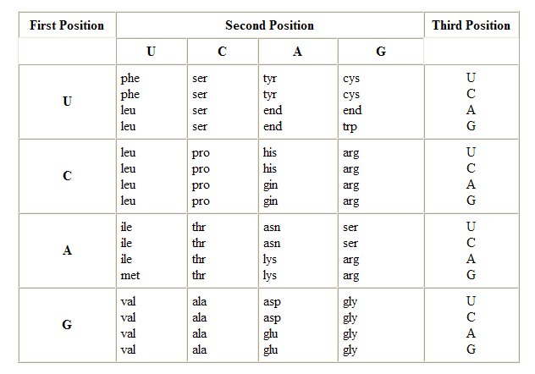

7. Which viral enzyme used to insert eukaryotic genes into bacteria can reverse the steps of questions 1-7.

8. Give an example where proton pumps are used in cells?

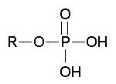

9. Name this functional group and give an example of a molecule where it could be found.

10. A peptide bond is an example of
_________ structure in proteins.
1° 2° 3° 4°

11. STRUCTURE AND FUNCTION
How does the structure of a phospholipid relate to its ability to form cell membranes?

12. Tell how spermatogenesis and oogenesis are different.

13. Name the transport proteins that assist the movement of water molecules across cell membranes.

14. Give an example of how negative feedback is used in homeostasis.

15. Give an example of where Na⁺-K⁺ pumps are used in cells.

16. What is the final electron receiver at the end of electron transport during cellular respiration?

17. Tell the kind of fermentation used by humans during exercise.

18. Tell how cells use energy coupling of exergonic and endergonic reactions to do work.

19. Many enzymes/molecules require NON-PROTEIN helpers called ______

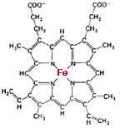
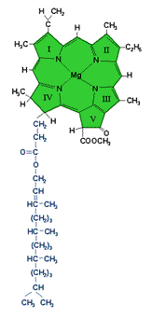
?
?

20. Identify these
molecules and their
missing helpers.

21. Name a hormone made by the pituitary gland and tell its target and function.

22. Give an example of an autosomal recessive disorder.

23. What is the cause of Down syndrome, Kleinfelter syndrome, and Turner syndrome?

24. A family has 3 sons and would like to have another baby. What is the probability the next child will be male?

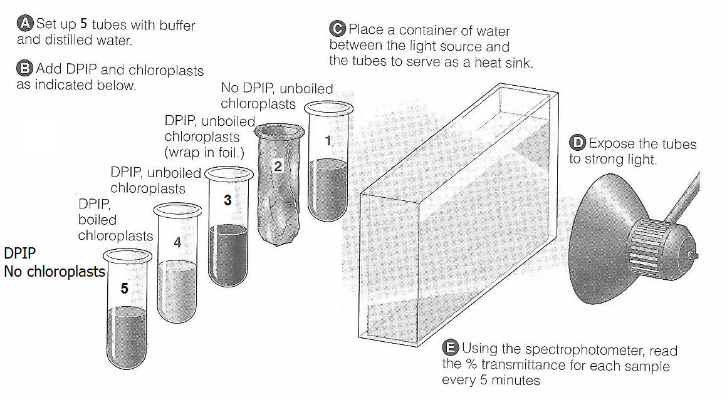
25. Lab 12 is shown above
In which tube would you expect to see an increase in % transmittance as measured with a spectrophotometer?

26. FRUIT FLY DATA
Results of a cross between homozygous WT (red eyed) flies and homozygous sepia eyed females are shown below.
 | WT male | WT female | Sepia male | Sepia female
F₁ | 4916 | 5010 | 0 | 0

 | WT male | WT female | Sepia male | Sepia female
F₂ | 3764 | 3717 | 1195 | 1251
Tell how this trait is inherited.
(Dominant/recessive; Autosomal/X-linked)
Draw a Punnett showing the parents & offspring in the F₂ cross.

27. Tell what the TWO sperm fuse with during double fertilization and what is the result of each.

28. Tell one way C₃ and C₄ plants are different.

29. Tell how the Casparian strip helps move water to the leaves.

30. Tell which cell part is responsible for the storage & release of Ca++ ions during muscle contraction.

31. Explain the changes in requirements for water during reproduction and sporophyte/gametophyte dominance as you move from mosses to ferns to gymnosperms to angiosperms in the plant kingdom.

32. Draw a graph to show the effect of increasing temperature on enzyme activity.

