APEX LEARNING REVIEW
AP BIOLOGY

1. Log into Apex Learning at www.apexvs.com using the username and password on the document given to you.

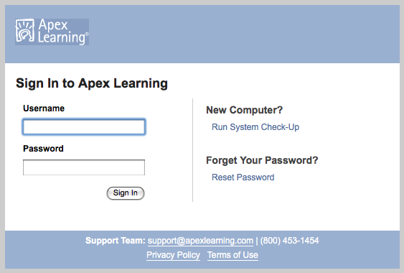

2. On the next page, you will change your password and accept the Student Code of Conduct.

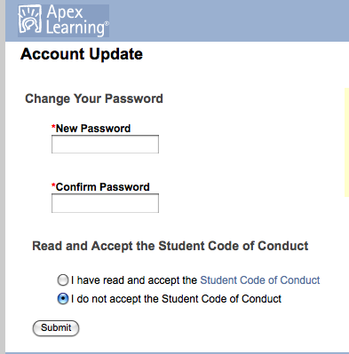

3. Now, do the Account Update by choosing two security questions.
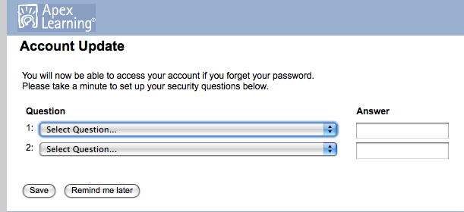

4. Click on Continue at the next page.

5. Now you are at your Home page and should look like this:

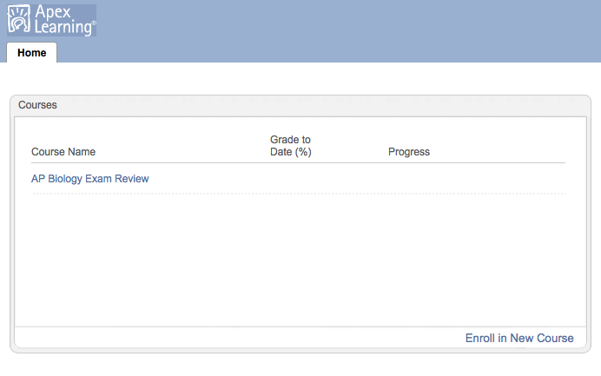

6. Click on AP Biology Exam Review to enter the course resources to start your review. After you log in from now on, this is the page you will show.

7. Notice how the review course is set up:

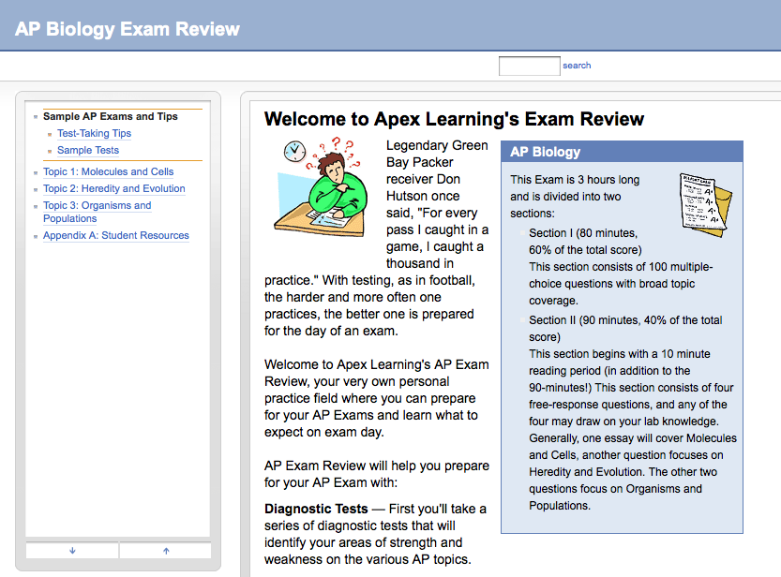

On the left hand side are the links that will take you to review resources for the three major topics we have learned in this course (Molecules and Cells, Heredity and Evolution, and Organisms and Populations). If you click on the topics, they will open up into even more specific topics and concepts.

Also, notice the Test-Taking Tips, Sample Tests, and Appendix A: Student Resources links. These links can really help you learn what to expect when you take your test, tips to improve your success, and practice tests you can take.

Also, read the text under Welcome to Apex Learning’s Exam Review. Notice there are Diagnostic Tests that you can take that will help you identify areas of strength and weakness on various AP Biology topics. After you perform the diagnostic test, Apex will suggest a personalized study plan to help you maximize your study time.

The tutorials in the study plan will give you an opportunity to practice concepts and processes you need to understand!

8. Click on the Topic 1: Molecules and Cells to see the links within that section.
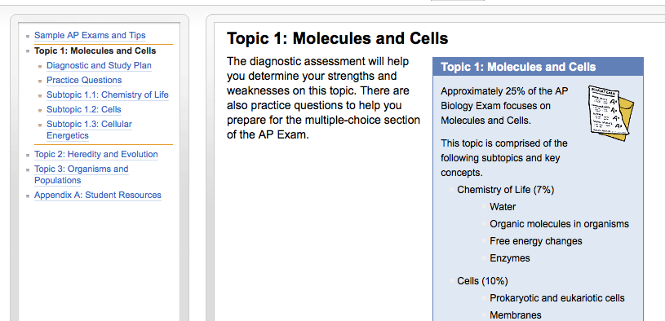

EXPLORE THE LINKS UNDER THE TOPIC 1 SECTION TO SEE THE WONDERFUL REVIEW MATERIAL!

9. Once you click on a resource link, use the arrows and the GO button in the lower right hand corner to navigate the page.
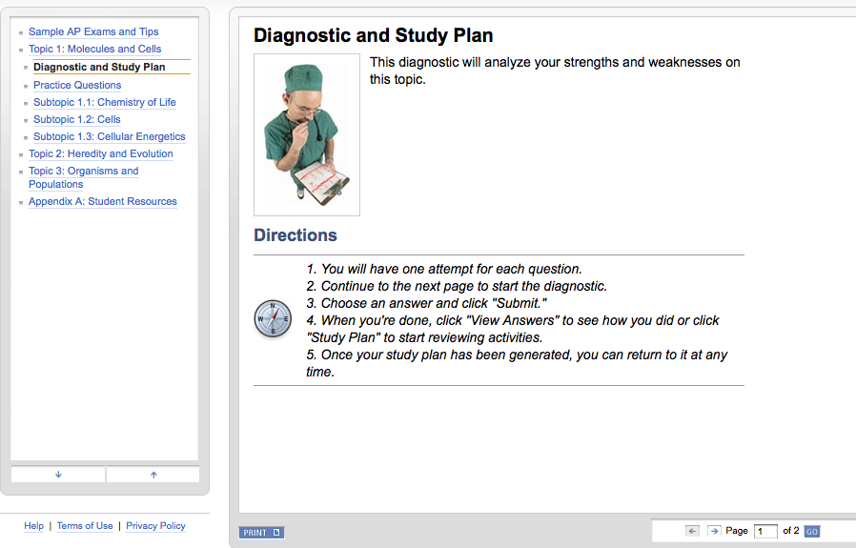
STUDY, PREPARE, REVIEW, APPLY, EVALUATION, PROCESS… ☺ YOU CAN DO THIS IS YOU PREPARE!

