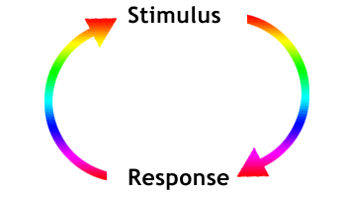
PLANT RESPONSE- Chapter 39
HORMONE = chemical messenger
~ produced by one part of the plant
~ translocated to other parts where it triggers a response
~ ALLOWS plant to react/adjust to external conditions w/o a nervous system
IMPORTANT PLANT HORMONES
1) AUXINS (EX: IAA= Indole-3-acetic acid)
- Controlled by ACTIVE TRANSPORT of auxin from cell to cell
- Often works in concert with or opposition to other hormones
EX: ratio of auxin to cytokinin determines initiation of root versus shoot buds
- elongation of cells; phototropism, gravitropism; apical dominance;
- stimulates proton pumps; acid weakens cell wall so cells can expand
- retards leaf abscission (drop leaves in fall)
- wound repair/promotes xylem/phloem differentiation
-Synthetic auxins = herbicides :2-4-D/Agent Orange ~ kills dicots (broadleaf weeds) but not monocots (corn)
TROPISM = hormone induced growth response toward/away from stimulus
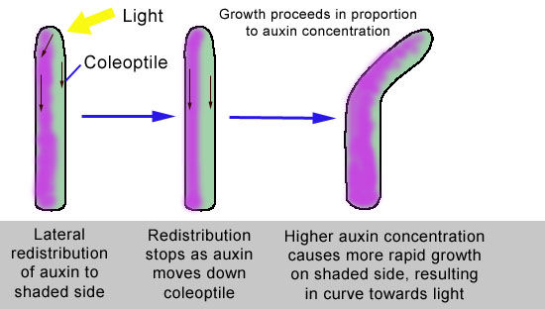
PHOTOTROPISM-response to light
(Positive- grow toward light; Negative-grow away from light)
-Differential rate of cell elongation;
-Shoot bends toward light due to asymmetrical distribution of auxins
- Light stimulates movement of auxin to dark side so cells on dark
side elongate faster than cells on light side

GRAVITROPISM-respond to gravity;
- Roots grow down/shoots grow up due to asymmetrical distribution of auxins;
THIGOMOTROPISM- respond to touch; EX: vines curl around supports
2) CYTOKININS- role in cell division/growth/differentiation;
-stimulate germination; delay senescence
3) GIBBERELLINS-
Promote seed/bud germination; leaf growth; stimulate flowering/fruit development;
Stimulate stem elongation; loosen cell walls so cells can expand
Many “dwarf” varieties don’t have working gibberellins
4) ABSCISIC ACID (ABA) - Often antagonistic to other hormones
Slows growth/promotes seed dormancy
LEAF ABSCISSION – leaves die and fall off in fall;
- Prevents deciduous trees from desiccation during winter when roots cannot absorb water from frozen ground
Stimulus is shortening days and cooler temperatures
-Signals closing of stomata in leaves under water stress to save water
5) ETHYLENE- “gas”
- Controls senescence (aging) - leaf fall, withering of flowers ~Role in APOPTOSIS= programmed cell death
- Promotes RIPENING OF FRUIT
EXAMPLE OF POSITIVE FEEDBACK- ethylene triggers ripening; ripening triggers more ethylene production
Reason to put fruit in paper bag to ripen ; “One bad apple spoils whole bunch”
PHOTOPERIODISM = physiological response to day length
Seasonal events; detect time of year by PHOTOPERIOD (relative length of night and day)
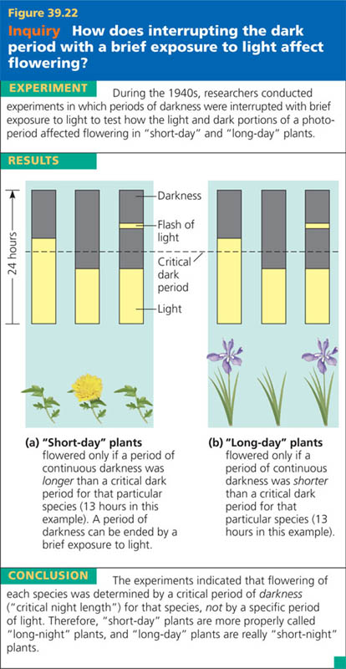
Circadian rhythm/ubiquitous to all eukaryotes; synchronized with the Earth's light-dark cycle
SHORT-DAY: flower in late summer/early fall/winter when daylight is decreasing (daylight < a critical length)
Really should be called LONG NIGHT PLANTS
if dark interrupted by flash of light . . . no flowers.
LONG-DAY: flower in late spring/early summer when daylight is increasing; (daylight > a critical length
SHORT NIGHT PLANTS-if dark interrupted by flash of light
. . . it flowers
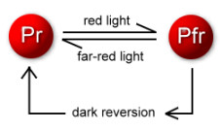
DAY-NEUTRAL: flowering unaffected by day length

PHYTOCHROME
Light-absorbing protein responsible for plant's response to photoperiod
Switching between forms controls various plant events
P_{r} (absorbs red light) ←→P_{fr} (absorbs far red light)
P_{fr} is biologically active form- triggers many plant responses to light
Synchronizes biological clock to the environment
PHYTOCHROME SYSTEM & BIOLOGICAL CLOCK allow plants to assess amount of daylight/season

SIGNAL TRANSDUCTION PATHWAY
2ND MESSENGERS- small, internally produced chemicals
transfer and amplify the signal from the receptor to other proteins that cause the response
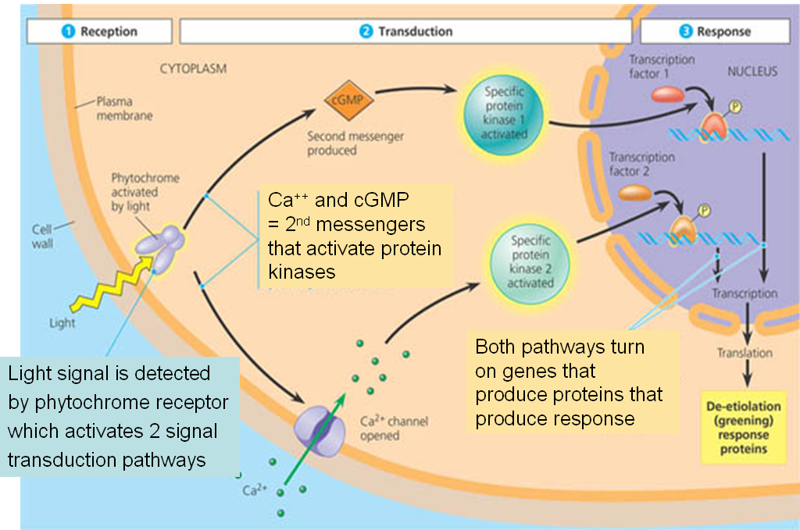
EX:
cGMP, cAMP

