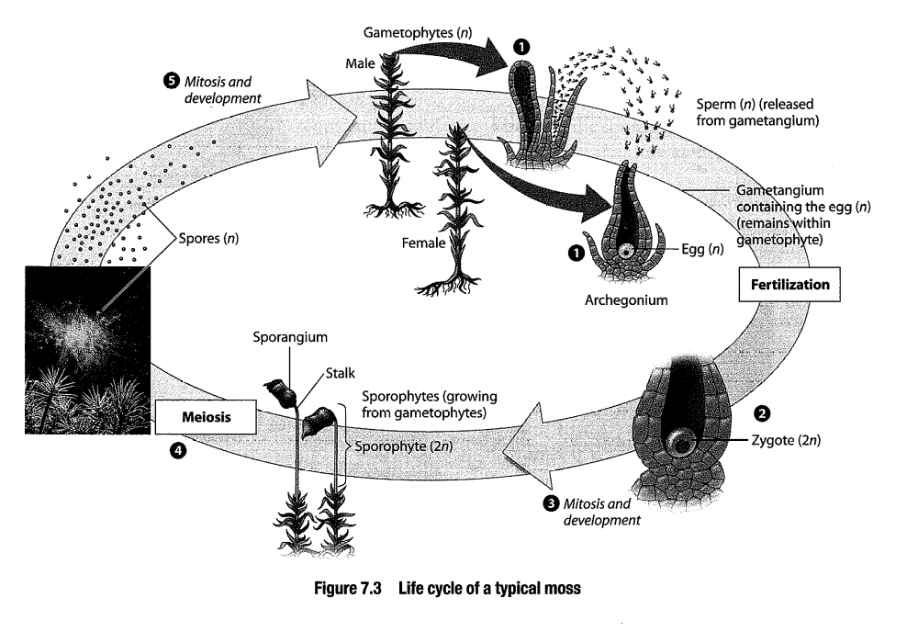  SEEDLESS NONVASCULAR PLANTS-  Mosses, Liverwort, Hornwort | 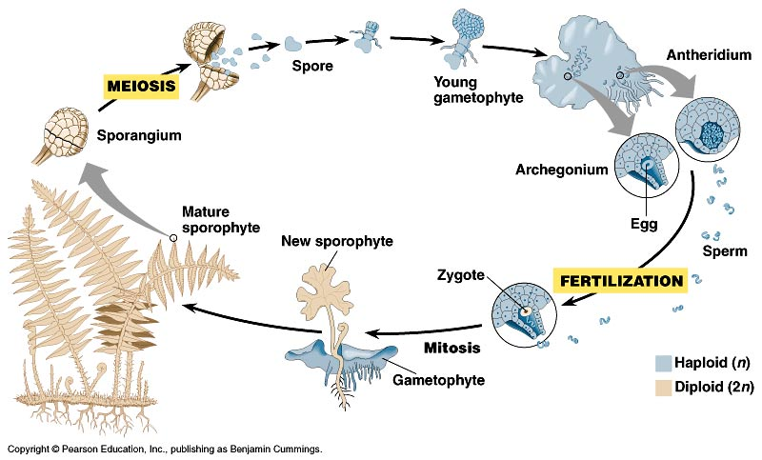  SEEDLESS VASCULAR-  Ferns, club mosses, horsetails
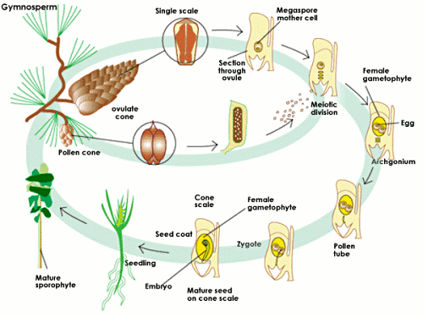  NAKED SEED VASCULAR PLANTS  Conifers, cycads, ginko | 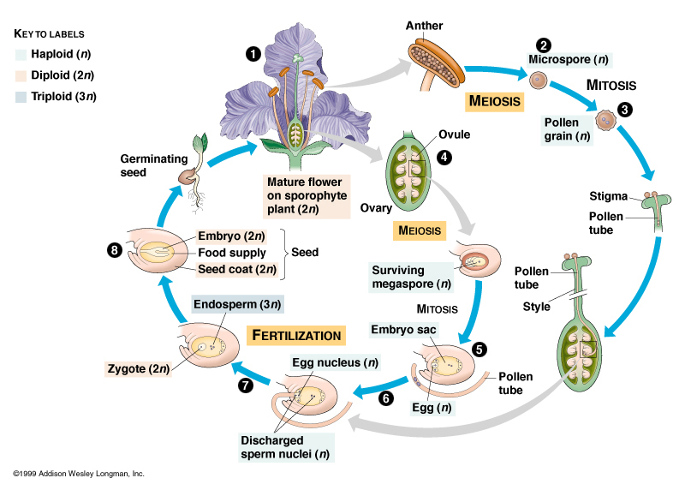  VASCULAR WITH SEEDS  flowering plants

 | SEEDLESS  NONVASCULAR | SEEDLESS  VASCULAR | NAKED SEED  VASCULAR | VASCULAR  WITH SEEDS
Examples

DOMINANT FORM
ALTERNATE FORM
How are sperm transferred?
Who relies on who?
Independence?

