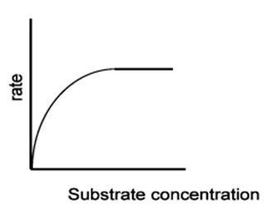
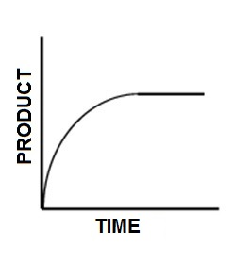
What is happening to the reaction rate in different parts of the graph?
What is happening when the graphs above “flat line” ?
How are these different?

What is happening to the reaction rate in different parts of the graph?
What is happening when the graphs above “flat line” ?
How are these different?

What is happening to the reaction rate in different parts of the graph?
What is happening when the graphs above “flat line” ?
How are these different?

