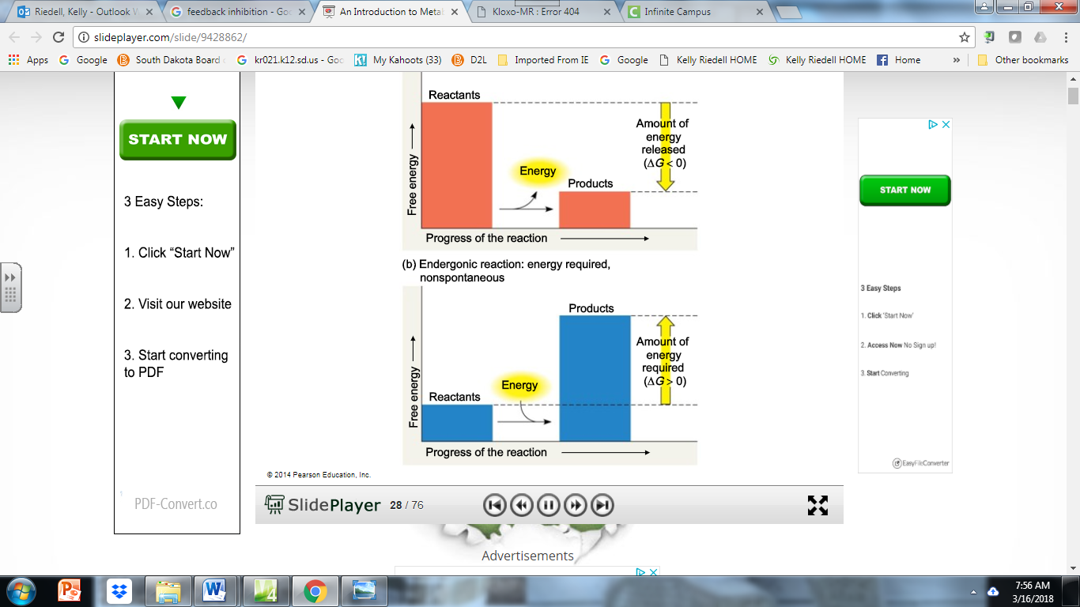

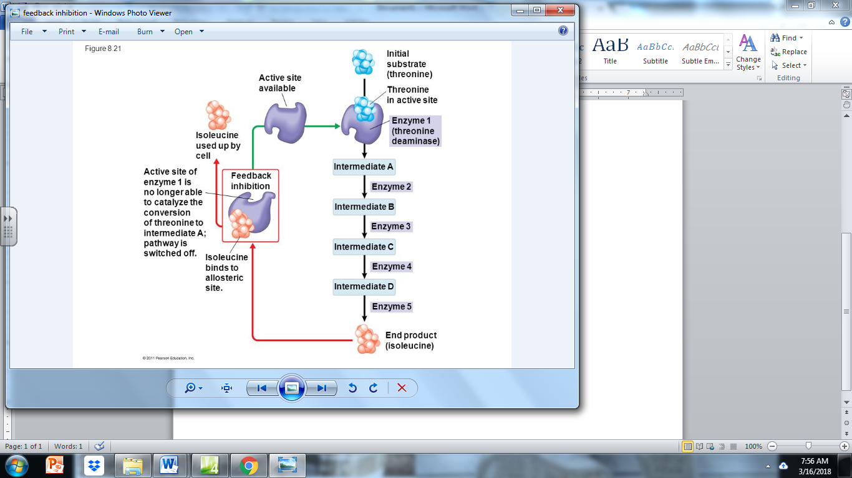

_____________________  
_____________________  
  
OR

______________________  
______________________