2009 #3
Phylogeny is the evolutionary history of a species.
a) The evolution of a species is dependent on changes in the genome of the species. IDENTIFY
TWO mechanisms of genetic change, and EXPLAIN how each affects genetic variation.
b) Based on the data in the table below, DRAW a phylogenetic tree that reflects the evolutionary
relationships of the organisms based on the differences in their cytochrome c amino-acid
sequences and EXPLAIN the relationships of the organisms. Based on the data, IDENTIFY
which organism is the most closely related to the chicken and EXPLAIN your choice.
c) DESCRIBE TWO types of evidence-other than the comparison of proteins- that can be used to
determine the phylogeny of organisms. DISCUSS one strength of each type of evidence you
described.
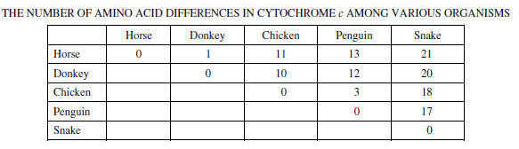

2011B #4. Phylogeny reflects the evolutionary history of organisms.
(a) Discuss TWO mechanisms of speciation that lead to the development of separate species from a common ancestor.
(b) Explain THREE methods that have been used to investigate the phylogeny of organisms. Describe a strength or weakness of each method.
(c) The two phylogenetic trees represent the relationship of whales to six other mammals. All of the organisms shown have a pulley-shaped astragalus bone in the ankle except for the whale.
• For each tree, describe a monophyletic group, the closest relative to the whale, and the point at which the pulley astragalus was lost or gained.
• Based on the principle of parsimony (the simplest explanation is the best) and the genomic information in the table shown, identify which tree is the best representation of the evolutionary relationship of these animals, and justify your answer
