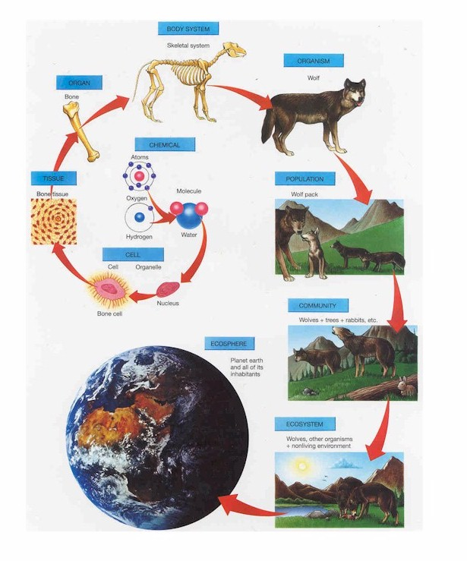
ECOLOGY NOTES (Chapters 50-55)
Ecology = Study of the interactions between organisms and their environment
Organisms → populations → communities → ecosystems → biomes → biosphere

Ecosystem = Biotic factors + Abiotic factors
BIOTIC | ABIOTIC
Living things;  All other organisms-  animals, plants, microorganisms | Non-living chemical & physical factors: temperature, light, rocks & soil, water, nutrients; wind; climate

Habitat- “location” - where it lives
Niche- “occupation” - where it lives PLUS interactions with biotic and abiotic factors
PRIMARY PRODUCTIVITY = amount of light energy converted to chemical energy; due to photosynthesis
Total primary production in ecosystem = GROSS primary productivity (not all of this available to consumers)
NET productivity = GROSS productivity - energy used during RESPIRATION

DOMINANT SPECIES: Most abundant species or highest biomass (total weight) in community
KEYSTONE SPECIES- species that has disproportionate effect on ecosystem relative to its abundance
Ex: Sea otters in kelp forests

MATTER  recycles WITHIN ecosystem and is REUSED | Carbon cycle  Nitrogen cycle  Water cycle  Phosphorus cycle
ENERGY  flows ONE WAY THROUGH ecosystem and is USED UP | 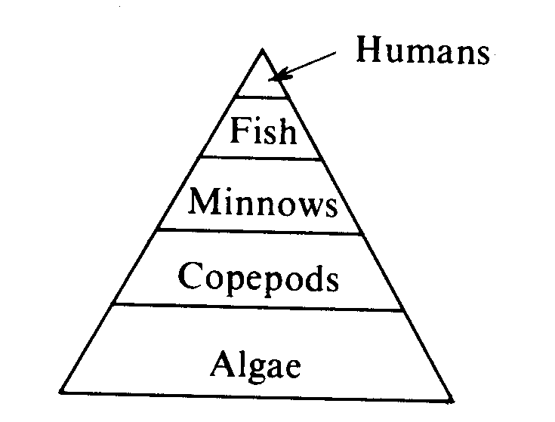  Food chains/webs- Energy passes to next TROPHIC level as  organisms are eaten;  1st level always = producers (autotrophs)  1° consumers (heterotrophs) eat producers  2° consumers eat 1° consumers  3° consumers eat 2° consumers  Only 10% of energy at each level is passed on  to next trophic level (limits # of levels possible)  Species can feed at more than one trophic level
HERBIVORES- eat plants; Ex: deer, rabbits, elephants
CARRNIVORES- meat eaters; Ex: lions, tigers
OMNIVORES- eat both plants and animals (Ex: humans, bears)
DETRITIVORES- scavenge/eat dead organisms; Ex: crabs, worms, vultures
DECOMPOSERS- absorb nutrients from dead organisms; Ex: fungi, bacteria

BIOTIC FACTORS that affect the distribution of organisms:
-COMPETITIVE EXCLUSION PRINCIPLE-no two species can share same niche
One with reproductive advantage will eliminate the other

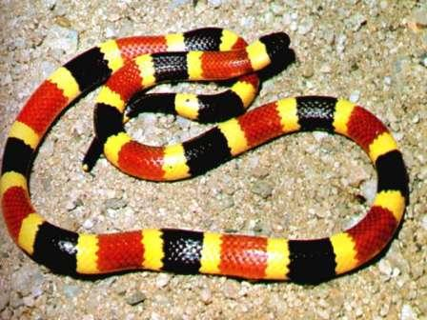
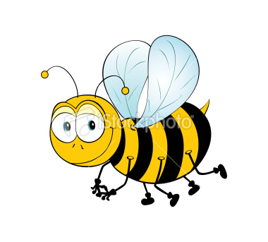
-PREDATION- hunt & kill each other for food (predator/prey) (+/-)
Defensive adaptations: CRYPTIC coloration (=camouflage) make prey difficult to spot
APOSEMATIC coloration- bright warning colors in organisms with poisons
EX: coral snake red/yellow; bees/wasps both yellow & black
Need trial and error learning to make it work
BATESIAN MIMICRY- harmless species mimics dangerous one
MULLERIAN MIMICRY- two harmful/distasteful species look alike
EX: bees and wasps; Viceroy/Monarch butterflies (originally thought Batesian)
-SYMBOSIS- different organisms live on, in, or near another
Mutualism- both benefit (+/+) (flower & bee)
Commensalism-one benefits; other neither helped nor harmed (hermit crab & snail) (+/0)
Parasitism-one benefits; other harmed (dog & tick) (+/-)
-PATHOGENS/DISEASE (+/-) bacteria, viruses, protests, fungi, prions - all decrease populations
-COOPERATION (+/+) – help each other, grooming, hunt in pack, share parenting
INTERSPECIFIC COMPETITION (-/-): Species compete for available resources
LIMITING FACTOR- necessary resource in short supply
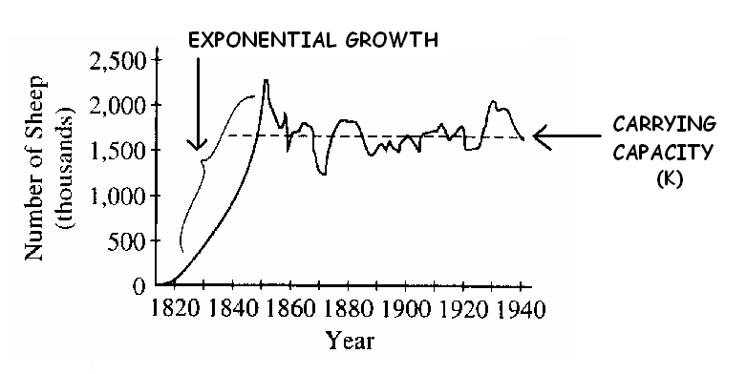
DENSITY DEPENDENT POPULATIONS- stabilize near carrying capacity
(Birth and death rates affected by food, space, disease, predation, stress due to crowding, toxins)

CARRYING CAPACITY- maximum population size that can be supported by available resources (K)

Exponential growth: characteristic of populations in ideal conditions  EX: introduced to new environments, recovering from disaster, or has not reached carrying capacity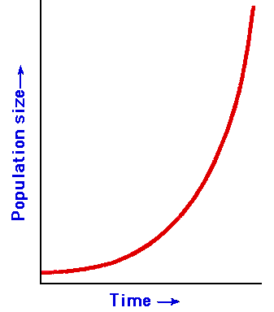;  abundant resources | 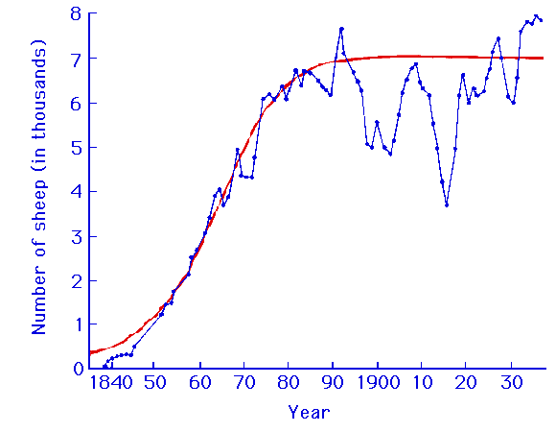S curve:  Population increases until carrying capacity  is reached

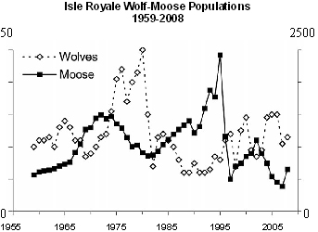
PREDATOR-PREY growth curves cycle together with lag
Increase in predators followed by decrease in prey
Decrease in predators followed by increase in prey
EX: Wolf and moose

SELECTION OF LIFE HISTORY TRAITS SENSITIVE TO DENSITY/CARRYING CAPACITY

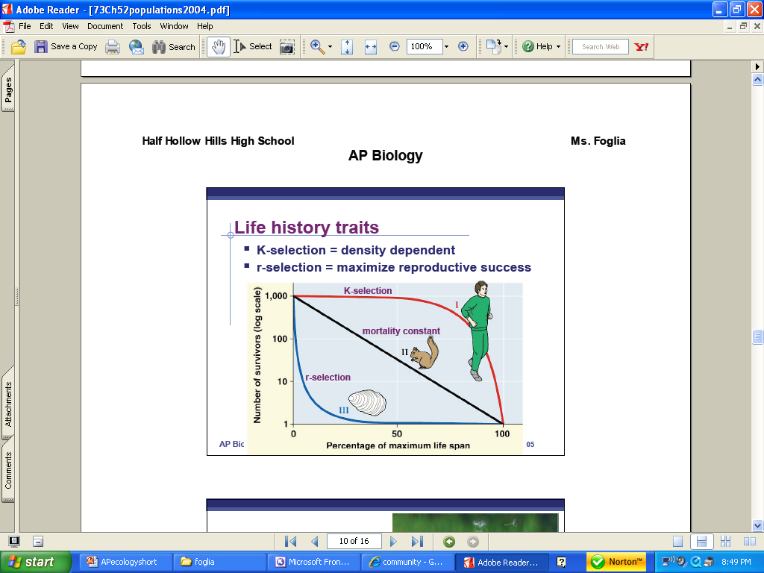
DEMOGRAPHY: study of population statistics
TYPE I (K-selection): low death rates in early/midlife; sharp death rate in old age
functions in populations close to carrying capacity
produce few offspring; high parental care; long gestation; longer life expectancy; increased chance of survival
EX: elephants, trees, humans
TYPE II: constant death rate over life span

TYPE III (r-selection):
Very high early death rate; few surviving to old age
exponential growth; quick reproduction and early maturity; many offspring; shorter life span; most don’t survive
EX: bacteria, diatoms, rodents, dandelions
BEHAVIOR- everything an animal does & how it does it
INNATE = automatic, inherited, triggered by SIGN STIMULUS
FIXED ACTION PATTERN: once start must complete action sequence
EX: Male red bellied stickleback fish attack objects with red underside; yawning makes others yawn;
egg rolling in geese; mating dances, human baby grasping
LEARNED = develop during animal’s lifetime
Some bird species learn songs during critical period; unable to learn later if miss critical period
Other species have open ended learning; can learn at any time

IMPRINTING = Learning at a specific CRITICAL PERIOD forming social attachments
- both learning & innate components
EX: baby ducks follow mother

ALTRUISTIC behavior (leads to KIN SELECTION)
Behavior favors reproductive success of relatives, even at a cost to own survival and/or reproduction
EX: warning call may get you eaten but family survives
COMMUNICATION
PHEROMONES = chemical signal that stimulates a response from other individuals
- alarm pheromones- warn others
- sex pheromones – attract mates
BEE WAGGLE DANCE-communicate location of food

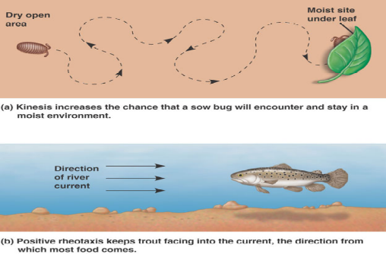
MOVEMENT
TAXIS = change in direction
automatic movement toward (+) or away from (-) a stimulus
- phototaxis
- chemotaxis
KINESIS = change in rate of movement in response to a stimulus

ENVIRONMENTAL PROBLEMS:
DEAD ZONES in lakes/Gulf of Mexico caused by agricultural runoff (fertilizer & animal waste)
EUTRIFICATION-process by which nutrients (especially phosphorus & nitrogen) become highly
concentrated in body of water causing increased growth of organisms such as algae.
Nutrient rich/oxygen poor; algae bloom blocks sunlight and kills off organisms below

OZONE DEPLETION-Caused by CFC’s (chlorofluorocarbons) in aerosols, refrigerators, air conditioners
“bad” Ozone (O₃) - near earth’s surface causes respiratory problems
“good” Ozone higher in atmosphere; protects us from harmful effects of UV-light
(skin cancer, cataracts, premature aging, crop damage)
Protective ozone layer has been thinning- loss greater in winter; greater over Antarctica
MONTREAL PROTOCOL- reduced/banned use of CFC’s; signed by U.S. and many other nations.
Depletion is slowing; example of International cooperation to solve environmental problem.

ACID RAIN- Caused by burning fossil fuels
Releases sulfur and nitrogen oxides into atmosphere that react with rain water → sulfuric and nitric acid; Acidic precipitation causes changes in soil and water pH in ecosystems downwind from industrial regions

GLOBAL WARMING- Caused by burning fossil fuels/deforestation
”Greenhouse effect”- Atmospheric gases (methane, CO₂) trap sunlight and warm planet
This is “good” = makes planet habitable (CO₂ naturally higher in winter, less photosynthesis happening)
Problem: Burning of fossil fuels has caused global CO₂ levels and therefore global temperatures to rise dramatically; Results in weather extremes; more severe storms; melting of ice caps; coastal flooding;
KYOTO ACCORD: Many nations pledged to reduce greenhouse gas emissions;
U.S. only major nation that hasn’t signed
COPENHAGEN (Dec 2009): Framework for plan but needs to be put into action
BIOLOGICAL MAGNIFICATION- Cause chemical pollution
Concentration of toxins in successive trophic levels (top level has greatest concentration)
Ex: DDT concentrated in eagles causing them to lay eggs with weakened shells → endangered
Rachel Carson wrote book (Silent Spring) warning of effect of DDT on non-target populations
Start of environmental movement
INVASIVE SPECIES-species (usually introduced by humans) that takes hold outside its native range
Few natural predators/diseases to control its numbers; out-compete native species
Ex: Zebra mussel, leafy spurge in SD; rabbits in Australia

BIOMES-
Major types of ecosystems that occupy broad geographic regions based on TEMP & RAINFALL

BIOME | Characteristics
Tropical Rainforest | Equatorial; greatest biodiversity  Intense vertical stratification; Canopy so dense/little light gets through  very wet; warm year-round  Rapid turnover of nutrients  many plants & animals, epiphytes (plant live on other plants)
Savanna | Grasses and scattered trees;  Dominant herbivores = insects  Fire = dominant abiotic factor; many plants fire-adapted/drought tolerant  Plant growth is substantial in rainy season  Large animals must migrate during regular seasons of drought  temperature: always warm
Desert | Sparse rainfall; plants & animals adapted to conserve/store water  Many CAM plants and plants adapted to prevent being eaten (spines on cacti)  temperature: varies daily/seasonally, hot & cold extremes  sparse vegetation & animals: cacti, succulents, drought tolerant, reptiles, insects, rodents, birds
Chaparral | Dominant: dense, spiny evergreen shrubs  Coastal area w/cool rainy winters and long, hot, dry summers|  scrubby vegetation, Plants are drought/fire adapted, herbivores, amphibians, birds, insects
Temperate Grassland  (Most of South Dakota) | Seasonal drought w/ occasional fires  many herbivores; Large grazing animals  precipitation: seasonal, dry season/wet season  cold winters/hot summers  prairie grasses fire/drought adapted, few trees:  deep, fertile soil good for agriculture
Temperate Deciduous Forest | Dense stands of deciduous (drop leaves in fall) trees  forests more open/not as tall as rain forests  Stratified: top layer trees; shrubs, herbaceous layer  precipitation: adequate, summer rains, winter snow  temperature: moderate warm summer/cool winter  many mammals hibernate/birds migrate
Coniferous Forest (Taiga) | Dominant: conifers  adequate to dry rainfall (temperate rain forest on coast)  cool year round  diverse mammals, birds, insects
Tundra (Artic & Alpine) | Permafrost (permanently frozen layer of soil)  very cold temps year round; high winds; little rain  NO trees or tall plants;20% or Earth’s terrestrial surface  lichens & mosses, migrating animals & resident herbivores

