Pattern Matching: Organic Molecules
What are living things made of? Sugar and spice and everything nice? (Or snips and snails and puppy dog tails . . .) Common sense tells us that living things are somehow different from non-living things, but how deep does that difference run? Are living things made from different kinds of atoms than those in non-living things? Different kinds of molecules?
There may be as many as 10,000 different kinds of molecules in a living thing. But are there a few common patterns? A few common functions?
Objectives:
Once you have completed these exercises you should be able to:
- Know what an organic molecule is and how it differs from an inorganic molecule.
- Identify the major classes of organic molecules.
- Identify the distinguishing features of each class of molecules.
- Given a typical example of an organic molecule, identify the class to which it belongs.

Pattern Matching
Table 1 reviews the most common atoms found in living organisms and some of their properties. (These atoms also occur in non-living things.) As you work, notice if the atoms in your molecules follow the indicated bonding patterns.
Table 1. CHNOPS: Common Elements in Living Things
Abbreviation | Name | Atomic Number | Atomic Weight | Usual # of Bonds
C | carbon | 6 | 12 | 4
H | hydrogen | 1 | 1 | 1
N | nitrogen | 7 | 14 | 3
O | oxygen | 8 | 16 | 2
P | phosphorus | 15 | 30 | 5
S | sulfur | 16 | 32 | 2, [4, 6]
Identifying Categories of Biological Molecules
Exercise 1
The objects you will be sorting are basic building blocks (subunits) of common macromolecules in living things. Do NOT refer to your books during this exercise. Use your own judgment in doing the sorting.
Cut out the set of unlabeled molecules below. Organize the 42 cards into groups based upon structural similarities. Pay special attention to:
• the elements (CHNOPS) in the molecule,
• the shape of the molecule,
• patterns within the molecule, and
• the ends of the molecule.
◊ How many groups of molecules do you have? _____
Explain your reasoning for creating these particular groups. (Quick-and-dirty sketches of general molecule shapes can be part of your explanations.)

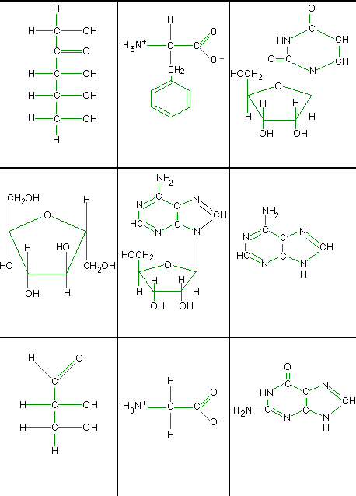

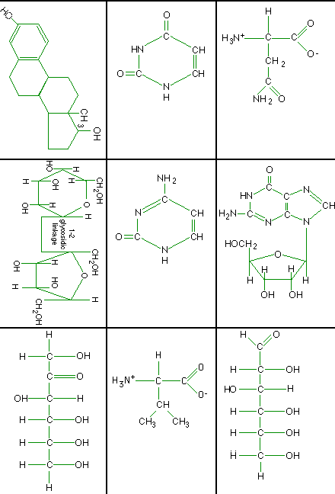

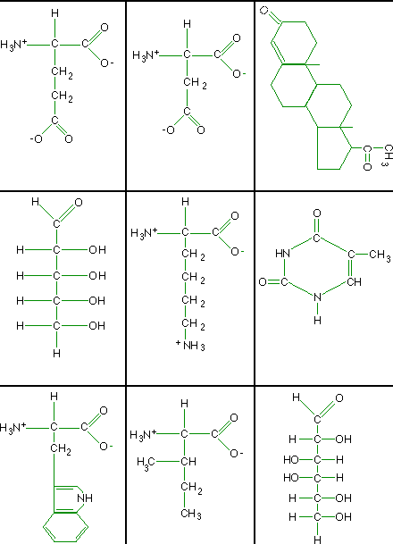

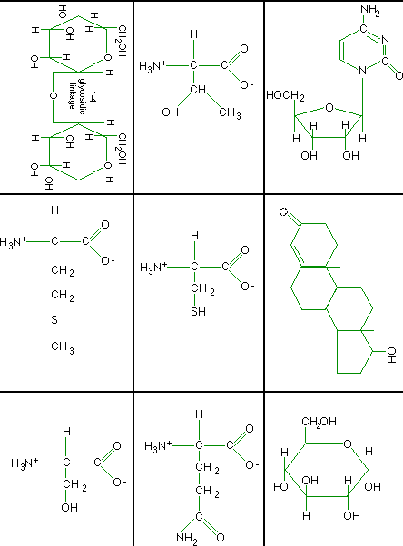

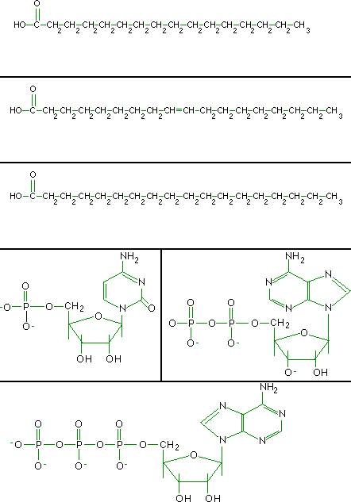

Pattern Matching: Part II
Chemists and other scientists use a variety of representational styles or conventions for drawing molecules, and they shift easily between them.
Take out your response to Part I of this exercise and check your groups of molecules against the grouping given here. At the same time, (a) learn a bit about how to read and interpret the various types of molecular formulas and (b) learn about the different groups of organic molecules.

Group 1: Amino Acids - Building Blocks of Proteins
Amino acids are the building blocks of proteins - molecules that play many important roles in the body (including muscle structure, hormones, antibodies, hemoglobin for carrying oxygen, other transport proteins for carrying molecules across cell membranes, toxins, and chemical messengers in the nervous system).
Figure 1 shows a "generic" amino acid. Another (more compact) way to represent the same molecule is "NH₃+ -- CHR -- COO-" or "NH₃+ -- CHR -- COOH".
Figure 1. "Generic" Amino Acid
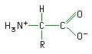

The "-N-C-C-" in the center of the molecule is known as its backbone and is a defining feature of amino acids. The backbones are linked together in a linear chain when amino acids are combined to form a protein. A typical protein chain may contain 150 - 1000 or more amino acids.
Figure 2. Protein Backbone
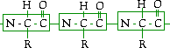

◊ Are the bonds between the nitrogen and the hydrogen atoms shown in Figure 1? Redraw the amino acid below, showing all of bonds between the atoms.

◊ In Figure 1, which atom is negatively charged?
The negative charge arises when a hydroxyl group ("-OH") gives up a positively charged hydrogen atom ("H+"), leaving the negatively charged oxygen atom ("O-"). The entire group, "- COOH" or "-COO-", is known as a carboxyl group. The amine and carboxyl groups and the "N-C-C-" backbone are defining features of amino acids.
◊ The bonds between the carbon and oxygen atoms are not shown in the above paragraph. Draw the molecular structure of a –COOH group.

◊ Does the carbon atom bond the same way to both oxygen atoms in the carboxyl group? How do you know?

Each amino acid has a different side group that is represented by "R" in Figures 1 and 2. Two amino acids with their particular side groups are shown below.
Figure 3. Side Groups in Asparagine & Valine
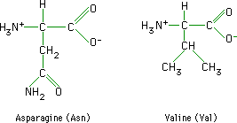

◊ Look in your textbook to find the section on amino acids. Draw three other amino acids below (be sure to include the names of the molecules).
Drawing 1. Draw Three Additional Amino Acids

◊ Paste the amino acids in your set of molecules below.

◊ Which of the CHONPS elements/atoms are found in ALL amino acids?

There are twenty common amino acids that are used to build protein molecules. Cells string amino acids together end-to-end as shown in Figure 2 .
◊ With 20 amino acids to choose from, how many different combinations are there for a protein that’s three amino acids long?

◊ How many combinations for a protein that’s 10 amino acids long?

◊ How about 50 amino acids long?

Considering that most proteins that a cell makes are hundreds of amino acids long, the number of different proteins that can be built is staggeringly large. (Admittedly, not every combination produces a functional protein,)

Group 2: Steroids - Type of Lipid
Cholesterol, shown below, is a steroid. Steroids are one type of molecule in the class of compounds known as lipids. Cholesterol plays an important role in membrane formation.
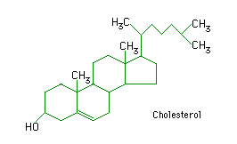
Figure 4. Cholesterol

Steroids can be recognized by their multiple rings of carbon atoms connected together. “But wait,” you say, “I don’t see any carbon atoms in the four rings in the cholesterol molecule!” Believe it or not, they are there.
Organic chemists use many shortcuts in drawing complex molecules. Because organic molecules include so many carbon atoms, chemists often do not include the letter C for carbon. In the cholesterol molecule above, there is a carbon atom (not drawn in most cases) at every point of each of the four rings and in the side chain. The bonds between the carbons are shown. In all but one case the carbon atoms are connected to one another by a single bond (one pair of shared electrons). In one ring there are two carbon atoms connected by a double bond.
◊ Draw an arrow to point at the double bond in Figure 4.
◊ To further simplify this drawing, none of the hydrogen atoms have been drawn. However, since you know that each carbon atom forms four bonds, you can fill in all the missing hydrogen atoms. Please redraw the cholesterol molecule below, representing all carbon atoms as “C”’s and including the missing hydrogen atoms bonded to the carbons. (Several carbons in the molecule already have four bonds and so will have no additional atoms added.)

◊ Paste your steroids below, and draw in the hydrogen atoms.
Drawing 3. Paste Your Steroids

Group 3: Fatty Acids – Another Type of Lipid
You should have some long hydrocarbon chains with a carboxyl group at one end. One of the defining features of these hydrocarbon chains is the absence of oxygen except in one carboxyl group at one end of the molecule.
These hydrocarbon chains are fatty acids. Fatty acids are the building blocks of oils and fats. There are two fatty acids in each of the millions of phospholipids that make up your cell membranes.
Figure 5. Three Representations of a Fatty Acid (lauric acid)
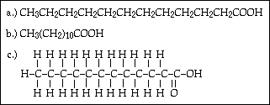

Fatty acids that contain no double bonds are saturated. An unsaturated fatty acid contains one or more double bonds (Figure 6).
Figure 6. Unsaturated Fatty Acid (oleic acid)
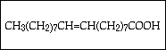

Fats are the most concentrated energy source in our diets, furnishing about 2.5 times the energy that sugar does, gram for gram. We store energy for future use in fats. Fats also insulate and protect the body and many internal organs.
◊ How many fatty acids do you have in your collection?
◊ How many are saturated?
◊ How many are monounsaturated?

◊ If a monounsaturated fatty acid has one double bond in its hydrocarbon chain, how do you think you would define a polyunsaturated fatty acid?

◊ Draw a short polyunsaturated fatty acid below.

◊ Paste your fatty acids below.

Group 4: Sugars - Building Blocks of Carbohydrates
Sugars are the building blocks of carbohydrates. They are literally hydrates of carbon, having the general formula "C_{n}(H₂O)_{n}". Sugars are burned (oxidized) to release energy in cellular respiration and they play an important role in homeostasis. Your body maintains the level of the sugar glucose in your blood within a very narrow range. Glucose is the immediate source of energy for your cells.
Sugars occur as ring structures. There are monosaccharides (single rings), disaccharides (double rings), and larger. In solution, single rings can dynamically change from straight chains to rings and back to straight chains. A straight chain sugar is shown below (Figure 7). Notice that every carbon has an oxygen atom attached to it.

Figure 7. Straight Chain Representation of a Sugar (ribulose)
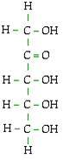
◊ How many straight chain sugars do you have in your set?

◊ Based on what you know so far, which of the CHNOPS elements are contained in sugars?

◊ How many single ring monosaccharides are in your molecule set?

◊ How many disaccharides are in your molecule set?

◊ One of the disaccharides is common table sugar. Look up “sucrose” in your textbook. Which two monosaccharides combine to form sucrose? Draw them below. Which atoms are removed during the bonding of the two monosaccharides?
Drawing 5. Common table sugar (sucrose)

Sugars can be joined together in long chains to form macromolecules called starch, cellulose, and glycogen (animal starch). Starch (in plants) and glycogen (in animals) are easily broken down into sugars for energy. Cellulose, on the other hand, which is made in plants, can be broken down only by a few organisms in the world (primarily the bacteria in the guts of termites). Yet all three types of macromolecules are made of long chains of sugar, and cellulose differs only by a small change in the connecting bond between each pair of sugars.
◊ In the space below, paste all your sugars, including straight chain sugars, monosaccharides, and disaccharides.
Drawing 6. Sugars

◊ Based on the molecules above, do all sugars have an oxygen attached to every carbon?

Group 5: Nucleic Acids -- Single and Double Ring Molecules Containing Nitrogen

So far we have identified three of the four major classes of molecules in living things:
- proteins and their subunits amino acids,
- lipids including fats and oils with their subunits, fatty acids, and steroids,
- carbohydrates, including starch, cellulose, and glycogen (animal starch) with their subunits, sugars.

You probably recognize these three types of molecules as major food groups as well as major classes of biological molecules. In contrast, nucleic acids, the fourth and last major group of molecules, are not a major food group. Nucleic acids include two kinds of molecules, RNA (ribonucleic acid) and DNA (deoxyribonucleic acid), and their subunits. In most organisms, DNA contains the genetic blueprint for the organism and is reproduced in its entirety in every cell of its body. RNA helps to translate the information in DNA into the production of thousands of different kinds of proteins, which in turn control development of the organism.
Each nucleotide or complete subunit of a nucleic acid has three parts, a nitrogenous base, a five-carbon sugar, and 1 to 3 phosphate groups (Figure 8).
Figure 8. Parts of a Nucleotide (uracil triphosphate)
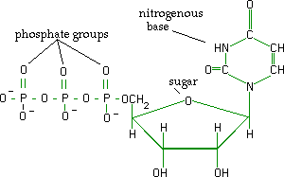

The nitrogenous bases consist of single or double rings, and each ring contains two nitrogens. DNA contains four nitrogenous bases: adenine (A) and guanine (G), each with double rings, and cytosine (C), and thymine (T), with single rings. RNA contains three of these, A, G, and C, and a fourth base, uracil (U).
◊ Paste your nitrogenous bases below.
Drawing 7. Paste Nitrogenous Bases

A nitrogenous base is combined with a five-carbon sugar, either ribose (for RNA) or deoxyribose (for DNA), as shown below. The arrows in Figure 9 point to the single structural difference between ribose and deoxyribose.
Figure 9. Ribose and Deoxyribose
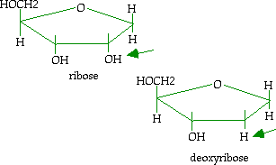

◊ How many molecules do you have that contain both a nitrogenous base and a five-carbon sugar? These are called nucleosides. Paste them below.
Drawing 8. Paste Nitrogenous Base & Sugar Molecules
(nucleosides) Below

Nucleosides can combine with one, two or three phosphates. The greater the number of phosphates, the greater the energy contained in the molecule. Adenosine triphosphate (ATP) is not only a major subunit of DNA and RNA, but also is a major energy carrier in living systems.

◊ How many nitrogenous bases do you have that are combined with a sugar and one or more phosphates? _____ Paste and label them below.
Drawing 9. Paste & Label Nucleoside Mono-, Di-, & Triphosphates Below

◊ In summary, which of the CHNOPS elements are contained in nucleic acids?

Summary
Organic molecules are carbon-based, whereas inorganic molecules are not.
Each class of macromolecules is built up from subunits. Except for cellulose, they are easily assembled and disassembled.
There are four major classes of organic molecules:
- proteins - the workhorses (enzymes, hormones, carriers, etc.) of the cells
- lipids - energy storage & protection, hormones, cholesterol , and phospholipids (membrane structure)
- carbohydrates - energy carriers, structural units
- nucleic acids - genetic information

Table 3. Summary Organic Molecules
Class | Building Blocks | Macromolecules | Atoms
Proteins | Amino Acids | Enzymes, Hormones | CHONS
 |  | Identifier Proteins
 |  | Carrier Proteins
 |  | Hemoglobin
 |  | Antibodies
 |  | Spindle Fibers, etc.
Lipids | Fatty Acids | Steroids | CHO
 | Glycerol | Oils  Waxes
Carbohydrates | Sugars | Starches | CHO
 |  | Cellulose
Nucleic Acids | Nucleotides | DNA, RNA | CHONP

Organic Molecules II

(Molecules are identical to previous sheets, but with names added for reference)
