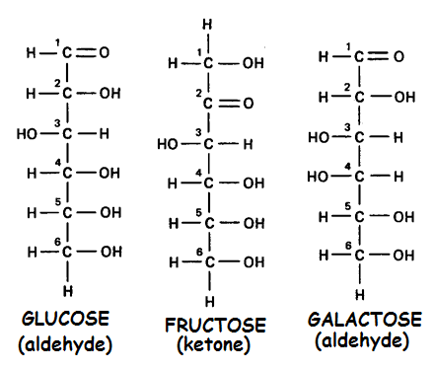
1. The sugars shown are examples of which type of isomer?

2. Fructose is an example of a(n) ___________ sugar. aldehyde ketone

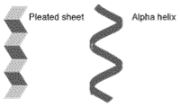
3. These shapes are examples of which level of protein structure.

4. Which kind of bond is responsible for the emergent properties of water such as cohesion, adhesion, and surface tension?

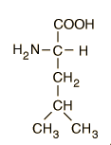
5. This molecule is an example
of which type of building
block used to make
macromolecules?

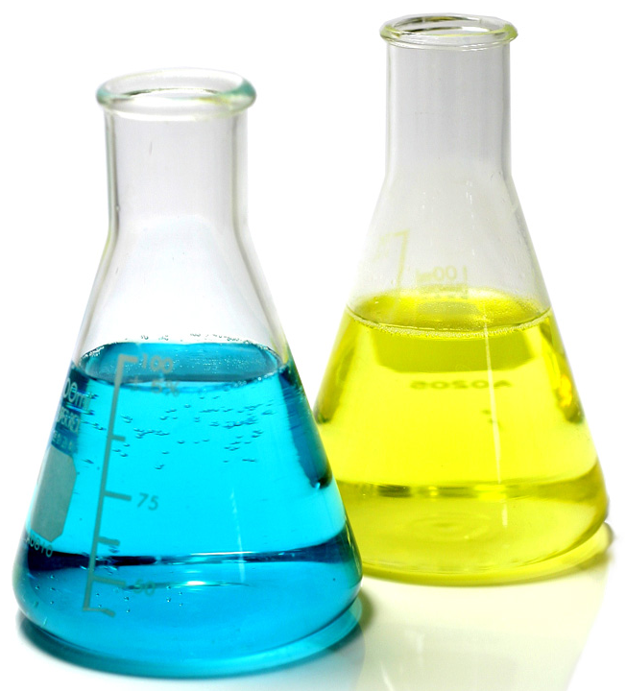
A B 6. Flask A = pH 6
Flask B = pH 9

Flask A is ____ times _____ acidic than flask B.
more less

7. Complete the sentence.
Nucleotides are to ______________ as
______________ are to proteins.

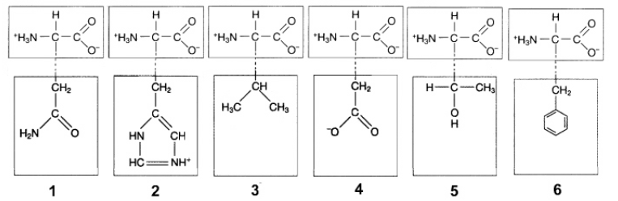

8. In the figure above, ionic attractions would form between the R groups of which amino acids?
a) 1 and 3
b) 2 and 4
c) 3 and 5
d) None of these

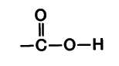
9. Identify this functional group.

10. How does adding this group to a molecule change its characteristics?

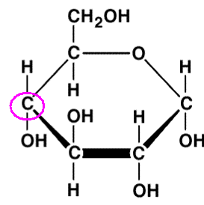
11. Use the numbering system you learned about to number the circled carbon.

12. Tell a polysaccharide that could be built using this molecule as a subunit.

13. Which monomer is incorrectly matched with its corresponding polymer?

a) Amino acids - proteins.
b) Monosaccharides - polysaccharides.
c) Fatty acids - nucleic acids.
d) Glucose - starch.

14. Tell one way DNA and RNA are different.

15. Name the subunits used to make a triacylglycerol.

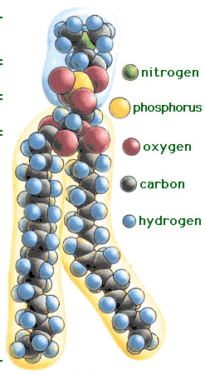
16. Which part of a phospholipid is polar, the head or the tails?

17. Chitin, cellulose, amylopectin, amylose, and glycogen are all examples of ______________

18. Nitrogen bases with 2 rings like adenine and guanine are called ______________

19. Animals store their sugar as ____________

20. Explain how hydrolysis and dehydration synthesis play a role in the charging and release of energy from ATP, the rechargeable power molecule used by cells for energy.

21. Tell how the function of polysaccharides made from α-glucose and β-glucose are different.

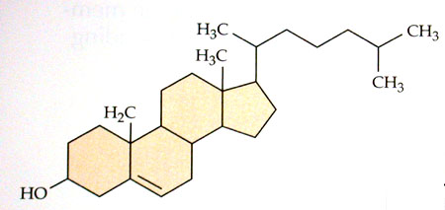
22. Lipids with this basic structure (3 rings and a dog house) are called ________________

23. ______________ is the attraction of water molecules to a surface.

24. In an experiment 100 plants are grown in identical pots, watered the same amount, and given the same amount of light. A fan is placed to blow a slight breeze on 50 of the plants. The other 50 are grown without a fan. Transpiration rate is measured and recorded. Identify the dependent and independent variables in this experiment.

25. Fatty acids with at least one double bond are called _____________.

26. Tell how a peptide and protein are different.

27. Name a functional group that would make a molecule more hydrophobic.

28. _____________ bonds are covalent bonds that hold amino acids together in a polypeptide chain.

29. Polar molecules are ________________
hydrophilic hydrophobic

30. Name the parts of a nucleotide subunit.

31. Which of these end up in the backbone (sides of the ladder) in a DNA molecule?

32. Carbohydrates made with only TWO sugars joined together like sucrose or lactose are called ____________.

33. Name a nitrogen base found in RNA but not DNA.

34. Tell the kind of glycosidic linkage found in cellulose and chitin.

35. What functional group does cysteine have that allows it to form disulfide bonds?

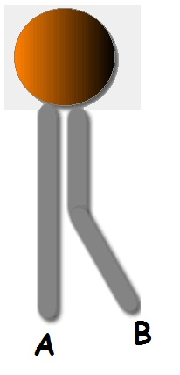
36. Which fatty acid tail in this phospholipid is unsaturated?

37. How can you tell?

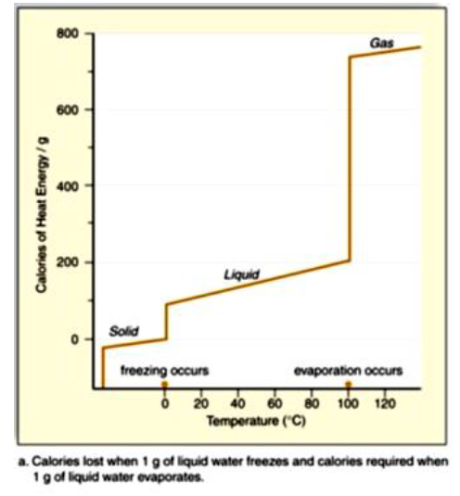

38. The figure at the right shows the calories of heat energy required to convert a gram of water from solid to liquid state, and then again from liquied to a gaseous state. This graph predicts which of the following properties of water that would affect plant survival.

a) Plant leaves doing transpiration are cooled down on hot days.
b) Inside a plant stem, cohesion and adhesion attract one
water molecule to the water molecule above it, allowing a
“chain” of water molecules to move up the stem.
c) At a plant’s roots, adhesion attracts water molecules to “stick” to root hairs, aiding absorption.
d) Sugar dissolves in water, leading to sugar being transported in the phloem transport tubes from the leaves down to the roots.

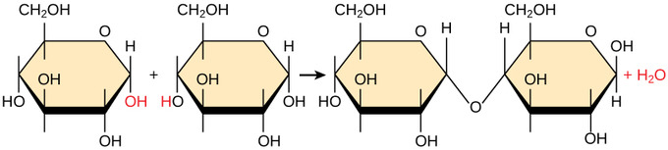
39. Name this chemical reaction.

