NAME ________________________________

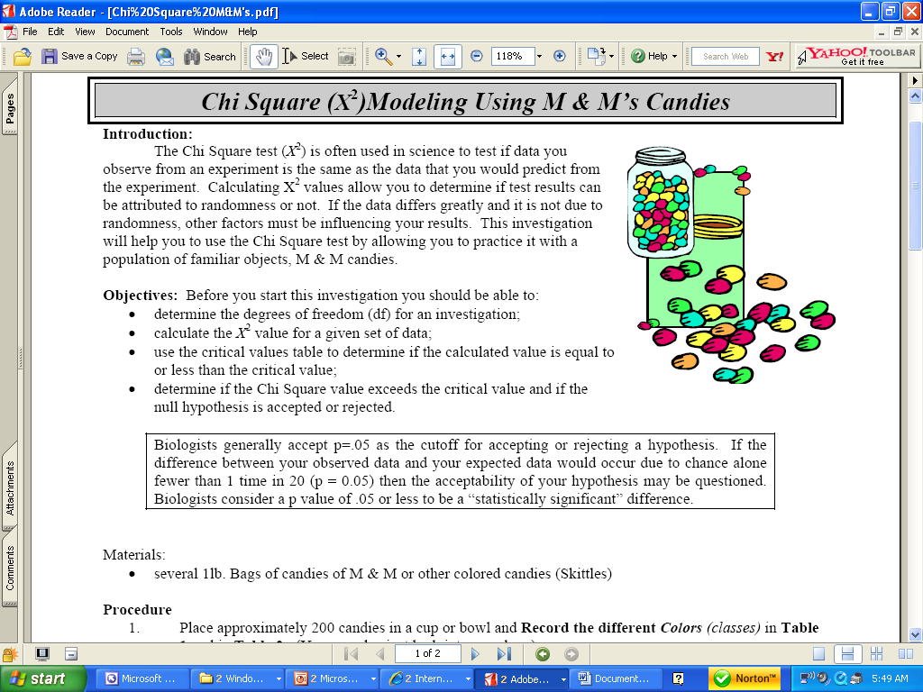

INTRODUCTION:
The Chi Square test (X²) is often used in science to test if data you observe from an experiment is the same as the data you would predict from the experiment. Calculating X² values allow you to determine if the test results can be attributed to randomness or not. If the data differs greatly and it is not due to randomness, other factors may be influencing your results.
* * * * * * * * * * * * * *
Write a NULL hypothesis that predicts the percentage of the different colors of M & M’s in your bag.
____________________________________________________________________________________________
____________________________________________________________________________________________

COLLECT DATA:
Use data from the M & M’s website to fill in the EXPECTED PERCENTAGES for each color below:
Count the M & M’s in your bag and fill in Number observed (o) for each color below.
Complete the Number Expected column (e) Hint: You must count all candies and calculate a total before doing this.

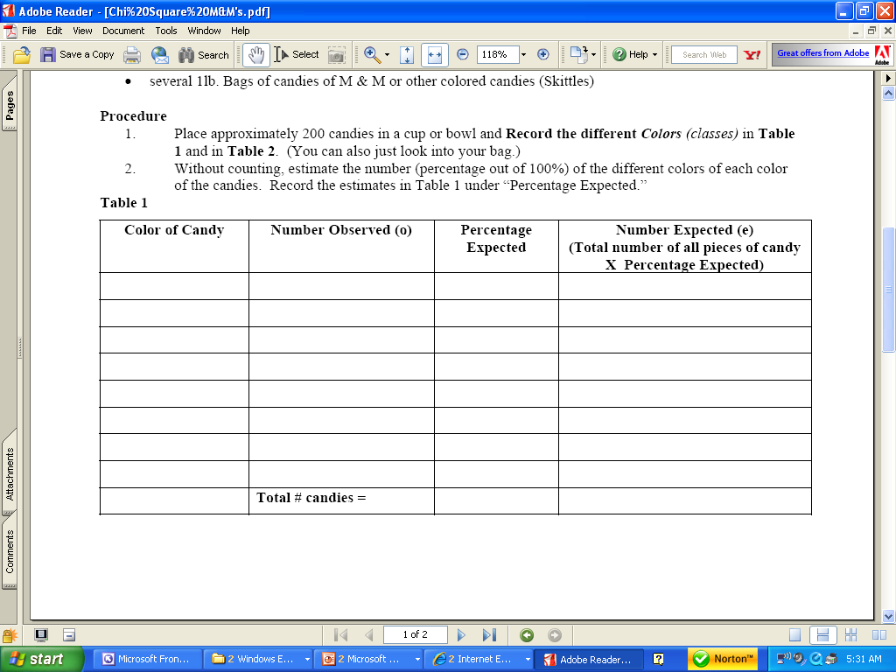

Transfer the (e) and (o) from Table 1 to the table below and complete the calculations.
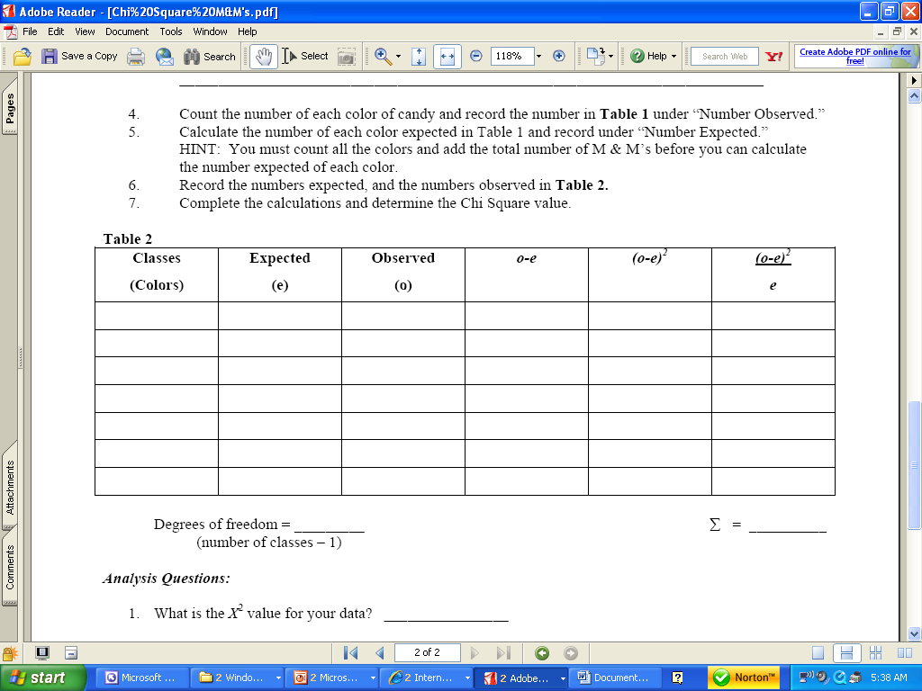

USE THE CHI SQUARE TABLE PROVIDED TO ANALYZE YOUR RESULTS.
Biologists generally accept a probability (p value) =0.05 or less to be a “statistically significant” difference and the cutoff for rejecting or failing to rejecting a hypothesis. That means:
• There is a 95% chance the differences between your observed and expected data are due to some factor
other than chance.
• The variance between the observed and expected results would occur from random chance alone only about
5% of the time (only 1 out of every 20 times).
• Therefore, we would conclude that chance factors alone are not likely to be the cause of this variance.
THINK ABOUT WHAT THAT MEANS. A SMALL calculated X² value means there are FEW differences between what you observed and what you expected. The NULL most likely correct.

NOTICE HOW THIS IS WORDED ! HYPOTHESES are NOT PROVEN CORRECT or ACCEPTED !
Having a calculated X² value higher than the critical value on the X² table DOES NOT PROVE the NULL hypothesis to be INCORRECT; it merely suggests that some other factor other than chance may be causing the difference. You should “REJECT THE NULL HYPOTHESIS”.
Having a calculated X² value lower than the critical value on the X² table DOES NOT PROVE the null hypothesis to be CORRECT. It merely tells you that from a statistical standpoint that it COULD BE correct, and that the variation from your expected results is probably due to random chance alone. You DO NOT ACCEPT the null hypothesis; you “FAIL TO REJECT” THE NULL HYPOTHESIS.
___________________________________________________________________________________.
ANSWER THE FOLLOWING ANALYSIS QUESTIONS

1. What is the calculated X² value for your data ? ____________

2. Which column do you need to check on the Chi-Square table for this data? ______________

3. What is the critical value for this data? __________________

4. Given your p-value, write a statement that describes the “goodness of fit” of your data.

5. Given the X² test results, do you “reject” or “fail to reject” the NULL hypothesis? EXPLAIN WHY OR WHY NOT.

6. If the hypothesis is rejected, propose an alternate hypothesis.

7. Suppose you were to obtain a Chi Square value of 7.82 or greater in your data analysis (with 2 degrees of freedom). What would this indicate?

8. Suppose you were to obtain a Chi Square value of 4.60 or lower in your data analysis (with 2 degrees of freedom). What would this indicate?

Modified from: Knight: http://www.iusd.k12.ca.us/uhs/apbiology/
and Kim Foglia: http://www.explorebiology.com/documents/Lab23ChiSquare2007.pdf

