SCIENTIFIC METHOD LAB
Analyze the following lab to determine its validity and reliability. Take the necessary steps to correct and validate this lab.
A marine biologist conducted a study of the ability of vertebrate blood to carry oxygen. He believed that a low environmental temperature would cause the organism’s blood to carry less oxygen than blood at a higher temperature. The following reflects the scientist’s experiment and the data he collected.
- Two identical tanks of salt water, each containing 25 gallons, were set up in the lab.
- Each tank was filled with the same types of organisms (perch and salmon)
- The same types of aerators were added to each tank to supply dissolved oxygen to the fish.
- In one of the tanks, marked TANK A, the temperature was decreased in increments of
5 °C every 20 minutes.
- In the second tank, marked TANK B, the temperature was raised in increments of 5 °C every 20 minutes.
- Blood was removed from each fish and measured for its oxygen content
Below are the results from the above experiment.
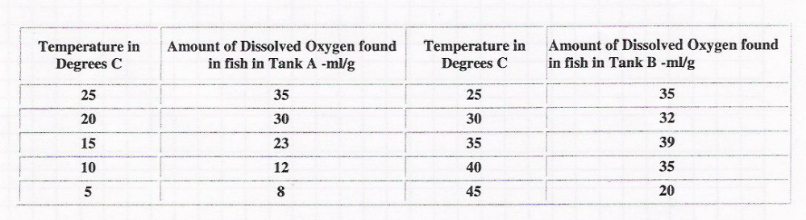
1. What is the hypothesis for this experiment?

2. Is this experiment a controlled experiment?

3. Explain your answer to #2.

4. What could have been done differently to achieve the same results?
MAKE A GRAPH OF THE DATA PROVIDED


5. What is the independent variable in this experiment?
6. What is the dependent variable in this experiment?
7. Based on the above data, is the hypothesis correct? Explain your answer.
8. What are the controls in this experiment?
9. What conclusion can you draw from the data?

