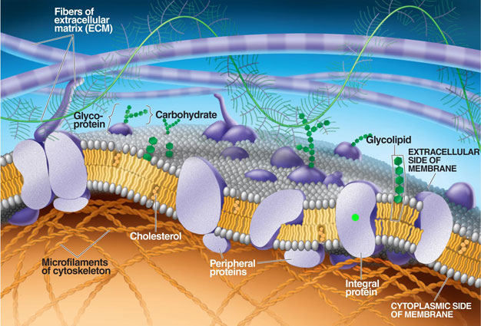
MEMBRANE STRUCTURE AND FUNCTION
PLASMA MEMBRANE- surrounds ALL cells
• Made of PROTEIN and PHOSPHOLIPIDS
PHOSPHOLIPIDS = AMPHIPATHIC
= Have both philic and phobic regions
• Form a BILAYER with polar heads out/phobic tails in
FLUID MOSAIC MODEL
• Current model for animal plasma membrane
• Held together by weak phobic interactions
that make membrane fluid
• Components can move laterally

FLUIDITY of MEMBRANES
• Different species have different FATTY ACID tails in their phospholipids
• UNSATURATED FATTY ACIDS make “kinks” so phospholipids can’t pack as close together
(remain fluid @ colder temps)
CHOLESTEROL (in animal cells only)
makes membranes less fluid at higher temps (keep phospholipids from moving around)
makes membranes more fluid at lower temps (keep phospholipids from packing closely together)

MEMBRANE PROTEINS
~ PERIPHERAL PROTEINS-loosely bound to surface
~ INTEGRAL PROTEINS- embedded in membrane
• TRANSMEMBRANE PROTEINS- span entire membrane

OTHER MEMBRANE COMPONENTS
CARBOHYDRATES (Ex: attached to GLYCOPROTEINS)
~ important in cell-cell recognition/immune system function and tissue development/differentiation
EX; important in blood transfusions/organ transplants/recognition of invaders by immune system
FUNCTION OF PHOSPHOLIPIDS
• phospholipid tails provide phobic barrier
• separate cell from liquid environment
• SELECTIVELY PERMEABLE- due to hydrophobic/hydrophilic arrangement of phospholipids
~ allows certain molecules to pass through- non-polar, hydrophobic, gases (hydrocarbons, CO₂ & O₂)
~ prevents other substances from passing through- ions, polar/hydrophilic, large
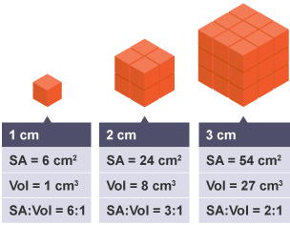
TRANSPORT PROTEINS/VESICLES assist movement of substances across bilayer that can’t go on their own

SURFACE AREA TO VOLUME RELATIONSHIP
As cells grow both surface area and volume increase,
but volume increases faster than surface area
SA/VOL ratio DECREASES
SMALLER CELLS MORE EFFICIENT AT TRANSPORT!
TYPES OF PASSIVE TRANSPORT
All move HIGH to LOW “DOWN” the concentration gradient
NO energy required
DIFFUSION
PASSIVE – Requires NO ENERGY
Automatic due to kinetic energy of molecules
Moves DOWN CONCENTRATION GRADIENT
from [HIGH] → [LOW] until reaches equilibrium
Ex: Oxygen/CO₂ cross capillary cell membranes

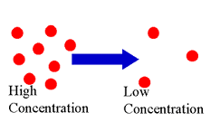

FACILITATED DIFFUSION with CARRIER PROTEINS
PASSIVE- Requires NO ENERGY
Trans-membrane proteins assist in movement
Molecule specific
Grab molecule, change shape, flip to other side
Moves from [HIGH] → [LOW]
Ex: Glucose
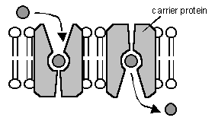

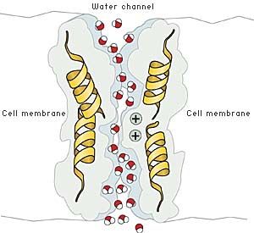
FACILITATED DIFFUSION with AQUAPORINS
OSMOSIS= Diffusion of water across a semi-permeable membrane
AQUAPORIN proteins move POLAR WATER molecules past phobic tails
[HIGH] → [Low]

FACILITATED DIFFUSION with ION CHANNELS
transmembrane proteins form “tunnels” across membrane
Moves from [HIGH] → [LOW]
Moves charged ions (Na⁺ , K⁺, Ca⁺⁺ Cl⁻⁾ past hydrophobic tails in center
Can be “gated” or not
Gates can open/close in response to electrical/chemical signals

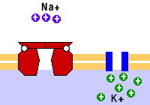

CYTIC FIBROSIS
-mutation in CRTF protein that transports Cl⁻
-thick mucus builds up in lungs/body organs -patients taste “salty” due to salt imbalance

TYPES OF ACTIVE TRANSPORT-requires energy
ENDOCYTOSIS
cell membrane engulfs substance
brings it into cell in a VESICLE
PHAGOCYTOSIS- “phage” = cell eating
large molecules/ whole cells
PINOCYTOSIS- “pino” = cell drinking
small molecules, fluids
Ex: White blood cell eating bacteria
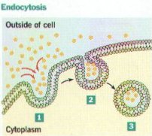
RECEPTOR MEDIATED ENDOCYTOSIS
Substances (=LILGANDS) bind to specific RECEPTORS in membrane
Vesicle forms from area with receptors
Often clustered in coated pits
EX: uptake of LDL-cholesterol carrier
requires receptor on cell surface

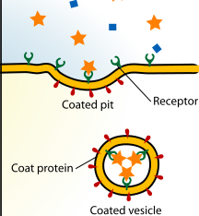

EXOCYTOSIS
VESICLES fuse with cell membrane and release substances outside cell
Ex; Golgi export
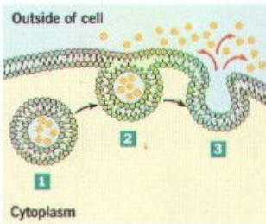

PUMPS
Can move AGAINST concentration gradient
[LOW] → [HIGH]
Used to create electrochemical gradients across cell membranes
SODIUM-POTASSIUM (Na⁺-K⁺) PUMP
Moves 3 Na⁺ ions in and 2 K⁺ ions out
Main electro-genic pump in ANIMALS
EX: Na⁺-K⁺ pump sets up membrane potential
Nerve signal results when Na⁺ and K⁺ exchange places
Then pump resets membrane for next signal
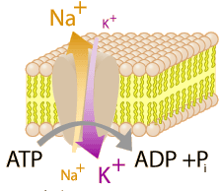

PROTON PUMP
Main electrogenic pump in PLANTS
ATP provides energy to pump H⁺ ions across a membrane
Stored H⁺ = potential energy to do work
EX: COTRANSPORT (see below)
ATP PRODUCTION
during cellular respiration/photosynthesis
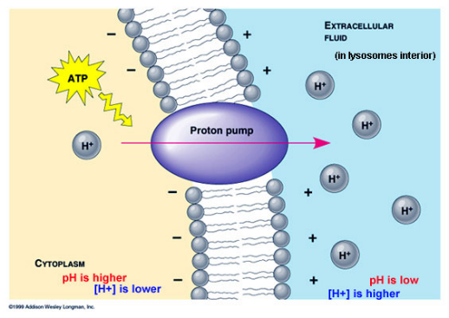

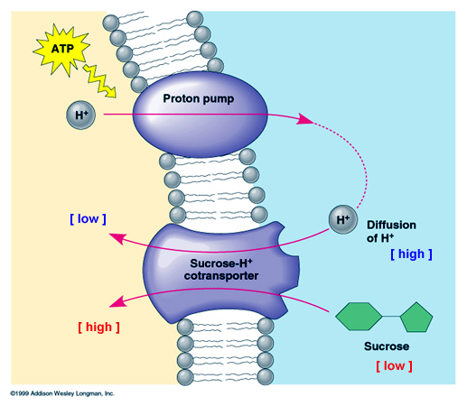

COTRANSPORT
Na⁺-K⁺/ Proton pumps use ATP to create concentration gradient
Movement of substance is linked to return of Na+/H+
as it flows back down its concentration gradient
EX: sucrose is linked to H⁺ transport

TONICITY
If there is a concentration difference on opposite sides of a membrane and solute can’t move, water will move from an area of HIGHER Ψ → LOWER Ψ
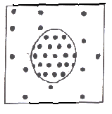 | 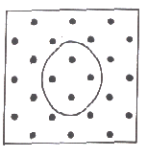 | 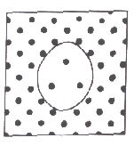
HYPOTONIC | ISOTONIC | HYPERTONIC
[solute] outside ‹ inside  Ψ outside > Ψ inside  Net movement of water into cell  Animal cells:  swell & burst = CYTOLYSIS  Plant cells  increase TURGOR PRESSURE  Cell walls keep cells from bursting | [solute] outside = inside  Ψ outside = Ψ inside  Net movement of water  is equal  No change in size | [solute] outside > inside  Ψ outside < Ψ inside  Net movement of water out  Animal cells:  shrink = CRENATION  Plant cells:  can’t shrink due to cell wall  Cell membrane pulls away from cell wall= PLASMOLYSIS

