The Nervous System:
Command & Control Center

Nervous systems consist of circuits of neurons (nerve cells) and supporting cells. Different organisms have different nervous systems.
-ventral nerve cord (invertebrate) -hollow dorsal cord (vertebrate)

There are two branches of the nervous system.
Central Nervous System
Peripheral Nervous System

Brain
Spinal Cord: nerve bundle that communicates with body
Somatic nervous system: voluntary control over muscles.
Autonomic nervous system: involuntary control over organs.

Structure of a vertebrate neuron:
Parasympathetic division: Rest and digest.
Sympathetic division: fight or flight.
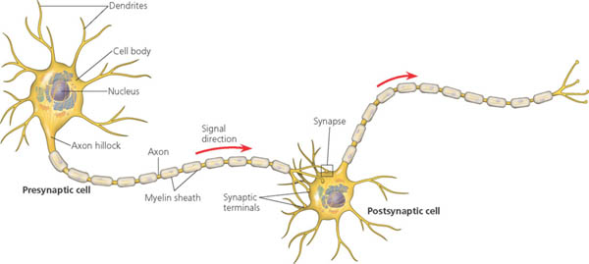

(Below)
Cell bodies and dendrites are black in these diagrams; axons are red. In (a) the cell body is connected only to the axon, which conveys signals from the dendrites to the axon’s terminal branches (at the bottom).
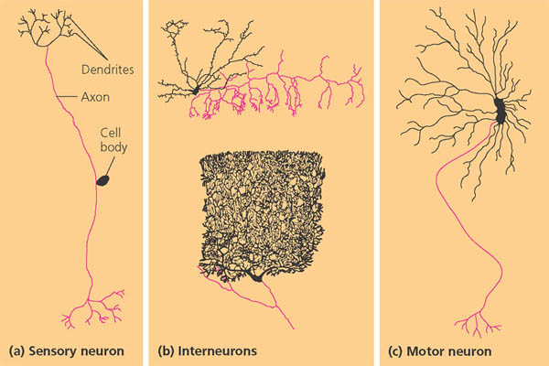

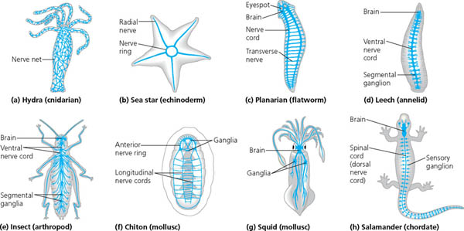

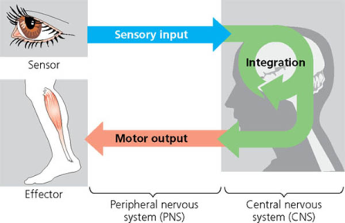
(above and right)
Different organisms have different nervous systems, some are more complex than others but they generally do the same thing. The sensory neurons transmit information that the sensors detect. Then the information is sent to the CNS where interneurons “put the pieces together.” Motor neurons then send the signal which stimulates a reflex, which is a body’s natural response to stimuli.

The nervous system also has cells that are essential for the structure of the nervous system called supporting cells or Glia. Some of these are:
Astrocyte: glial cell that provides structural and metabolic support for neurons.
Blood-brain barrier: a specialized capillary arrangement in the brain that restricts the passage of most substances into the
brain, thereby preventing dramatic fluctuations in the brain’s environment.
Radial glia: in an embryo, supporting cells that form tracks along which newly formed neurons migrate from the neural tube; can
also act as stem cells that give rise to neurons and other glia.
Oligodendrocyte and Schwann cells: a type of glial cell that forms insulating myelin sheaths around the axons of neurons in the
central nervous system.
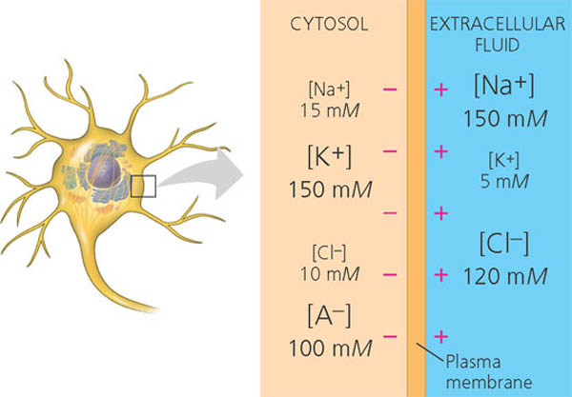
Ion Pumps and Ion Channels Maintain the Resting Potential of a Neuron
Every cell has a voltage across its plasma membrane called a membrane potential. The inside of the cell is negative relative to the outside.
Resting Potential: is when a nerve fiber has more positive ions outside and more negative ions inside.
Action Potential: is the sudden change on stimulation. Na+ ions move in through Na+ gated channels.
Gated Ion Channels are open or close in response to membrane stretch, the binding of a specific ligand, or a change in the membrane potential.

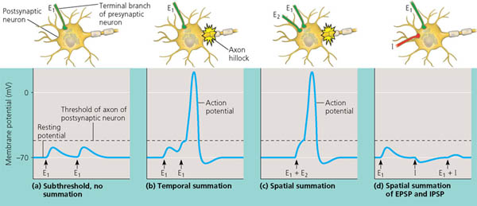
Direct Synaptic Transmission
The neurotransmitter binds to ligand–gated ion channels in the postsynaptic membrane, producing an excitatory or inhibitory postsynaptic potential.
Indirect Synaptic Transmission
The binding of neurotransmitter to some receptors activates signal transduction pathway which produce slowly developing but long–lasting effects in the postsynaptic cell.
Neurotransmitters
The same neurotransmitter can produce different effects on different types of cells. Major known neurotransmitters include acetylcholine, biogenic amines (epinephrine, norepinephrine, dopamine, and serotonin), various amino acids and peptides, and the gases nitric oxide and carbon monoxide.
The cerebral cortex controls voluntary movement and cognitive functions

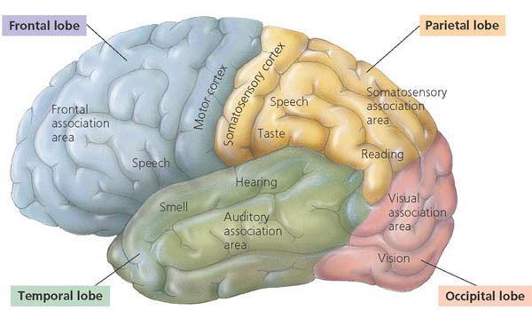
Each side of the cerebral cortex has four lobes—frontal, temporal, occipital, and parietal—which contain primary sensory areas and association areas.

Information Processing in the Cerebral Cortex
Specific types of sensory input enter the primary sensory areas. Adjacent association areas process particular features in the sensory input and integrate information from different sensory areas. In the somatosensory cortex and the motor cortex, neurons are distributed according to the part of the body that generates sensory input or receives motor commands.
Lateralization of Cortical Function
The left hemisphere is normally specialized for high–speed serial information processing essential to language and logic operations. The right hemisphere is stronger at pattern recognition, nonverbal ideation, and emotional processing.
Language and Speech
Portions of the frontal and temporal lobes, including Broca′s area and Wernicke′s area, are essential for generating and understanding language.
Emotions
The limbic system, a ring of cortical and noncortical centers around the brainstem, mediates primary emotions and attaches emotional “feelings” to survival–related functions. The association of primary emotions with different situations during human development requires parts of the neocortex, especially the prefrontal cortex.
Memory and Learning
The frontal lobes are a site of short–term memory and can interact with the hippocampus and amygdala to consolidate long–term memory. Experiments on invertebrates and vertebrates have revealed the cellular basis of some simple forms of learning, including sensitization and long–term potentiation.
Consciousness
Modern brain–imaging techniques suggest that consciousness may be an emergent property of the brain based on activity in many areas of the cortex.

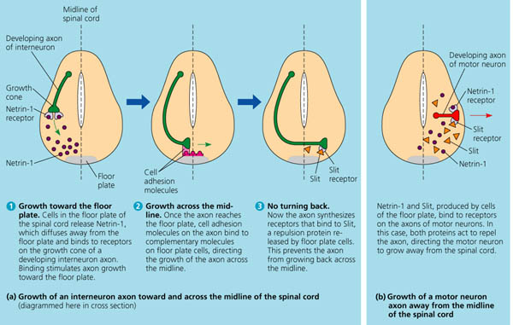
Nerve Cell Development
Signal molecules direct an axon′s growth by binding to receptors on the plasma membrane of the growth cone. The genes and basic events involved in axon guidance are similar in invertebrates and vertebrates. Knowledge of these events may be applied one day to stimulate axonal regrowth following CNS damage.
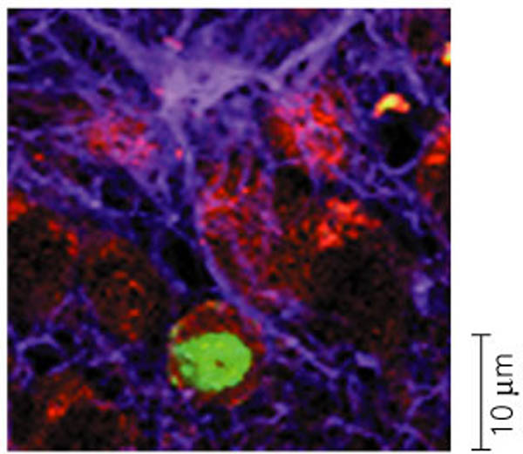
Neural Stem Cells
The adult human brain contains stem cells that can differentiate into mature neurons. The induction of stem cell differentiation and transplantation of cultured stem cells are potential methods for replacing neurons lost to trauma or disease.

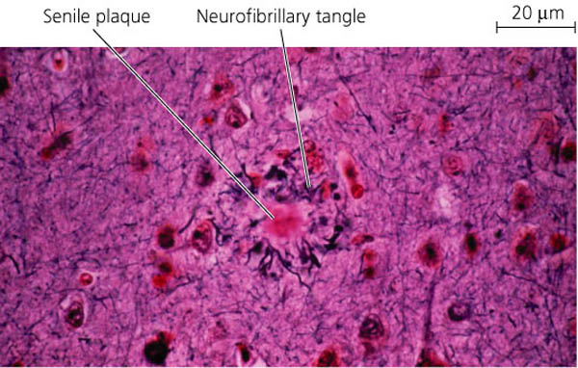
Diseases and Disorders of the Nervous System
Schizophrenia is characterized by hallucinations, delusions, blunted emotions, and other symptoms. Depression includes bipolar disorder, characterized by manic (high–mood) and depressive (low–mood) phases, and major depression, in which patients have a persistent low mood. Alzheimer′s disease is an age–related dementia in which neurofibrillary tangles and senile plaques form in the brain. Parkinson′s disease is a motor disorder caused by the death of dopamine–secreting neurons in the substantia nigra.

