Excretory System - Ch. 44
Functions: filters blood & helps maintain water balance (osmoregulation)

•Homeostasis
-Keep the balance of the body
-Osmoregulation
-solute balance & gain or loss of water
-Excretion-
-elimination of nitrogenous wastes
-Thermoregulation
-temperature regulation

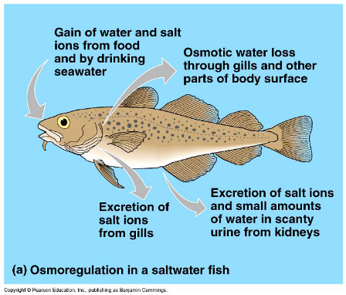
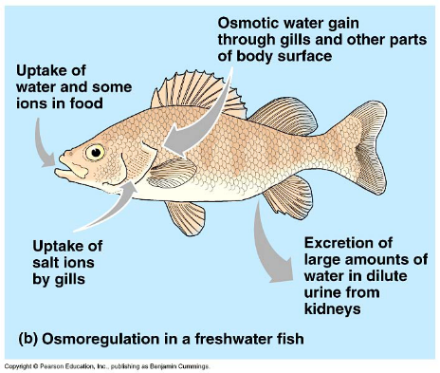
•Osmotic Challenges
-ioosmotic (equal concentrations)
-hypoosmotic (freshwater fish)
-hyperosmotic (saltwater fish)

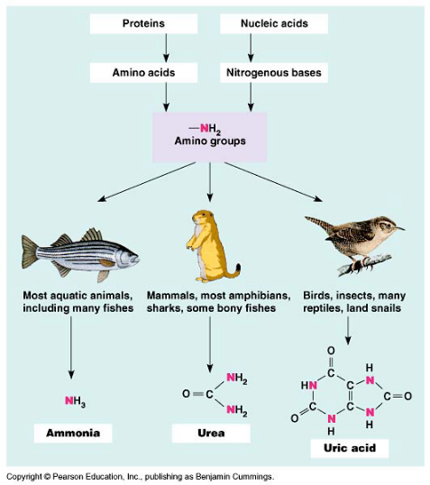

•Forms of Nitrogenous Wastes
-proteins & amino acids leave extra Nitrogen that cells need to dispose
-Ammonia – most toxic & most soluble (NH₃)
-can’t hold on to for very long & need to dispose of right away
-Urea – low toxicity level & middle solubility (2NH₂ + CO₂)
-takes some energy to form but animals can store
-Uric Acid – least toxic & least soluble (C₅H₄N₄O₃)
-takes the most energy to form

•Different Excretory Systems
-Protonephridium – platyhelminthes
-dead end tubules w/ cilia that ‘flicker’ (flame-bulb system) & move waste to pores (nephridiopores)
-Metanephridia – most anelids
-internal openings that collect & excrete body fluids through waste pores (1/body segment)
-Malpighian Tubes – insects & terrestrial arthropods
-internal openings that connect to digestive tract & reabsorb nutrients from feces
-Vertebrate Kidneys
-function in osmoregulation & excretion

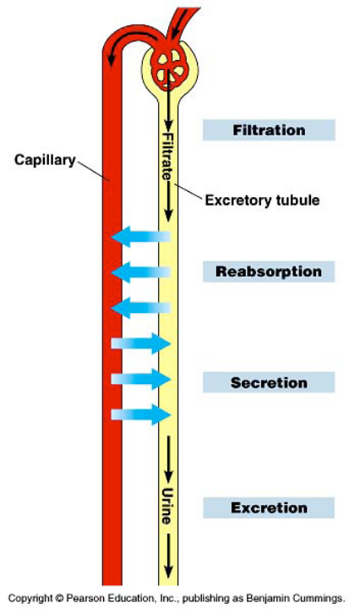
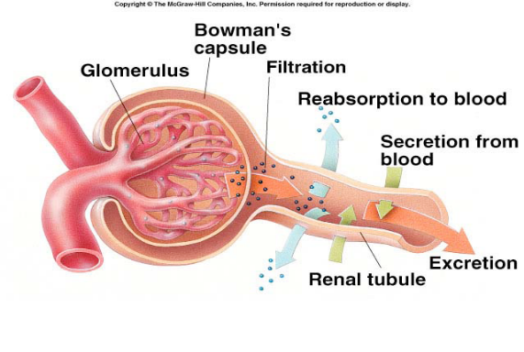

•Filtration
-body fluids (blood) collected
-water soluble material removed
Filtered out: NOT:
- H₂0 - Cells
- Glucose - Proteins
- Salts/ions (large particles)
- Urea

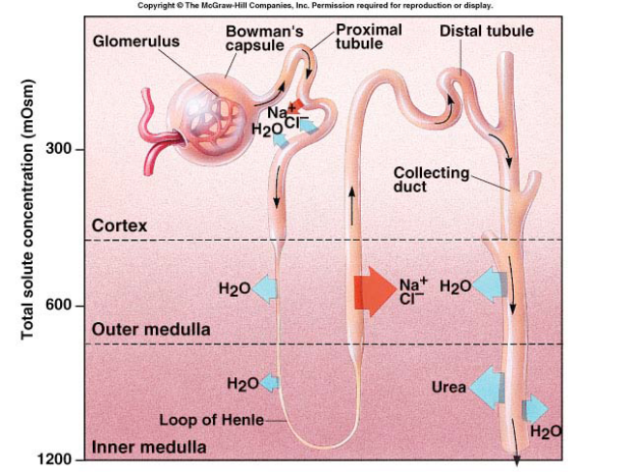
Descending tube
Ascending tube

•Reabsorption (use diffusion as much as possible to save energy)
-reabsorbs needed substances back into blood
-Proximal tube = acidity control
-reabsorbs HCO₃⁻(bicarbonate ions, NaCl, H₂0, Nutrients, K⁺
-Descending tube = high H₂0 permeability
-reabsorbs H₂0
-Ascending tube = low H₂0 permeability
-reabsorbs NaCl⁻
-Distal tube = acidity control
-reabsorbs K⁺ and HCO₃⁻

•Excretion
-remove excess substances & toxins from body
-Humans (like all mammals) excrete urea form of nitrogenous waste
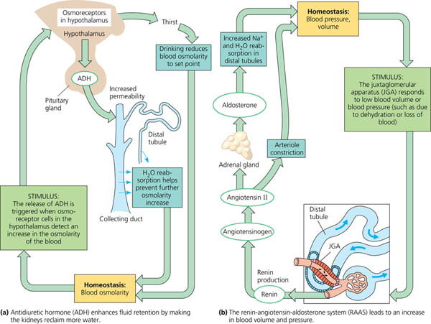
•Maintaining Water Balance
-regulated by nervous system & hormonal control of water and salt reabsorption in the kidneys
-ADH Hormone (Antidiuretic Hormone)
-increases permeability of collecting duct & reabsorption of water in kidneys (more water stays in blood)
(figure a.)
-RAAS System (Renin-Angiotensin- Aldosterone system)
-increases blood volume & pressure (figure b.)
-ANF Factor (Atrial natriuretic factor)
-opposite of RAAS system
-lower blood volume & pressure

•Kidney Structure & Function
-bean shaped organs on either side of the vertebral column
-2/person
-supplied with blood from renal artery & renal vein
-interaction center of circulatory system & excretory system
•Nephron Structure & Function
- 1 million/kidney
- loop of Henle is main part
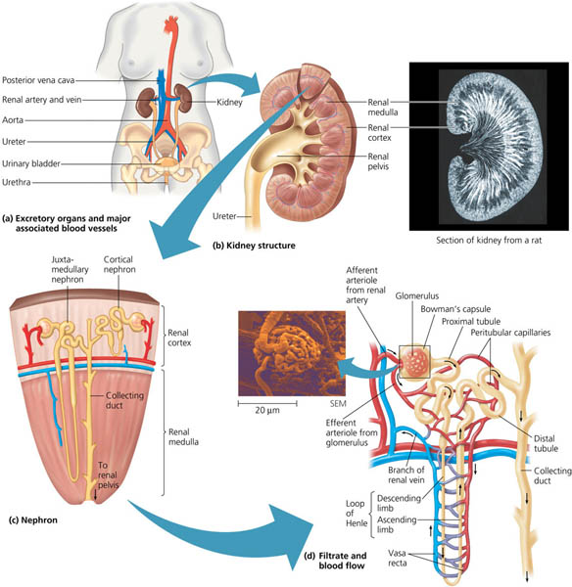
- countercurrent multiplier system = expends energy to create concentration gradients

