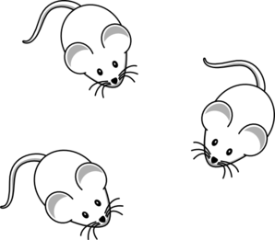
MUTAGEN MICE
A group of mice was fed a diet with a mutagen added that was thought to
affect tail length in mice. Another group of mice was fed the same diet
w/o the mutagen added.
- WRITE AN H ₀ :
- Is there a control group in this experiment?
- What might be some control variables to consider if you were designing this experiment.
- Measure the tails of mice provided by your teacher.
- Post your measurements on class data chart
- Determine RANGE, MEAN, MEDIAN, MODE, STANDARD DEVIATION, and SEM
for the mice in the CONTROL and MUTAGEN groups.
- Graph the means for both groups and add error bars.
- SUMMARIZE THE RESULTS. USE EVIDENCE TO SUPPORT YOUR CLAIM.

MUTAGEN MICE
A group of mice was fed a diet with a mutagen added that was thought to
affect tail length in mice. Another group of mice was fed the same diet
w/o the mutagen added.
- WRITE AN H ₀ :
- Is there a control group in this experiment?
- What might be some control variables to consider if you were designing this experiment.
- Measure the tails of mice provided by your teacher.
- Post your measurements on class data chart
- Determine RANGE, MEAN, MEDIAN, MODE, STANDARD DEVIATION and SEM
for the mice in the CONTROL and MUTAGEN groups.
- Graph the means for both groups and add error bars.
- SUMMARIZE THE RESULTS. USE EVIDENCE TO SUPPORT YOUR CLAIM.

MUTAGEN MICE
A group of mice was fed a diet with a mutagen added that was thought to
affect tail length in mice. Another group of mice was fed the same diet
w/o the mutagen added.
- WRITE AN H ₀ :
- Is there a control group in this experiment?
- What might be some control variables to consider if you were designing this experiment.
- Measure the tails of mice provided by your teacher.
- Post your measurements on class data chart
- Determine RANGE, MEAN, MEDIAN, MODE, STANDARD DEVIATION, and SEM
for the mice in the CONTROL and MUTAGEN groups.
- Graph the means for both groups and add error bars.
- SUMMARIZE THE RESULTS. USE EVIDENCE TO SUPPORT YOUR CLAIM.

