Generate An Argument
Effect of Environmental Stimuli on Cell Division (Mitosis)

Introduction:
In an effort to increase production of onions as crops, scientists are studying how added natural environmental stimuli (in this case chemicals) might increase onion root growth. Onion roots are small and increased root growth may lead to increased water and nutrient absorption.

Scientists also found fungal pathogens that grow in the soil can produce a lectin-like protein found in the area around the soybean roots. This protein may have been secreted by the fungus. Lectins in general induce mitosis in some root apical meristem tissues. Lectin may therefore be a promising chemical to add to the soil around onions to stimulate root growth and decrease time between plantings.

In many instances, rapid cell divisions weaken plant tissues. One alternative would to be to use a different chemical to stimulate root growth. One choice would be caffeine. Caffeine has a stimulating effect on some organisms and perhaps it could have some impact on cell reproduction.

Part 1: Baseline Cell Reproduction
Before a variable can be tested, the normal pattern of cell division must be established for onion root tips as a method of comparison.
- Use prepared slides to find examples of cells in each stage of the cell cycle. Record images (photographically or by hand). Label all visible structures. Label each image with the phase that is being shown.
- Using the prepared slides available at your work-station, count 300 cells in the field of view. For each cell, note the stage of the cell cycle/mitosis that you see. You may have to use multiple fields of view or different slides to count 300 cells. Be sure you do not duplicate fields of view in your count.
- Confer with your groupmates and tabulate a total count of cells and a count of cells in each cell cycle/mitosis stage. Determine the percentage of cells in each stage.
- Estimate the time spent during each stage of the cell cycle if the average cell cycle takes 13 hours.

Part 2: Environmental Stimulus
Data was collected for onion tips soaked in a lectin solution (shown below). Using the data collected in part 1 as your control, for each essential question below choose a claim to support and one to refute. Use your collected data and data from the table as evidence to present your reasoning. In addition to tabular data, use the Chi Square test as support for your claim. Your collected data should be considered the “expected” when performing Chi Square analysis.

Essential Question 1: How does lectin affect the number of cells undergoing mitosis in onion root tip cells?
Claim 1: Lectin is no more effective than what is seen in normal onion root tip cells.
Claim 2: Lectin increases the number of cells undergoing mitosis in onion root tip cells.
Claim 3: Lectin decreases the number of cells undergoing mitosis in onion root tip cells.

Essential Question 2: Is caffeine a viable replacement for lectin to stimulate greater onion root cell growth.
Claim 1: Caffeine is no more effective than what is seen in normal onion root tip cells.
Claim 2: Caffeine increases the number of cells undergoing mitosis in onion root tip cells when compared to lectin.
Claim 3: Caffeine decreases the number of cells undergoing mitosis in onion root tip cells when compared to lectin.

Table 1: Effects of lectin and caffeine on cells in onion root tips.
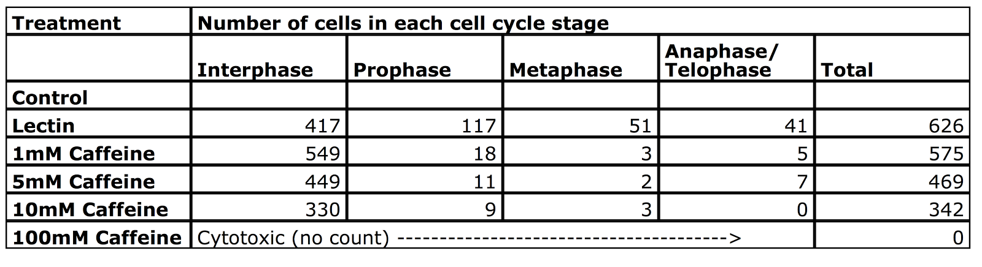

Product:

Part 1: Slideshow construction, and posting.
With your group,, use the data provided to develop a claim that best answers this question. Once your group has developed your claim, prepare a brief slideshow that you can use to share and justify your ideas. Your slideshow should include all of the following information:
- Background: Images and calculations from part 1 of the lab.
- For part 2 of the lab:
  - The Research Question
  - Your Claim: State the claim you are trying to support
  - Your Evidence: Include genuine evidence (data, analysis, & interpretation). Make sure to include a hypothetical cladogram showing the evolutionary relationships among the mammals.
  - Your Reasoning: Provide a justification of your evidence that explains why the evidence is relevant and why it provides adequate support for the claim.
  - Organize your argument in a way that enhances readability
  - Use a broad range of words, including vocabulary that you have learned in class.
  - Utilize proper grammar, punctuation, and error-free spelling.

Post your slideshow to the class blog in a post with the labels (“argument”, “genetics”, and any others that you feel are appropriate). Make it so that anyone in our school google apps can comment on your slides.

Part 2: Commenting and Response
View and comment on at least five other group’s slideshows (use the insert menu to add a comment).
Remember, as you critique the work of others, you need to decide if their conclusions are valid or acceptable based on the quality of their claim and how well they are able to support their ideas. In other words, you need to determine if their argument is convincing or not. One way to determine if their argument is convincing is to ask them some of the following questions:
- How did you analyze or interpret your data? Why did you decide to do it that way?
- How do you know that your analysis of the data is free from errors?
- Why does your evidence support your claim?
- Why did you decide to use that evidence? Why is your evidence important?
- How does your justification of the evidence fit with accepted scientific ideas?
- What are some of the other claims your group discussed before agreeing on your claim and why did you reject them?

Part 3: Response
Working in your group, respond to all comments that were left. Incorporate any feedback into your slideshow that you feel is appropriate, and make sure to reply to all comments left on your slideshow.

