MITOSIS LAB Name _______________________________
Scientists reported that a fungal pathogen may negatively affect the growth of soybeans. Soybean growth decreased during three years of high rainfall, and the soybean roots were poorly developed. A lectin-like protein was found in the soil around the soybean roots. This protein may have been secreted by the fungus. Lectins induce mitosis in some root apical meristem tissues. In many instances, rapid cell divisions weaken plant tissues. You have been asked to investigate whether the fungal pathogen lectin affects the number of cells undergoing mitosis in a different plant, using onion root tips.
What is your experimental hypothesis?
_________________________________________________________________________________
_________________________________________________________________________________
What is your NULL hypothesis?
__________________________________________________________________________________________________________________________________________________________________
What is the independent variable? _______________________________________________
What is the dependent variable ? ________________________________________________
How would you design an experiment with onion bulbs to test whether lectins increase the number of cells in mitosis?
_________________________________________________________________________________
___________________________________________________________________________________________________________________________________________________________________________________________________________________________________________________
___________________________________________________________________________________________________________________________________________________________________________________________________________________________________________________
___________________________________________________________________________________________________________________________________________________________________________________________________________________________________________________
_____________________________________________________________________________________________________________________________________________________________________________________________________________________________________________________________________________________________________________________________________________________________________________________________________________________
_________________________________________________________________________________
_________________________________________________________________________________
___________________________________________________________________________________________________________________________________________________________________________________________________________________________________________________
_________________________________________________________________________________
Circle and identify at least one cell showing each of the following phases:
interphase, prophase, metaphase, anaphase, telophase, cytokinesis
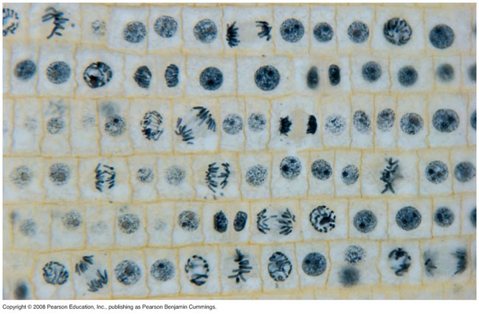

Data from this experiment is provided below:
CLASS DATA
GROUP | INTERPHASE | MITOTIC | TOTAL
CONTROL | 1055 | 762 | 1817
TREATED | 2016 | 1005 | 3021
For this experiment, the number of treated cells in interphase and mitosis will be the OBSERVED (o) values.
To find the expected values, calculate the percentage of cells in interphase and mitosis in the control group from the data provided.
PERCENTAGES
 | CONTROL | TREATED
INTERPHASE
MITOTIC
TOTAL | 100% | 100%
Multiply the percentages by the total number of cells in the treated group; this will give the expected numbers (e). Calculate the chi-square ( X² ) value for the experiment.
TREATED | OBSERVED | EXPECTED | o-e | (o-e)² | (o-e)²  e
INTERPHASE
MITOTIC
Σ = ________
Degrees of freedom = ____________
Critical value = ______________
CONCLUSION:
Is there a significant difference in the mitotic rate between the treatment and control groups?
What evidence is there to support your conclusion?
_________________________________________________________________________________
___________________________________________________________________________________________________________________________________________________________________________________________________________________________________________________
___________________________________________________________________________________________________________________________________________________________________________________________________________________________________________________
___________________________________________________________________________________________________________________________________________________________________________________________________________________________________________________

MEIOSIS: Crossing over in Sordaria NAME _______________________________
The fungus Sordaria fimicola exchanges genetic material when two mycelia meet and fuse. The resulting zygote undergoes meiosis to produce asci; each ascus contains eight haploid spores. A single gene determines spore color.
A cross was made between wild type (+;black) and tan (tn) strains. The resulting zygote produces either parental type asci, which have four black and four tan spores in a row (4:4 pattern) or recombinant asci, which do not have this pattern.

What process that happens during prophase I
of meiosis results in recombinant asci? _____________________________
MEIOSIS and CROSSING OVER IN SORDARIA

Meiosis with NO crossing over Meiosis WITH crossing over
DATA- Count asci on 3 cards | NUMBER OF ASCI  SHOWING  4:4 PATTERN  (PARENTAL) | NUMBER OF ASCI SHOWING CROSSOVER  (RECOMBINANTS)
CARD 1
CARD 2
CARD 3
TOTAL

One map unit equals one recombinant per 100 total events. The percentage of asci showing crossover divided by 2 equals the map units in this activity. This is done because each spore produced by meiosis undergoes a mitotic division.

LOOK AT THE LIFE CYCLE DIAGRAM FOR THIS FUNGUS.
Meiosis is a reduction division producing 1n cells from the division of a 2n cell, but the products that are produced are different in different organisms.
Which type of cells are produced by meiosis in Sordaria? ___________________________
Which type of cells are produced by meiosis in humans? _____________________________
Why did you divide the % of asci showing crossovers by 2? _____________________________________
_________________________________________________________________________________
MAKE A CONNECTION:
Use what you know about crossing over to predict the connection between the distance between two genes on a chromosome and their frequency of crossing over. ( Draw a picture below if that helps. )
_________________________________________________________________________________
_________________________________________________________________________________

