Use the link on the AP Bio webpage to the LAB Bench website http://www.phschool.com/science/biology_place/labbench/index.html
TAKE NOTES IN YOUR BILL as you complete the tutorial.
LAB 12- DISSOLVED OXYGEN AND PRIMARY PRODUCTIVITY – Pre Lab
QUESTIONS:
Which environment has the greater concentration of dissolved oxygen:
salt or fresh water?
Which environment has the greater concentration of dissolved oxygen:
warm water (31°C) or cool water (18°C) ?
Which environment has the greater concentration of dissolved oxygen:
a clear pool or a pond with a heavy algal mat? EXPLAIN
What is the equation for photosynthesis?
In this lab you will collect and graph both your individual data and class data.
Why do we use class mean data?
To measure how much oxygen water can hold (saturation), you need to be able to read a nomograph.
USE A STRAIGHT EDGE to practice by making the measurements necessary to answer the question. Line up the straight edge on the line for temperature and Oxygen. Look to see where it crosses the % saturation line

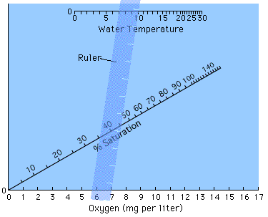

What is the percent oxygen saturation for a water sample at 10° C that has 7 mg O₂/l ?
What is the percent oxygen saturation for a water sample at 25 C that has 7 mg O₂/l?

ANALYSIS OF RESULTS
To help you analyze and understand the results of your own experiment, look at the
illustration below and then look at the sample problem. You don’t need to graph the data.
Just look at the graph provided below in the Lab Quiz.
= ________________________________
= ________________________________

= _ _______________________________

_________________________________________________________________________________
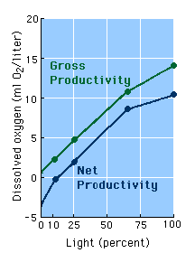
LAB QUIZ
1. In which aquatic environment would you expect dissolved oxygen to be the highest?
a. A mountain lake that is clear and cold
b. A bog where the water is shallow and warm and there is a mat of aquatic plants
c. A marine tidepool
d. A cold mountain stream dropping over a series of small rock falls
e. A coral reef in a still lagoon
2. At the right is the correct graph of the data you were given in the
Sample Problem. Study this graph to answer the following question.
At what light intensity do you expect there to be no net productivity?
a. Any intensity below 100%
b. Only at intensities of 0% and 2%
c. Any intensity below 10%
d. Any intensity above 25%

3. What is meant by "net productivity" and how is it calculated in a sample aquatic environment?
a. It is a measure of the organic products of photosynthesis that accumulate after cellular respiration
by those organisms is taken into account, and it is calculated by subtracting the amount of oxygen
in the dark bottle from the amount in the light bottle.
b. It is a measure of the amount of respiration in a test area and it is calculated by subtracting the amount
of oxygen present in the light bottle from the amount in the dark bottle.

c. It is the total amount of carbon fixed, and it is calculated by measuring the amount of oxygen present
in a bottle kept in the light.

d. It is the amount of oxygen produced during the day, and it is calculated by subtracting the amount of
oxygen in the light bottle from the amount in the dark bottle.

Culture A | Culture B
Little phytoplankton | Rich in phytoplankton
Rich in zooplankton | Rich in zooplankton
Low initial dissolved oxygen | High initial dissolved oxygen

4. A biology class used two aquatic cultures as
described at the right for the experiment with
screens that reduce light.
They measured dissolved oxygen initially, and then
after 24 hours.

What results would you predict for this experiment?

a. The net productivity in culture A will be much higher than in that in culture B

b. Culture B will have both higher gross productivity and higher net productivity than culture A.
c. The net productivity for culture A will be negative at greater light intensity than that for culture B.

d. Cultures A and B will show similar results because of the comparable quantities of zooplankton.
e. Net productivity in culture B will exceed gross productivity in high light intensity.

CHECK FOR UNDERSTANDING : LAB 12- Dissolved oxygen
Answer the following in your BILL
1. Explain the difference between Gross Primary Productivity (GPP) and Net Primary Productivity (NPP).
2. If NPP in an ecosystem is positive, what will happen to the biomass of that ecosystem over time?
3. What if NPP is negative?
4. An ecologist interested in determining productivity of a local lake collected the following data in mg/O₂/day
Initial sample: 9.8 Dark Bottle: 8.6 Light Bottle: 12.3

Calculate the NPP in mg/O₂/day . Show your work and circle your answer

5. You will be using a bunch of screens in the lab. How are you using them and what are they intended to represent?

