KINGDOM: ANIMALIA
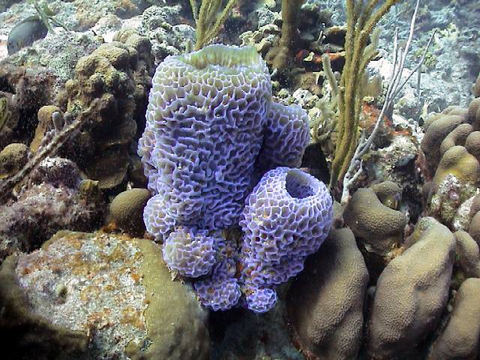
PHYLUM: PORIFERA (Ex: sponges)
SUBKINGDOM: PARAZOA (No true tissues/no organs)
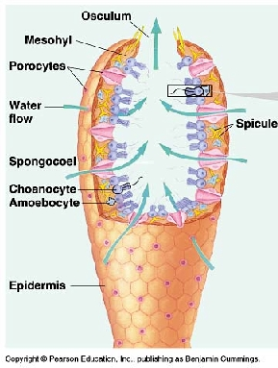
Most primitive animal
Cells are independent
Sessile (non-moving)
ASYMMETRY
Move water in through small holes (OSTIA) out through big hole (OSCULUM)
HERMAPHRODITES-make both eggs and sperm
EVOLUTIONARY DEAD END- no know descendants alive today

* * * * * * * * * * * *
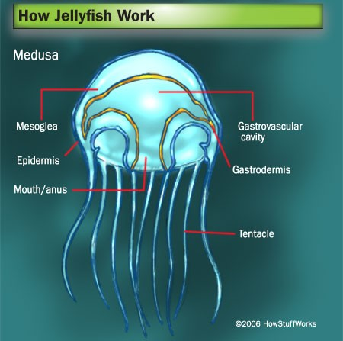
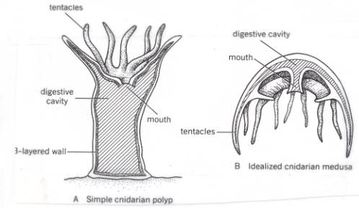
PHYLUM: CNIDARIA (EX: jellyfish, hydra, coral, anemones)
SUBKINGDOM:METAZOA (true tissues)
DIPLOBLASTIC (two germ layers)
RADIAL SYMMETRY
TWO FORMS
POLYP (sessile) and MEDUSA (free swimming)
ONE OPENING GASTROVASCULAR CAVITY
Stinging cells = NEMATOCYSTS

* * * * * * * * * * * * * * *
SUBKINGDOM: EUMETAZOA (true animals = 3 germ layers)
ALL WORMS:
INVERTEBRATE PROTOSTOMES
have BILATERAL SYMMETRY (BILATERIA)
Breathe THROUGH SKIN
PLATYHELMINTHES (FLAT) | NEMATODA (ROUND) | ANNELIDA (SEGMENTED)
ACOELOM | PSEUDOCOELOM | EUCOELOM
< 2 opening digestive system  GASTROVASCULAR CAVITY (Planaria)  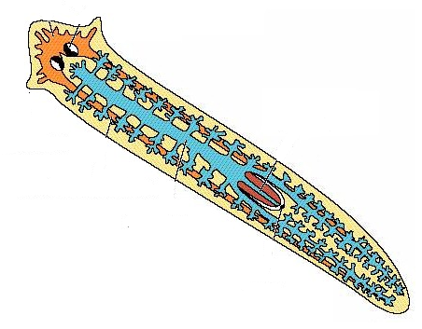  OR NO openings  (tapeworm)  OPEN circulation  EX: Planaria, flukes, tapeworms  some parasitic: Schistosomiasis (blood fluke) | 2 opening digestive system  OPEN Circulation  Free living = important decomposers  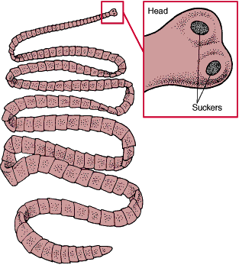  Many are parasites  EX: pinworms, hookworms,  dog heartworm, Ascaris,  Trichinella (trichinosis) | 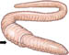  2 opening digestive system  SEGMENTATION  CLOSED circulation  Most HERMAPHRODITES  EX: earthworms, leeches
 | 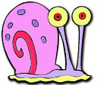 | 
BIVALVES: 2 shells  clams, oysters | GASTROPODS: 1 shell  snails, slugs | CEPHALOPODS: no shell octopus, squid
PHYLUM: MOLLUSCA
COELOMATE = true coelom
2 opening digestive system
OPEN circulation except CEPHALOPODS
“SOFT BODIES”
Many have shells secreted by MANTLE
* Some think mollusks are related to annelids
because many marine mollusks and annelids have ciliated TROCHOPHORE larva; but mollusks NOT SEGMENTED
* * * * * * * * * * * * * * *
PHYLUM: ECHINODERMATA (Ex: starfish, sea urchins, sand dollars)

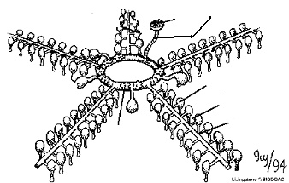
SPINY SKIN
All MARINE (live in salt water)
LARVA-BILATERAL SYMMETRY; ADULTS-RADIAL
ENDOSKELETON
INVERTEBRATE DEUTEROSTOMES
WATER VASCULAR SYSTEM with TUBE FEET
PHYLUM: ARTHROPODA
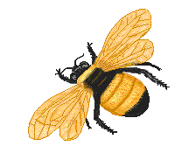 INSECTS
6 legs
HEAD, THORAX, ABDOMEN
Excrete URIC ACID with MALPIGHIAN TUBULES
TRACHEA & SPIRACLES-respiratory
Ex: Grasshopper, bee, ant
ARACHNIDS
8 legs
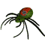CEPHALOTHORAX, ABDOMEN
Excrete URIC ACID with MALPIGHIAN TUBULES
BOOK LUNGS-respiratory
Ex: Spiders, ticks, scorpions
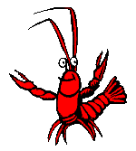 CRUSTACEANS
10 legs
CEPHALOTHORAX, ABDOMEN
GILLS-respiratory
GREEN GLANDS - excretory
Ex; crayfish , lobster, crab
Largest, most successful animal phylum
COELOMATE
INVERTEBRATE PROTOSTOMES
SEGMENTATION
JOINTED APPENDAGES
EXOSKELETON made of CHITIN
OPEN circulatory system
Many undergo METAMORPHOSIS
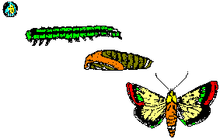

PHYLUM: CHORDATA
SUBPHYLUM:VERTEBRATA

ALL COELOMATE DEUTEROSTOMES

FISH
CHONDRICHTHYES-ENDOSKELETON of cartilage Ex: sharks, rays, skates
OSTEICHTHYES-ENDOSKELETON of bone Ex: perch, bass, eel
- Most RAY FINNED-have spines in fins
- LOBE-FINNED-have tiny arm/leg bones in fins;
Evidence suggests extinct LOBE-FINNED fish are ancestors of amphibians and other vertebrates (TIK-TAALIK)
2 chamber heart/1 loop circulatory system
GILLS
scales/fins
swim bladder or lungs
ECTOTHERMIC = “cold blooded”
* * * * * * * * * * * * * * *
AMPHIBIAN Ex; frog, toad, salamander
“Double life” = aquatic larva morphs to terrestrial adult
Thin, moist skin
3 chamber heart
2 loop circulation
ECTOTHERMIC
Lay eggs without
shells
REPTILIA Ex: snake, lizard. Tortoise, crocodile
Thick, scaly skin
ECTOTHERMIC
Most 3 chamber heart/2 loop circulatory system
Excrete URIC ACID
INTERNAL FERTILIZATION
OVIPAROUS- Lay AMNIOTIC EGGS

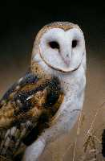


BIRDS (AVES)
Wings/feathers
ENDOTHERMIC = “warm blooded”
4 chamber heart/2 loop circulatory system
Hollow, light weight bones
Air sacs attached to lungs for efficient gas exchange
Excrete URIC ACID
Lay AMNIOTIC EGGS



MAMMALIA
ENDOTHERMIC
Fur or hair
MAMMARY GLANDS make milk for young
MONOTREMES | MARSUPIAL | PLACENTAL (EUTHERIA)
Lay amniotic eggs  Ex: platypus, echidna | Placenta for short time  Incubate in pouch  Ex: kangaroo, koala,opossum | True placenta nourishes  embryo inside mother  Ex: humans, dog, elephant

4 chamber heart/2 loop circulatory system
Lungs for respiration
Excrete UREA
Most VIVIPAROUS-live birth

