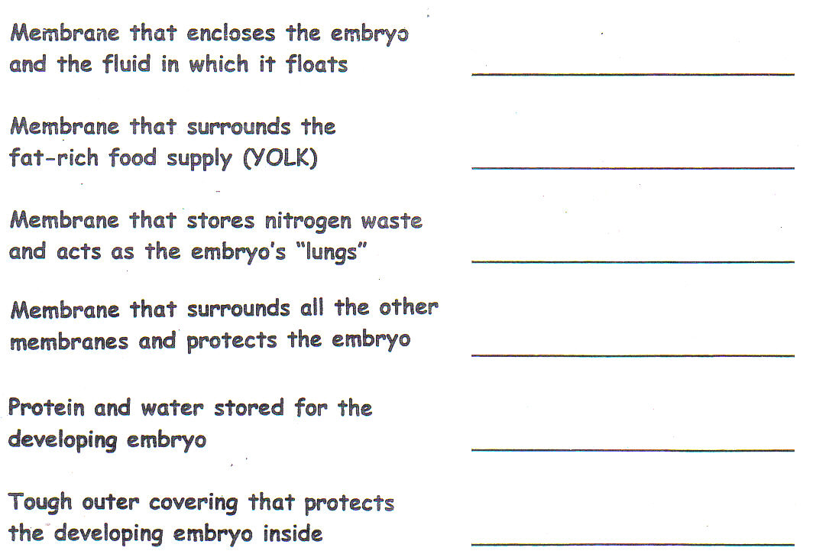
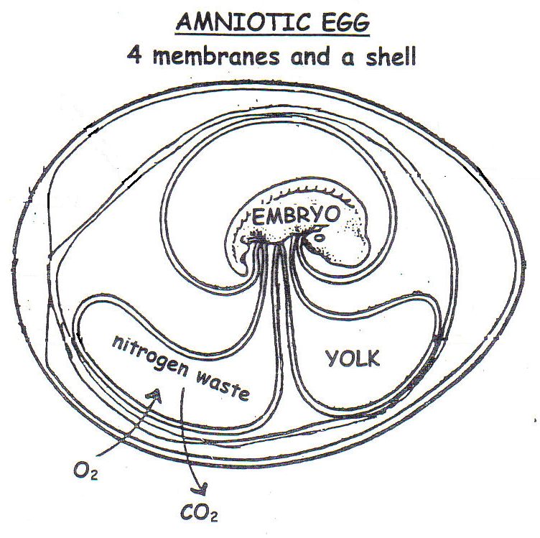

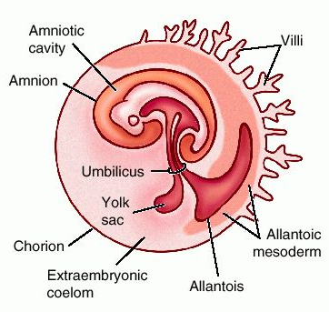
Shell placed around developing embryo;
laid OUTSIDE mother’s body;
nourishment comes from egg __________________________________
Shell placed around developing embryo;
egg held INSIDE mother’s body
until ready to hatch or hatches inside;
nourishment comes from egg __________________________________
No shell around egg; embryo develops
INSIDE mother’s body attached to placenta;
Nourishment comes from mother ________________________________

