Name _____________________________ Period _________

AP Biology Date ______________________

GENETICS PRACTICE 2: BEYOND THE BASICS

Solve these genetics problems. Be sure to complete the Punnett square to show how you derived your solution.

INCOMPLETE DOMINANCE
1. In radishes, the gene that controls color exhibits incomplete dominance. Pure-breeding red
radishes crossed with pure-breeding white radishes make purple radishes. What are the
genotypic and phenotypic ratios when you cross a purple radish with a white radish?

CO-DOMINANCE

2. Certain breeds of cattle show incomplete dominance in coat color. When pure breeding red
cows are bred with pure breeding white cows, the offspring are roan (red and white hairs both show).
Summarize the genotypes & phenotypes of the possible offspring when a roan cow is mated
with a roan bull

3. A man with type AB blood marries a woman with type B blood. Her mother has type O
blood. List the expected phenotype & genotype frequencies of their children.

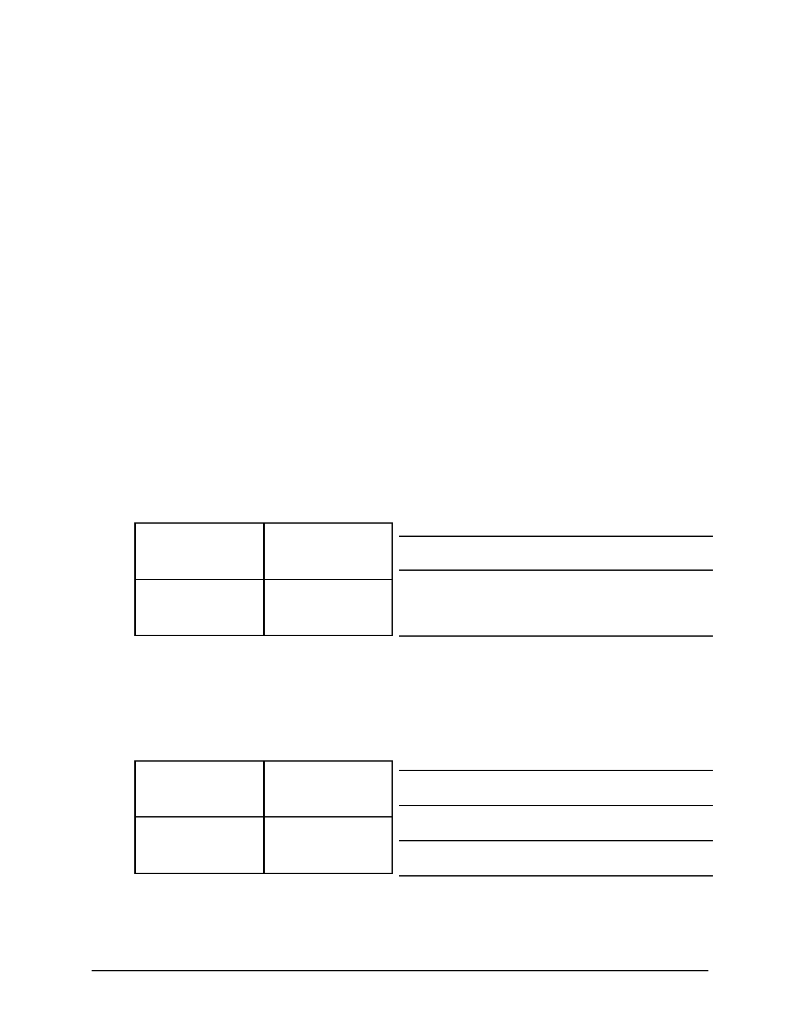
Name _____________________________ AP Biology

4. The father of a child has type AB blood. The mother has type A.

Which blood types can their children NOT have?

5. A woman with type A blood and a man with type B blood
could potentially have offspring with what blood types?

6. The mother has type A blood. Her husband has type B blood.
Their child has type O blood. The father claims the child can't
be his. Is he right?

7. The mother has type B blood. Her husband has type AB blood.
Their child has type O blood. The father claims the child can't
be his. Is he right?

8. The mother has type AB blood. The father has type B blood.
His mother has type O blood. What are all the possibilities of
blood type for their children?

LETHAL DOMINANT
________________________

________________________

________________________

________________________

________________________

9. Achondroplasia (dwarfism) is caused by a dominant gene. A woman and a man both with
dwarfism marry. If homozygous achondroplasia results in death of embryos, list the
genotypes and phenotypes of all potential live-birth offspring.

What is the expected ratio of dwarfism to
normal offspring?

SEX-LINKED
10. The genes for hemophilia are located on the X chromosome. It is a recessive disorder. List
the possible genotypes and phenotypes of the children from a man normal for blood clotting
and a woman who is a carrier. (HINT: You have to keep track of what sex the children are!)

EXTRA CREDIT: Remember those roan cows from question 2? They also have a second gene
for horn vs. hornless cattle. The allele for horns dominates the allele for hornless. If a bull and
cow are heterozygous for both genes, what are the probabilities for each possible phenotype?

2 of 2

