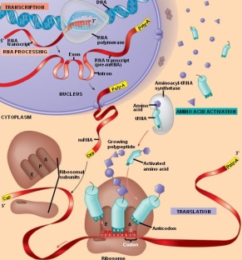
SHOW WHAT YOU KNOW PROJECT -
Use the diagram provided and make a video tracing the flow of chemical information from the gene to the protein product.
• You must include a description/explanation of everything in the picture.
• 3 people/group
• Everyone in group must talk in video
• Be sure to include important: locations, enzymes, molecules involved
THINGS TO INCLUDE:
- Transcription (location, enzymes, steps)
- Pre-mRNA editing (introns/exons/5’cap/polyA tail
- Exit from nucleus
- Translation (location, cell parts, RNA functions, initiation, elongation, termination,
codon/anticodon, A, P, & E sites)
- t-RNA charging
- What happens after the polypeptide is made? (3D structure folding, modifications)
- Post transcriptional regulation
- Post translational regulation

