NAME___________________________________

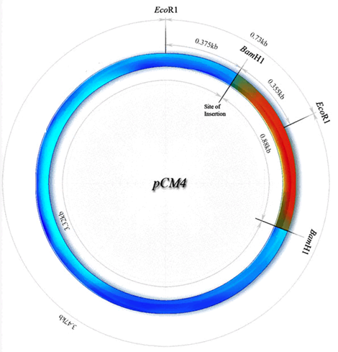RESTRICTION MAP  
Use the restriction map shown to answer the following questions:  
  
How large is this plasmid? _____________ bp

How many fragments would be produced if this plasmid was cut with the restriction enzyme EcoR1? ________  
  
How many fragments would be produced if this plasmid was cut with the restriction enzyme BamH1? ________

How large would each of these be?   
 ____________ bp __________ bp

How many fragments would be produced if this plasmid was cut with both   
 EcoR1 AND BamH1? _______

Draw the patterns you would expect to see if the following digests were analyzed using DNA gel electrophoresis.

