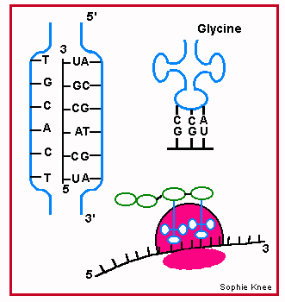

|  |  |  |  |  |  |  |  |  |  |  |  |  |  |  |  |  |  |  |  |
| --- | --- | --- | --- | --- | --- | --- | --- | --- | --- | --- | --- | --- | --- | --- | --- | --- | --- | --- | --- |
|  |  |  |  |  |  |  |  |  |  |  |  |  |  |  |  |  |  |  |  |

|  |  |  |  |  |  |  |  |  |  |  |  |  |  |  |  |  |  |  |  |
| --- | --- | --- | --- | --- | --- | --- | --- | --- | --- | --- | --- | --- | --- | --- | --- | --- | --- | --- | --- |
|  |  |  |  |  |  |  |  |  |  |  |  |  |  |  |  |  |  |  |  |



|  |  |  |  |  |  |  |  |  |  |  |  |  |  |  |  |  |  |  |  |
| --- | --- | --- | --- | --- | --- | --- | --- | --- | --- | --- | --- | --- | --- | --- | --- | --- | --- | --- | --- |
| C | T | A | C | A | T | G | C | G | A | T | G | T | G | A | T | T | G | A | A |