DESKTOP RFLP ANALYSIS NAME _________________________
GEL #1
LAY OUT 3 YARN PIECES ON YOUR DESK; DON’T STRETCH !
TRIM GREEN & PURPLE YARN PIECES SO THEY ARE THE SAME LENGTH- 50 cm
Use the SAME EcoRI “restriction enzyme” provided to cut ALL the DNA strands.
- “LADDER” DNA (TAN yarn) – Cut pieces that are 10 cm, 20 cm, 30 cm, 40 cm long
- Individual #1 (PURPLE yarn) – Make cuts at 10 cm AND 32 cm
- Individual #2 (GREEN yarn) – Make cuts at 10 cm AND 15 cm AND 40 cm

Set up the top of your desk as a gel
- Use sticky notes to LABEL the + and – poles
- Use sticky notes to LABEL your lanes
- Use sticky notes to LABEL distance on the gel

Load each “well” with DNA from one individual.
“Run your gel”. In real life, current would be applied to cause the fragments to move along the gel

LADDER DNA Individual #1 Individual #2
(TAN) (PURPLE) (GREEN)

GEL #2:- CUT DNA from the INDIVIDUAL #1 (PURPLE yarn) with DIFFERENT RESTRICTION ENZYMES.
LAY OUT 3 YARN PIECES ON YOUR DESK; DON’T STRETCH !
TRIM ALL YOUR YARN PIECES SO THEY ARE THE SAME LENGTH- 50 cm
Use the “restriction enzymes” provided to:
- Cut one piece of yarn with EcoR1 –Cuts at 10 cm AND 32 cm
- Cut one piece of yarn with HindIII– Cuts at 22 cm
- Cut one piece of yarn with BOTH EcoR1 AND HindIII (Use BOTH of the above cuts)
Set up the top of your desk as a gel
- Use sticky notes to LABEL the + and – poles
- Use sticky notes to LABEL your lanes
- Use sticky notes to LABEL distance on gel
Load your “gel” with your “DNA” that has been cut with “restriction enzymes”.
Complete RFLP analysis and draw a picture of the results below.
EcoR1 HindIII EcoR1 + HindIII

GEL #1 ANALYSIS QUESTIONS:
EXPLAIN WHY DNA moves in an electric field toward the POSITIVE pole.

EXPLAIN the purpose of the “LADDER” DNA.

EXPLAIN the relationship between FRAGMENT SIZE and DISTANCE the fragment moved on a gel.

EXPLAIN the relationship between the number of restriction sites and the number of fragments produced.

EXPLAIN why Individual #2 showed only 3 bands if you made 3 cuts. (4 fragments of DNA)

Do you think the gel pattern would be the same for Individual #1’s DNA if it was cut with a different restriction enzyme? EXPLAIN YOUR ANSWER.

Linus Pauling used RFLP analysis to show that the sickle cell mutation caused a change in the DNA code. He cut the genes from a person with normal hemoglobin and a person with sickle cell anemia with the same restriction enzyme and compared them using RFLP analysis.
Use what you know about the sickle cell mutation and restriction recognition sites to EXPLAIN how a mutation could change the NUMBER and LENGTHS OF FRAGMENTS on a gel .

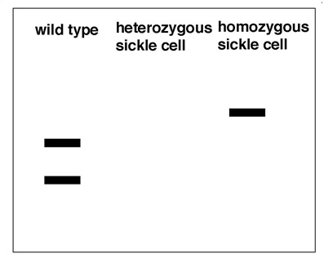
MAKE A PREDICTION about what the gel pattern from a person who is heterozygous for the sickle cell allele might look like. HINT: Think about what the word HETEROZYGOUS means.

___________________________________________________________________________________

GELL #2:
Explain why DNA from the SAME person shows different patterns in the gel if cut with different restriction enzymes.

____________________________________________________________________________________
Give at least FOUR (4) EXAMPLES of how DNA ANALYSIS can be used to compare DNA.
1.
2.
3.
4.

