DESKTOP RFLP ANALYSIS NAME _________________________
LAY OUT YARN PIECES ON YOUR DESK; DON’T STRETCH !
TRIM PURPLE & GREEN YARN PIECES SO THEY ARE THE SAME LENGTH- 50 cm
Use the SAME EcoRI “restriction enzyme” provided to cut ALL the DNA strands.
- “LADDER” DNA (TAN yarn) – Cut pieces that are 10cm, 20 cm, 30 cm, 40 cm long
- Individual #1 (PURPLE yarn) – Make cuts AT 10 cm AND 32 cm
- Individual #2 (GREEN yarn) –Make cuts AT 10 cm AND 15 cm AND 40 cm
Set up the top of your desk as a gel
- Use sticky notes to LABEL the + and – poles
- Use sticky notes to LABEL your lanes
- Use sticky notes to LABEL distances on gel

Load “LADDER DNA” into well #1; Load the other 2 lanes with DNA from Individual #1 and #2
Run your gel”. In real life, current would be applied to cause the fragments to move along the gel
LADDER DNA Individual #1 Individual #2
(TAN) (PURPLE) (GREEN)

ANALYSIS QUESTIONS:
EXPLAIN WHY DNA moves in an electric field toward the POSITIVE pole.

EXPLAIN the purpose of the “LADDER” DNA.

EXPLAIN the relationship between FRAGMENT SIZE and DISTANCE the fragment moved on a gel.

EXPLAIN the relationship between the number of restriction sites and the number of fragments produced.

EXPLAIN why Individual #2 showed only 3 bands if you made 3 cuts. (4 fragments of DNA)

Do you think the gel pattern would be the same for Individual #1’s DNA if it was cut with a different restriction enzyme? EXPLAIN YOUR ANSWER.

Linus Pauling used RFLP analysis to show that the sickle cell mutation caused a change in the DNA code. He cut the genes from a person with normal hemoglobin and a person with sickle cell anemia with the same restriction enzyme and compared them using RFLP analysis.
Use what you know about the sickle cell mutation and restriction recognition sites to EXPLAIN how a mutation could change the NUMBER and LENGTHS OF FRAGMENTS on a gel .

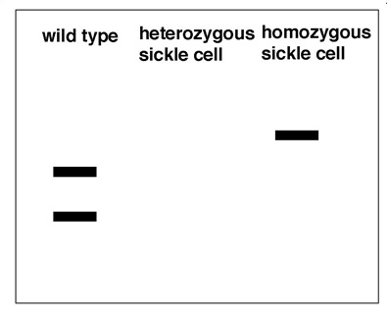
MAKE A PREDICTION about what the gel pattern from a person who is heterozygous for the sickle cell allele might look like. HINT: Think about what the word HETEROZYGOUS means.

Give at least FOUR (4) EXAMPLES of how DNA ANALYSIS can be used to compare DNA.
1.
2.
3.
4.

