OPERON REVIEW NAME _________________________

Use your pool noodle operon to demonstrate the following then draw a picture below.  
Be sure to include: RNA polymerase, repressors, and any other molecules needed to show how this works.  
  
*trp OPERON WHEN TRYPTOPHAN LEVELS ARE LOW:*

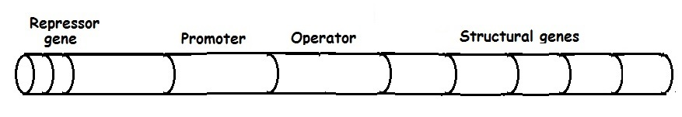 GENE TURNED ON

*trp OPERON WHEN TRYPTOPHAN LEVELS ARE HIGH*

 GENE TURNED OFF

WITHOUT TRYPTOPHAN this operon is turned **ON OFF** (Circle one)

The *trp* operon is a **REPRESSIBLE INDUCIBLE** OPERON (Circle one)

When this operon is “turned on“ the repressor is **ACTIVE INACTIVE** (Circle one)

When this operon is “turned off” the repressor is **ACTIVE INACTIVE** (Circle one)

When tryptophan is attached to the repressor, the repressor is **ACTIVE INACTIVE** (Circle one)

The use of a repressor protein to turn this operon off is an example of __________________ control.

**positive negative**

Repressible operons are most commonly associated with enzymes that function in ___________________ pathways. **catabolic anabolic**  
  
The structural genes in the trp operon code for enzymes that ____________________ tryptophan.

**produce breakdown**

**EXPLAIN** what happens to transcription of the *trp* operon when tryptophan is absent and **WHY.**

Use your pool noodle operon to demonstrate the following then draw pictures below.  
Include: RNA polymerase, repressors, and any other molecules needed to show how it works.  
  
*lac OPERON WHEN LACTOSE LEVELS ARE HIGH:*



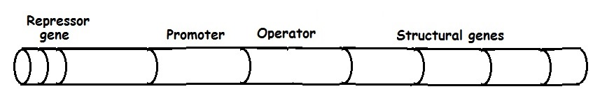  
 GENE TURNED ON

*lac OPERON WHEN LACTOSE LEVELS ARE LOW:*

 GENE TURNED OFF

WITHOUT LACTOSE this operon is turned **ON OFF** (Circle one)

The *lac* operon is a **REPRESSIBLE INDUCIBLE** OPERON (Circle one)

When this operon is “turned on“ the repressor is **ACTIVE INACTIVE** (Circle one)

When this operon is “turned off“ the repressor is **ACTIVE INACTIVE** (Circle one)

When lactose is attached to the repressor, the repressor is **ACTIVE INACTIVE** (Circle one)

The use of a repressor protein to turn this operon off is an example of __________________ control.

**positive negative**

Inducible operons are most commonly associated with enzymes that function in ___________________ pathways. **catabolic anabolic**

The structural genes in the lac operon code for enzymes that ____________________ lactose.

**produce breakdown**

**EXPLAIN** what happens to transcription at the lac operon and when lactose is absent and **WHY.**

In addition to a repressor, the lac operon is also POSITIVELY controlled by an inducer protein. The presence of lactose alone is NOT enough to turn on the lac operon, if GLUCOSE is also present. NO expression of the operon will occur unless the CAP inducer (Catabolic Activator protein) is present. This ensures that bacteria will utilize glucose before any other carbon source as a source of energy.

There is an inverse relationship between glucose levels and cyclic AMP (cAMP) levels in bacteria. When glucose levels are high cAMP levels are low and when glucose levels are low cAMP levels are high. In bacteria, cAMP binds to a cAMP binding protein called CAP. This cAMP-CAP complex binds to a site in the promoter increasing transcription of the operon. Since the role of the CAP-cAMP complex is to turn on transcription, this type of control is called POSITIVE CONTROL.

*lac OPERON WHEN GLUCOSE IS LOW and LACTOSE LEVELS ARE HIGH:*

 GENE TURNED ON

*lac OPERON when GLUCOSE and LACTOSE are BOTH PRESENT:*



GENE TURNED OFF



WHEN BOTH GLUCOSE AND LACTOSE are present the *lac* operon is turned **ON OFF** (Circle one)

When glucose is present c-AMP is **LOW HIGH** in the cell.

When CAP binds with cAMP it becomes **ACTIVE INACTIVE** (Circle one)

When cAMP-CAP complex binds to the promoter transcription **INCREASES DECREASES**  (Circle one)

**EXPLAIN** which TWO things happen in a bacterial cell to turn on the lac operon when glucose is low and lactose is high.

PICK AN OPERON: The operon I picked is ___________________________________  
  
The operon you chose is similar to which of these operons? ***lac trp***(Circle one)

The operon you chose is **inducible repressible** (Circle one)

In a cell the repressor for your assigned operon is usually in the **active inactive** form. (Circle one)  
 and the gene is turned **OFF ON** (Circle one)

DRAW PICTURES TO SHOW HOW YOUR ASSIGNED OPERON WORKS:

 TURNED ON

 TURNED OFF

_______________________________________________________________________________

What are the advantages of having genes organized into operons in prokaryotes?

How are structural genes different from regulatory genes?

How is the way genes are laid out on the DNA different in eukaryotes vs prokaryotes?

COMPARE AND CONTRAST REPRESSIBLE AND INDUCIBLE OPERONS.  
Fill in the chart to organize what you know about the *lac* and *trp* operons.

|  |  |  |
| --- | --- | --- |
| Operon | *lac* | *trp* |
| Involved in regulating  **anabolic** or **catabolic** pathways? |  |  |
| Structural genes for this operon code for proteins that do what? | Function | Function |
| This gene is usually  **TURNED ON TURNED OFF** |  |  |
| The operon is  **inducible** or **repressible** |  |  |
| Type of CONTROL for this operon  **POSITIVE NEGATIVE BOTH** |  |  |
| The repressor is produced in an  **active** or **inactive** form |  |  |
| What conditions are necessary for the repressor protein to become ACTIVE? |  |  |
| What conditions are necessary for the inducer protein (CAP) to become ACTIVE? |  | X |

Regulatory sequence on an operon where RNA polymerase binds = ________________________  
  
Regulatory sequence on an operon where the repressor binds = _________________________

Regulatory sequence on the lac operon where the cAMP-CAP inducer binds = ______________________