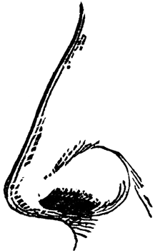
WHAT’S UP WITH . . . . PHEROMONES? WHAT’S UP WITH . . . . PHEROMONES?
What are pheromones? What are pheromones?
What messages can they send? What messages can they send?
What are VNO’s? What are VNO’s?
Do humans respond to pheromones? Do humans respond to pheromones?
FIND OUT ALL YOU CAN. FIND OUT ALL YOU CAN.

WHAT’S UP WITH . . . . PHEROMONES? WHAT’S UP WITH . . . .PHEROMONES?
What are pheromones? What are pheromones?
What messages can they send? What messages can they send?
What are VNO’s? What are VNO’s?
Do humans respond to pheromones? Do humans respond to pheromones?
FIND OUT ALL YOU CAN. FIND OUT ALL YOU CAN.

WHAT’S UP WITH . . . . PHEROMONES? WHAT’S UP WITH . . . . PHEROMONES?
What are pheromones? What are pheromones?
What messages can they send? What messages can they send?
What are VNO’s? What are VNO’s?
Do humans respond to pheromones? Do humans respond to pheromones?
FIND OUT ALL YOU CAN. FIND OUT ALL YOU CAN.

WHAT’S UP WITH . . . . PHEROMONES? WHAT’S UP WITH . . . .PHEROMONES?
What are pheromones? What are pheromones?
What messages can they send? What messages can they send?
What are VNO’s? What are VNO’s?
Do humans respond to pheromones? Do humans respond to pheromones?
FIND OUT ALL YOU CAN. FIND OUT ALL YOU CAN.

WHAT’S UP WITH . . . . PHEROMONES? WHAT’S UP WITH . . . .PHEROMONES?
What are pheromones? What are pheromones?
What messages can they send? What messages can they send?
What are VNO’s? What are VNO’s?
Do humans respond to pheromones? Do humans respond to pheromones?
FIND OUT ALL YOU CAN. FIND OUT ALL YOU CAN.

