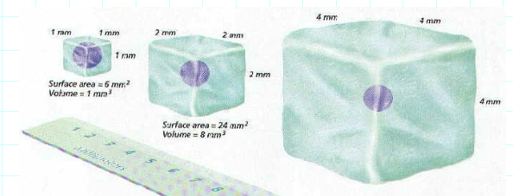
DIFFUSION IN POTATOES LAB ___________________________
Bigger isn’t always better
PRE LAB: Fill-in the table below by making the appropriate calculations
 | Surface area  (cm²)  L X W X 6 | VOLUME  (cm³)  L X W X H | SA/Volume  Ratio
1cm X 1cm X 1cm
2cm X 2cm X 2cm
3 cm X 3cm X 3 cm

Which “potato cell” model had the:
LARGEST SURFACE AREA? __________________ SMALLEST SURFACE AREA? __________________
LARGEST VOLUME ? _______________________ SMALLEST VOLUME? ______________________
LARGEST SA/VOLUME RATIO? ________________ SMALLEST SA/VOLUME RATIO? _______________
WHAT IS THE PATTERN? What happens to the SURFACE AREA/VOLUME RATIO as the size of a cell INCREASES,?

A HIGH surface area/volume ratio means cells can get molecules where they need to go more quickly more slowly
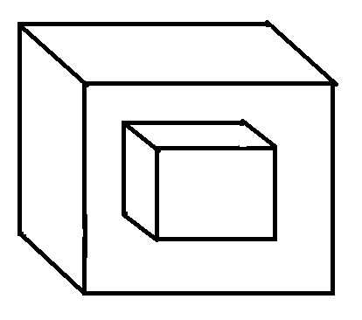
CALCULATIONS:
BIG OUTSIDE CUBE = TOTAL VOLUME
LITTLE INSIDE CUBE = VOLUME DIFFUSION DIDN’T REACH
BIG OUTSIDE CUBE VOLUME – LITTLE INSIDE CUBE VOLUME = VOLUME REACHED BY DIFFUSION
POTATO  CELL | Big Cube Volume  L X W X H  (cm³) | Width of white center square (cm) | Little white  Cube Volume  L X W X H  (cm³ ) | Big cube volume – Little cube volume  = Volume reached by diffusion  (cm ³ ) | % Diffusion =  Volume reached by diffusion  Big Cube Volume  X 100
1cm X 1cm X 1 cm
2cm X 2cm X 2 cm
3cm X 3cm X 3cm
Which size model of a cell (potato cube) showed the highest % diffusion? EXPLAIN WHY?

COMPARING CELLS:
 | SURFACE AREA | VOLUME | SA/Volume RATIO
CELL ONE  2cm X 2cm X 2cm | L X W X 6 | L X W X H
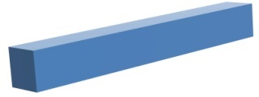CELL TWO  1cm X 1cm X 8 cm | (L x W) X 2 + (L X W) X 4 | L X W X H

How do the volumes of Cell 1 and Cell 2 compare? _________________________________________________
How do the surface areas of Cell 1 and Cell 2 compare? _____________________________________________
Which of these cells has the LARGEST Surface area/Volume ratio? CELL 1 CELL 2
Which of these cells has the SMALLEST Surface area/Volume ratio? CELL 1 CELL 2
EXPLAIN the connection between a cell’s SURFACE AREA/VOLUME RATIO and its ability to obtain nutrients and
oxygen and remove waste products.

