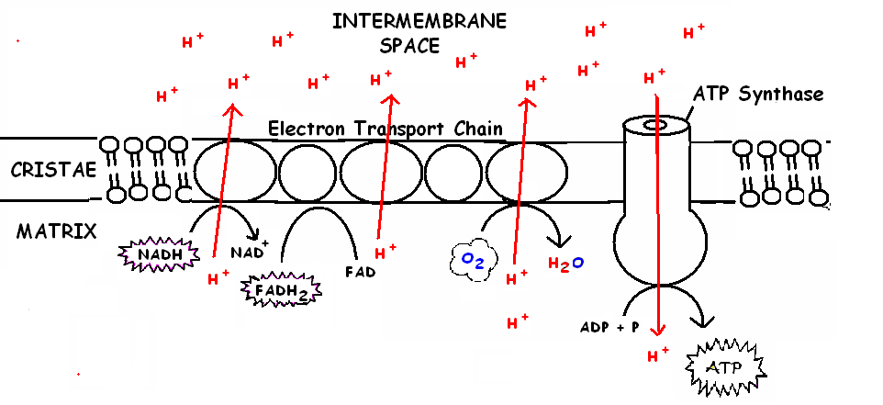
1 glucose
→ 32 ATP

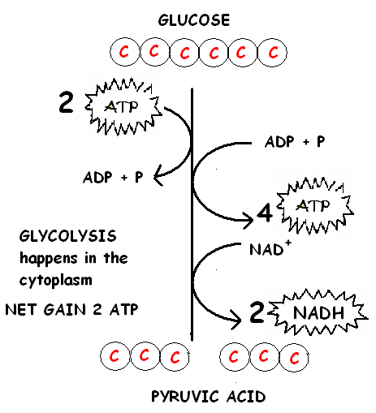
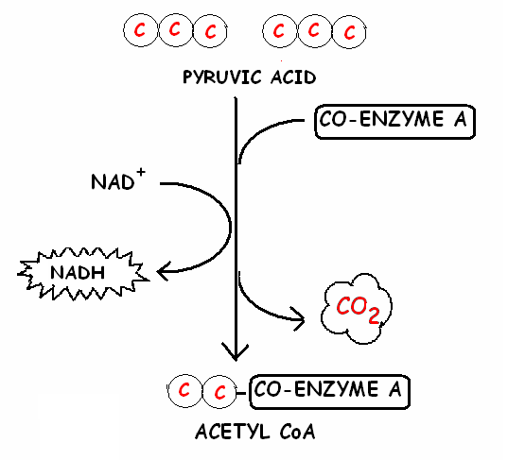
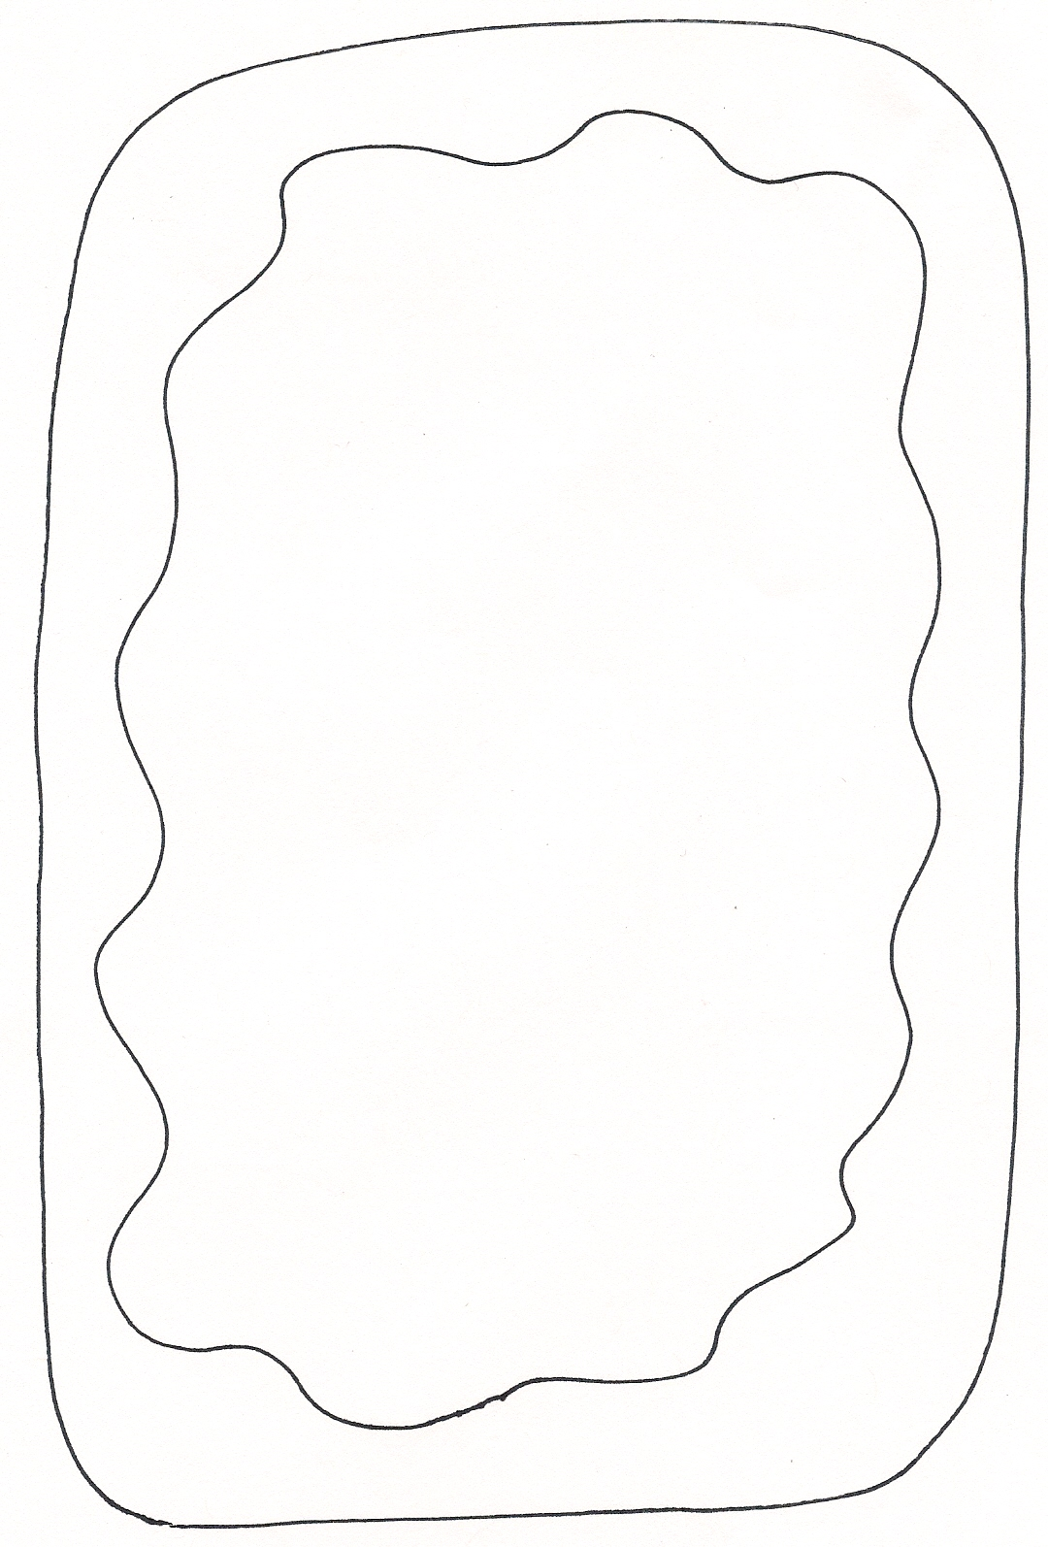

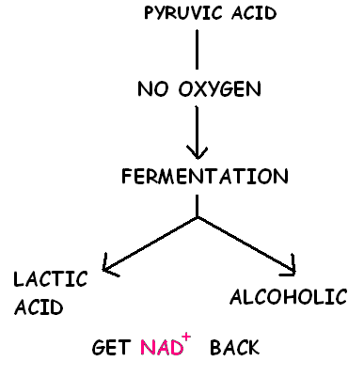
With
OXYGEN
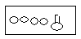
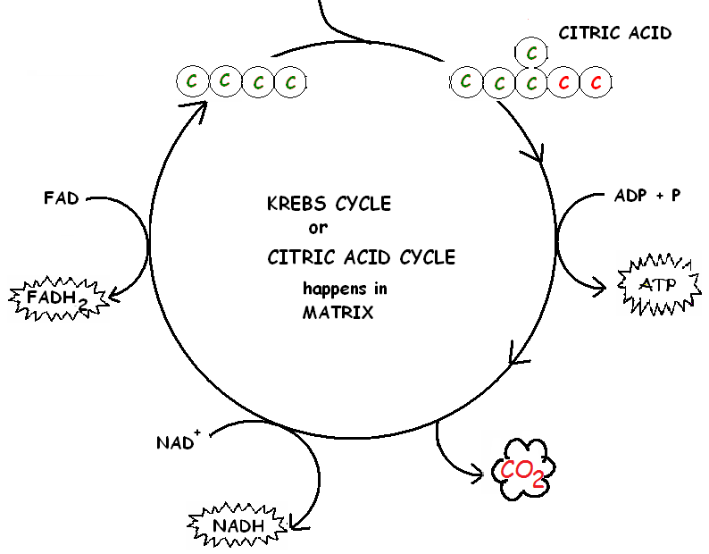
1 glucose→ Krebs
6 CO₂
2 ATP
8 NADH
2 FADH₂

3
2
DRAW RESPIRATION-Kelly Riedell

