FILL IN THE BOXES, COLOR & COUNT THE DIFFERENT PHENOTYPES
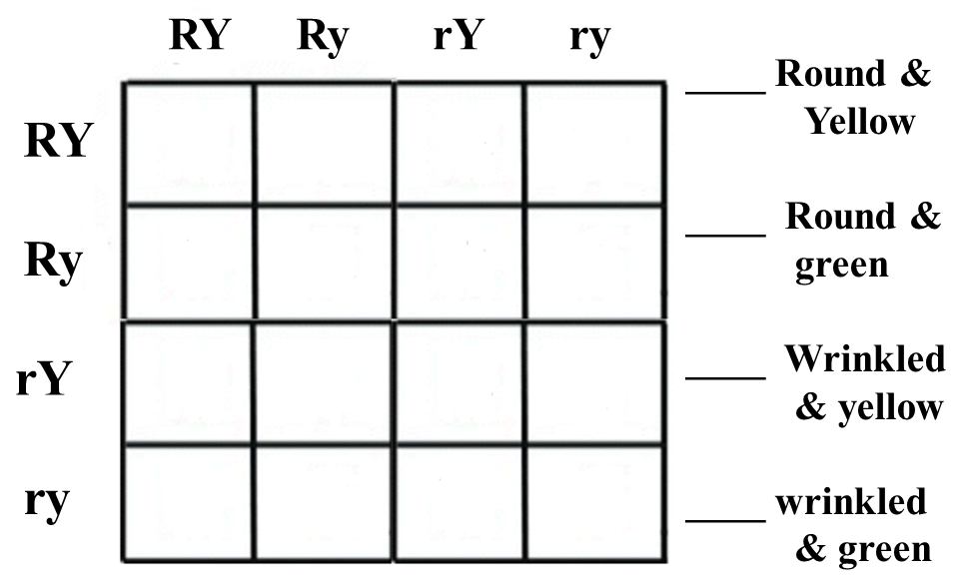

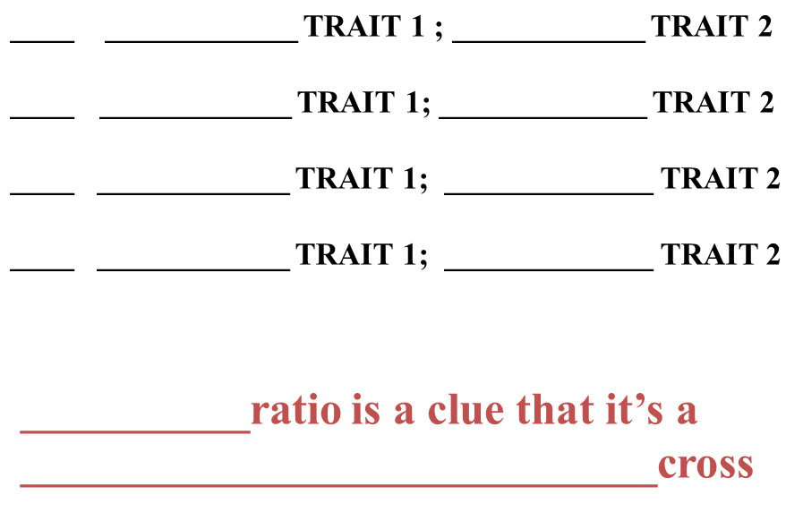
HOW DOMINANT OR RECESSIVE?
MANY?

