**HOMOZYGOUS MONOHYBRID (1 gene) CROSS**

**R = round T = tall Y = yellow peas P = purple flowers  
 r = wrinkled t = short y = green peas p = white flowers**

**PURE-BREEDING YELLOW SEED parent X PURE-BREEDING GREEN SEED parent.**

|  |  |
| --- | --- |
|  |  |
|  |  |

**POSSIBLE OFFSPRING**

**GENOTYPE PHENOTYPE**

**_________ _________________**

**What is the probability an offspring will show the DOMINANT TRAIT (YELLOW SEEDS)? ________  
What is the probability an offspring will show the RECESSIVE TRAIT (GREEN SEEDS)? ________  
__________________________________________________________________________________**

**HOMOZYGOUS PURPLE FLOWER parent X HOMOZYGOUS WHITE FLOWER parent.**

|  |  |
| --- | --- |
|  |  |
|  |  |

**POSSIBLE OFFSPRING**

**GENOTYPE PHENOTYPE**

**_________ _________________   
  
What is the probability an offspring will show the DOMINANT TRAIT (PURPLE FLOWERS)? ________  
What is the probability an offspring will show the RECESSIVE TRAIT (WHITE FLOWERS)? ________**

**HOMOZYGOUS TALL plant X PURE-BREEDING SHORT plant.**

|  |  |
| --- | --- |
|  |  |
|  |  |

**POSSIBLE OFFSPRING**

**GENOTYPE PHENOTYPE**

**________ _________________**

**What is the probability an offspring will show the DOMINANT TRAIT (TALLNESS)? __________  
What is the probability an offspring will show the RECESSIVE TRAIT (SHORTNESS)? _________**

**SEE A PATTERN FOR HOMOZYGOUS MONOHYBRID CROSSES:**

**If you cross plants that are HOMOZYGOUS DOMINANT with plants that are HOMOZYGOUS RECESSIVE for a trait, ________ % of the offspring will show the DOMINANT trait and the ___________________ trait will not show at all.**

**USE THE PATTERN ABOVE TO MAKE PREDICTION ABOUT A CROSS WITHOUT A PUNNETT**

**If you cross a HOMOZYGOUS ROUND SEED plant with a PURE-BREEDING WRINKLED SEED plant  
 100% will look __________________ 0% will look ____________________**

**The offspring will have a 100% probability of having the ______ genotype.**

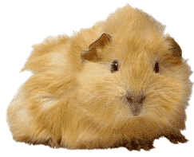**HETEROZYGOUS MONOHYBRID CROSSES**

|  |  |
| --- | --- |
|  |  |
|  |  |

**A black coat (B) is DOMINANT in guinea pigs. A brown coat (b) is RECESSIVE.   
  
Make a cross between TWO HETEROZYGOUS BLACK guinea pigs.**

**POSSIBLE OFFSPRING**

**GENOTYPE PHENOTYPE**

**_________ _________________  
 _________ ________________  
 _________ _________________**

**What is the probability that an offspring will be black? _________   
What is the probability that an offspring will be brown? _________  
What is the probability that an offspring will be a HYBRID? ________  
What is the probability that an offspring will be HOMOZYGOUS DOMINANT ? _________  
What is the probability that an offspring will be HOMOZYGOUS RECESSIVE? ___________  
___________________________________________________________________________**

|  |  |
| --- | --- |
|  |  |
|  |  |

**Purple fur (P) is DOMINANT in monsters. Yellow fur (p) is RECESSIVE.   
  
Make a cross between TWO HETEROZYGOUS PURPLE MONSTERS.**

**POSSIBLE OFFSPRING**

**GENOTYPES PHENOTYPES**

**_________ _________________  
 _________ ________________  
 _________ _________________**

**What is the probability that an offspring will be purple ? __________  
What is the probability that an offspring will be yellow? __________  
What is the probability that an offspring will be a heterozygous? _________  
What is the probability that an offspring will be HOMOZYGOUS DOMINANT ? _________  
What is the probability that an offspring will be HOMOZYGOUS RECESSIVE? ___________**

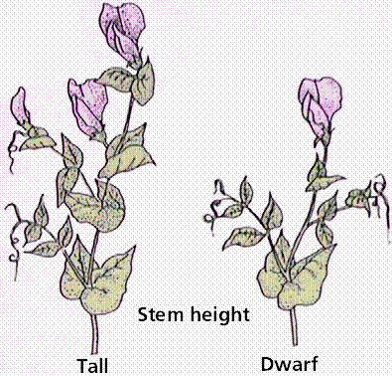**Tallness (T) is DOMINANT in pea plants. Shortness (t) is RECESSIVE.   
  
Make a cross between TWO HETEROZYGOUS TALL PEA PLANTS.**

|  |  |
| --- | --- |
|  |  |
|  |  |

**POSSIBLE OFFSPRING**

**GENOTYPES PHENOTYPES**

**_________ _________________  
 _________ ________________  
 _________ _________________**

**What is the probability that an offspring will be tall ? __________  
What is the probability that an offspring will be short? __________  
What is the probability that an offspring will be a heterozygous? _________  
What is the probability that an offspring will be HOMOZYGOUS DOMINANT ? _________  
What is the probability that an offspring will be HOMOZYGOUS RECESSIVE? ___________  
__________________________________________________________________________**

**SEE A PATTERN FOR HETEROZYGOUS MONOHYBRID CROSSES:**

**If you cross 2 parent plants that are BOTH HETEROZYGOUS for a trait   
the offspring will show a ____ : ____ phenotypic ratio (DOMINANT:RECESSIVE)  
________ % of the offspring will show the DOMINANT trait and  
________ % of the offspring will show the RECESSIVE trait.**

**USE DOMINANT OR RECESSIVE TO FILL IN THE BLANKS BELOW:  
¼ of the offspring will have two __________________ alleles,   
½ will be hybrids with one _______________ and one _______________ allele, and   
¼ will have two _________________ alleles.**

**USE THE PATTERN ABOVE TO MAKE PREDICTION ABOUT A CROSS  
If you cross two HETEROZYGOUS ROUND SEED plants   
 75% will LOOK __________________ 25% will LOOK __________________  
The probability is:  
¼ will have the genotype ______ ½ will have the genotype _____ ¼ will have the genotype _____**

**MAKING HOMOZYGOUS TWO GENE CROSSES:   
HOMOZYGOUS ROUND & YELLOW X PURE-BREEDING WRINKLED & GREEN**

**Parent genotype _____________ ____________**

**Possible gametes ____ ____ ____ ____ ____ ____ ____ ____**

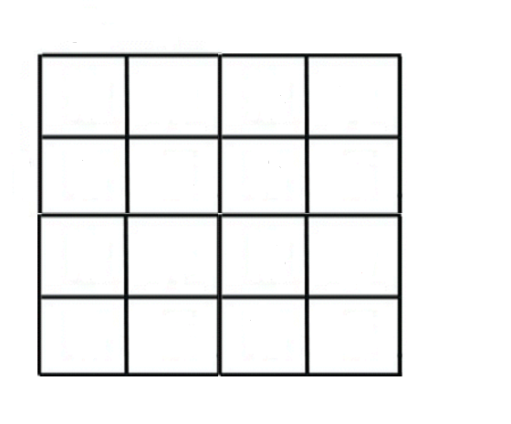 **How many out of 16 will be ?**

**_____ ROUND & YELLOW**

**_____ WRINKLED & YELLOW**

**_____ ROUND & GREEN**

**_____ WRINKLED & GREEN**

**SEE A PATTERN FOR HOMOZYGOUS TWO GENE CROSSES:**

**If you cross plants that are PURE DOMINANT for TWO TRAITS with plants that are PURE RECESSIVE for TWO TRAITS, ________ % of the offspring will look DOMINANT for BOTH traits and the TWO ________________ traits will not show at all.**

**USE THE PATTERN ABOVE TO MAKE PREDICTION ABOUT A CROSS  
If you cross a HOMOZYGOUS PURPLE TALL parent with a HOMOZYGOUS WHITE SHORT parent.   
 100% of the offspring will LOOK __________________ ______________ and  
 ALL will have the GENOTYPE ___________**

**HETEROZYGOUS DIHYBRID CROSSES  
make a cross between two HETEROZYGOUS ROUND & YELLOW parents.**

**Parent genotype _____________ ____________**

**Possible gametes ____ ____ ____ ____ ____ ____ ____ ____**

**WHAT IS THE PROBABILITY AN   
 OFFSPRING WILL BE ?**

**_____ ROUND & YELLOW**

**_____ WRINKLED & YELLOW**

**_____ ROUND & GREEN**

**_____ WRINKLED & GREEN**

**____ ____________ TRAIT 1 ; _____________ TRAIT 2**

**_­­­­_­­­__ ____________ TRAIT 1; _____________ TRAIT 2**

**____ ____________ TRAIT 1; _____________ TRAIT 2**

**____ ____________ TRAIT 1; _____________ TRAIT 2**

**____________ ratio is a clue that it’s a ___________________ _________________cross**

**\*\*\*\*\*\*\*\*\*\*\*\*\*\*\*\*\*\*\*\*\*\*\*\*\*\*\*\*\*\*\*\*\*\*\*\*\*\*\*\*\*\*\*\*\*\*\*\*\*\*\*\*\*\*\*\*\*\*\*\*\*\*\*\*\*\*\*\*\*\*\*\*\*\*\*\*\*\*\*\*\*\*\*\*\*\*\***

**USE THE PATTERN TO MAKE A CROSS WITHOUT A PUNNETT  
CROSS TWO HETEROZYGOUS ROUND & PURPLE parents**

**The probability is :  
9/16 will be _________________ & _________________  
3/16 will be _________________ & _________________  
3/16 will be _________________ & _________________  
1/16 will be _________________ & _________________**

**INCOMPLETE DOMINANCE:**

**In Four O’Clock plants RED FLOWERS (R) are INCOMPLETELY DOMINANT over white (W)   
flowers. Heterozygous plants show a BLENDED INTERMEDIATE phenotype of PINK flowers.**

**MAKE A CROSS WITH 2 HETEROZYGOUS FOUR O’CLOCK PLANTS.**

|  |  |
| --- | --- |
|  |  |
|  |  |

**POSSIBLE OFFSPRING**

**PROBABILITY GENOTYPE PHENOTYPE**

**__________ ________ _________________   
 __________ ________ _________________   
 __________ ________ _________________**

**\*\*\*\*\*\*\*\*\*\*\*\*\*\*\*\*\*\*\*\*\*\*\*\*\*\*\*\*\*\*\*\*\*\*\*\*\*\*\*\*\*\*\*\*\*\*\*\*\*\*\*\*\*\*\*\*\*\*\*\*\*\*\*\*\*\*\*\*\*\*\*\*\*\*\*\*\*\*\*\*\*\*\*\*\*\*\*\*\*\*\***

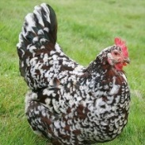**CODOMINANCE  
  
In chickens, alleles for BLACK (B) and WHITE (W) color are CODOMINANT.   
  
Heterozygous chickens show a black and white speckled (ERMINETTE) phenotype.**

**MAKE A CROSS WITH 2 HETEROZYGOUS ERMINETTE chickens.**

|  |  |
| --- | --- |
|  |  |
|  |  |

**POSSIBLE OFFSPRING**

**PROBABILITY GENOTYPE PHENOTYPE**

**__________ ________ _________________   
 __________ ________ _________________   
 __________ ________ _________________**

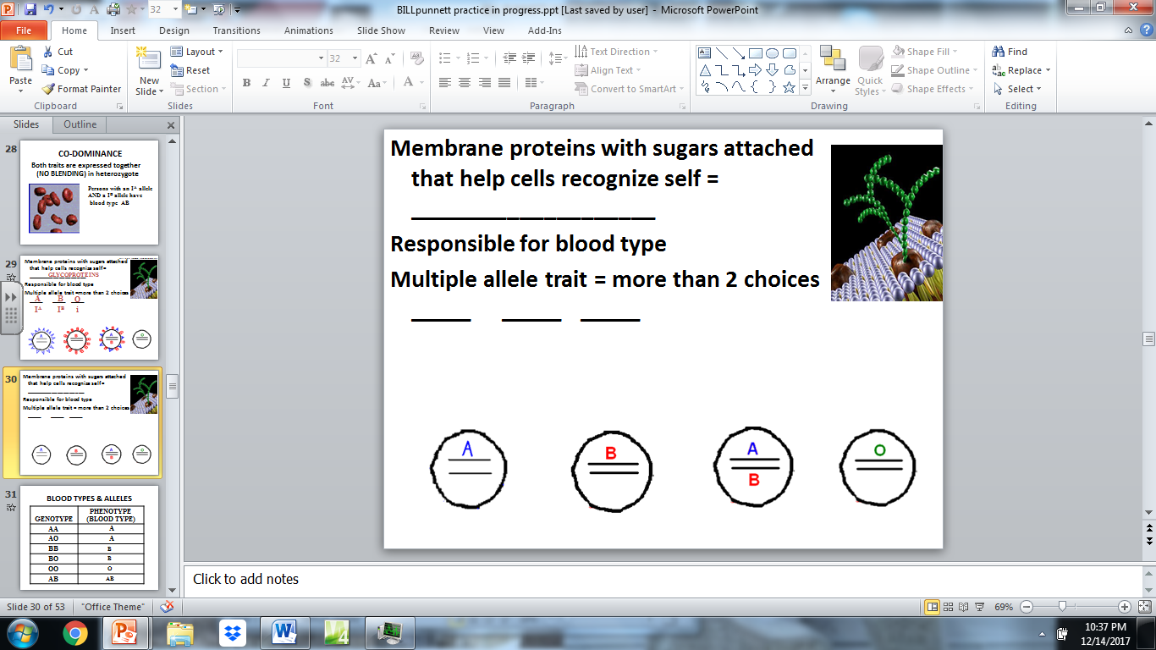

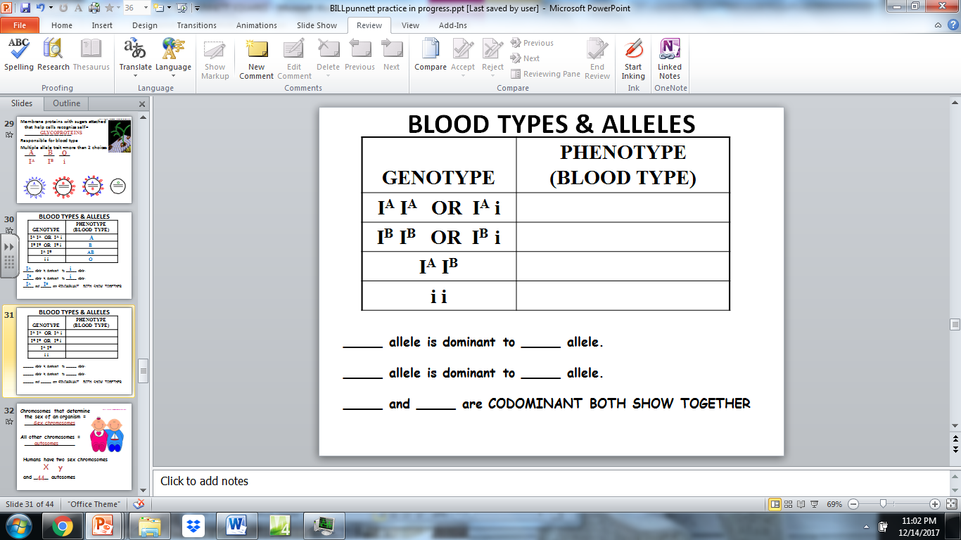

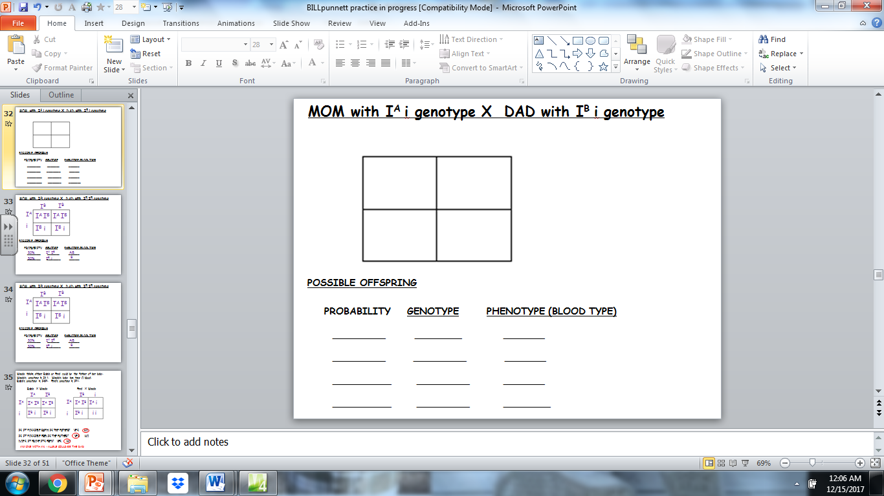

**\*\*\*\*\*\*\*\*\*\*\*\*\*\*\*\*\*\*\*\*\*\*\*\*\*\*\*\*\*\*\*\*\*\*\*\*\*\*\*\*\*\*\*\*\*\*\*\*\*\*\*\*\*\*\*\*\*\*\*\*\*\*\*\*\*\*\*\*\*\*\*\*\*\*\*\*\*\*\*\*\*\*\*\*\*\*\*\*\*\*\*\*\*\*\*\*\*\*\*\*\*\*\*\*\*\*\*\*\*\*\***

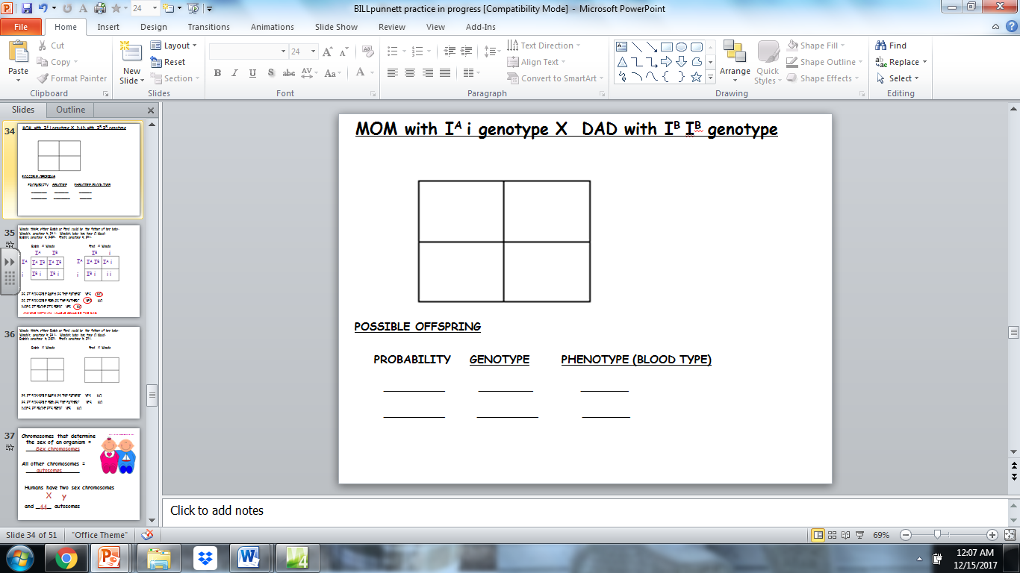

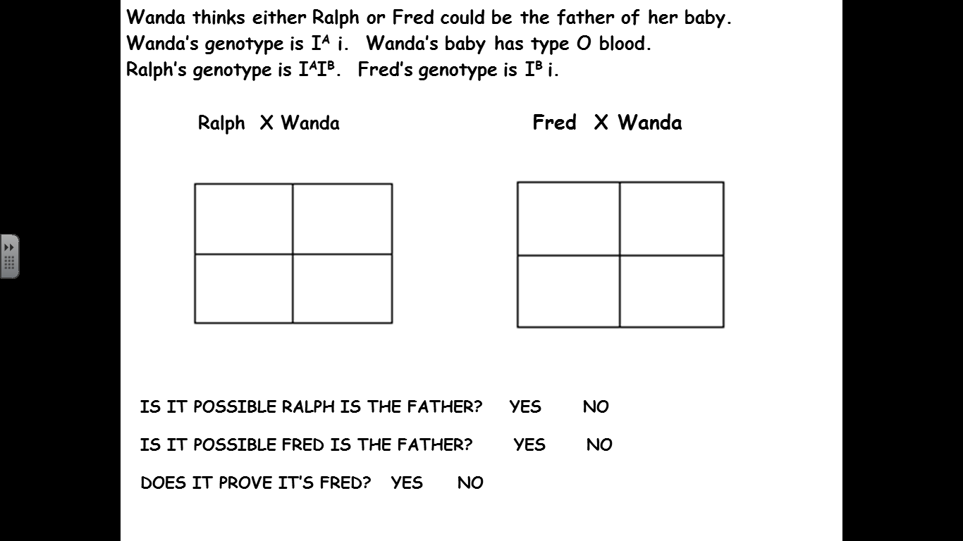

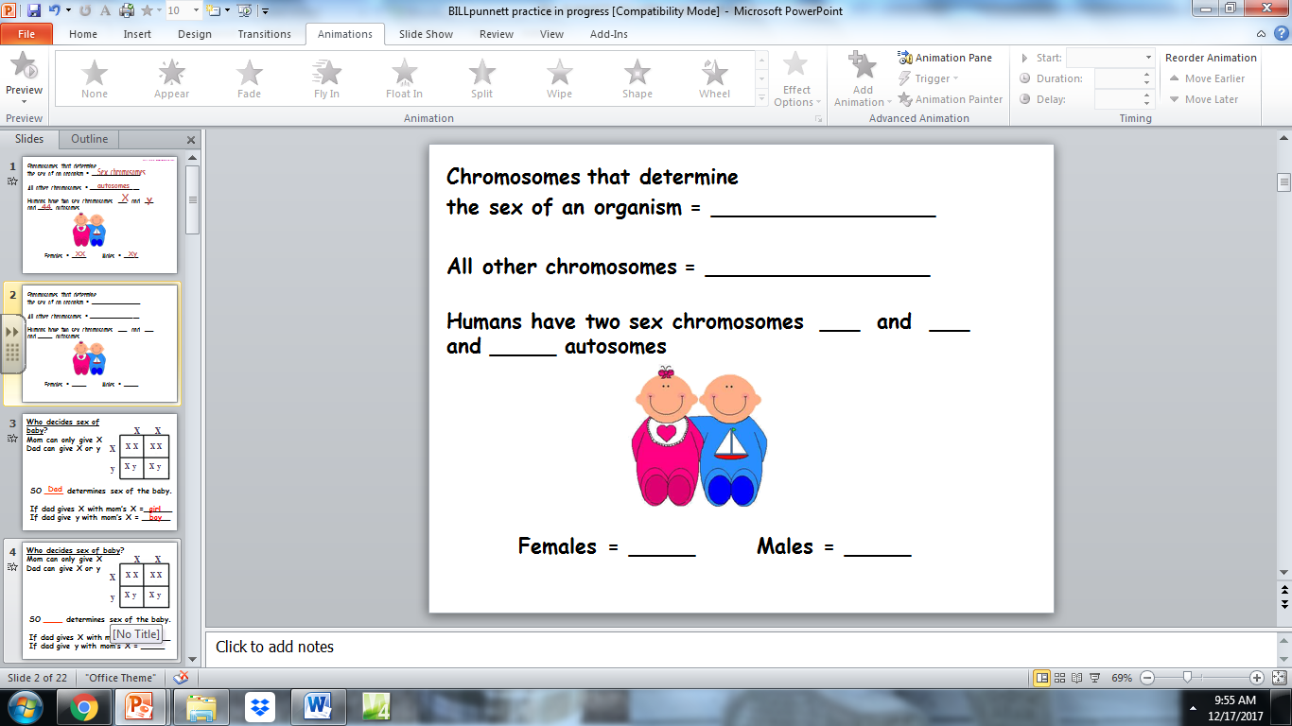

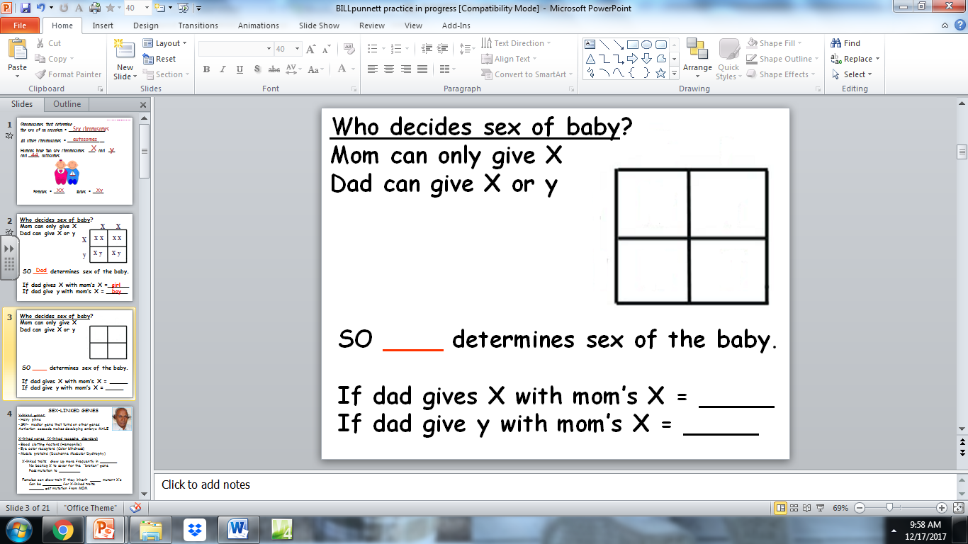

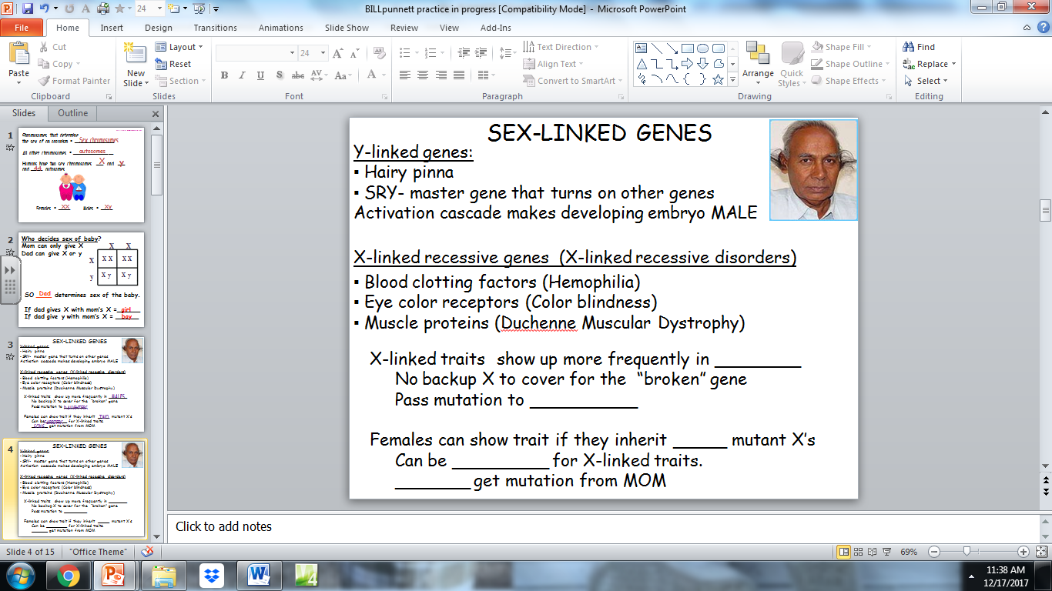

**SEX-LINKED GENES-Patterns different in males vs females**

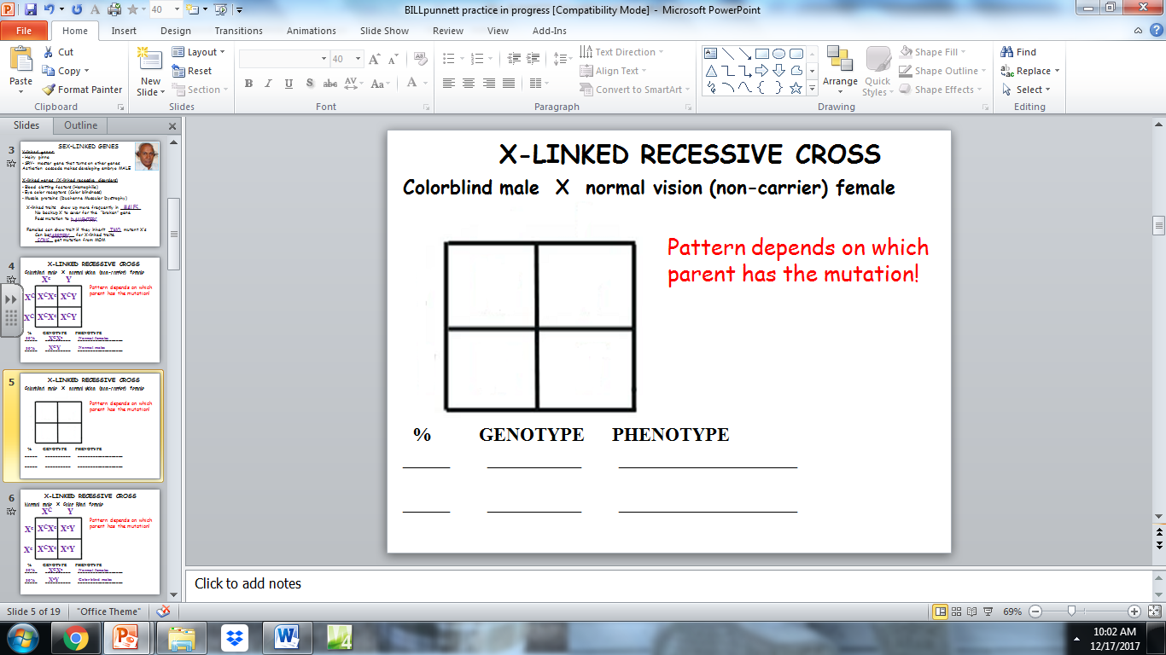

_____________________________________________________________________________________________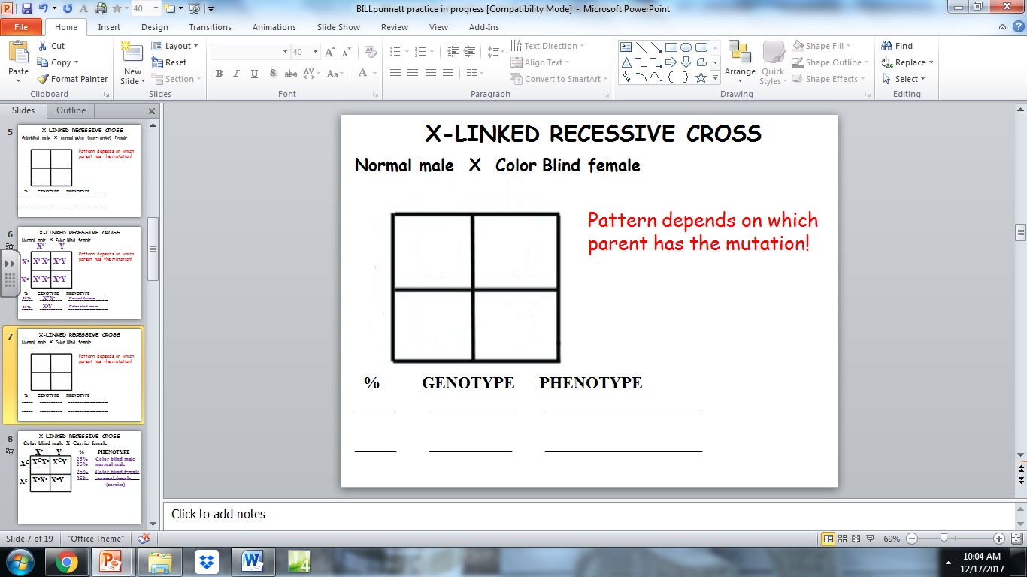

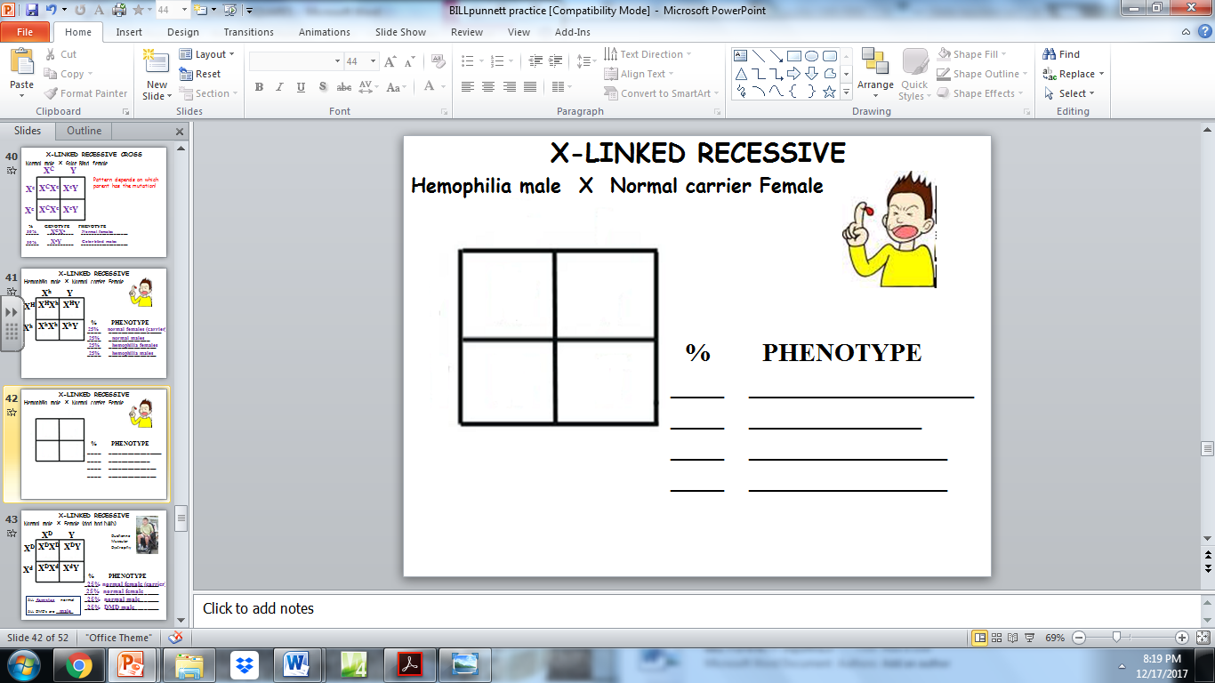

_____________________________________________________________________

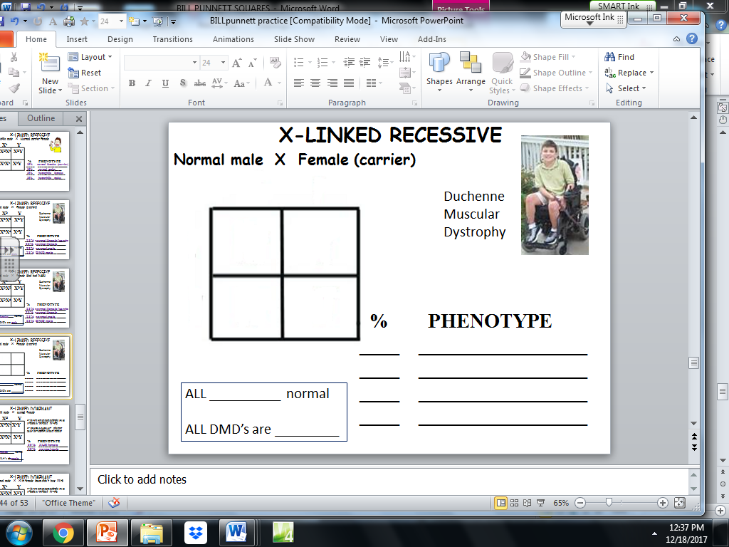

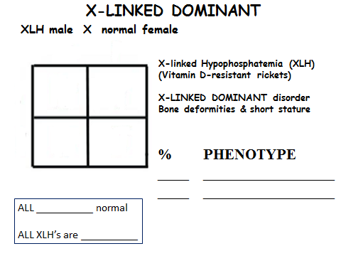

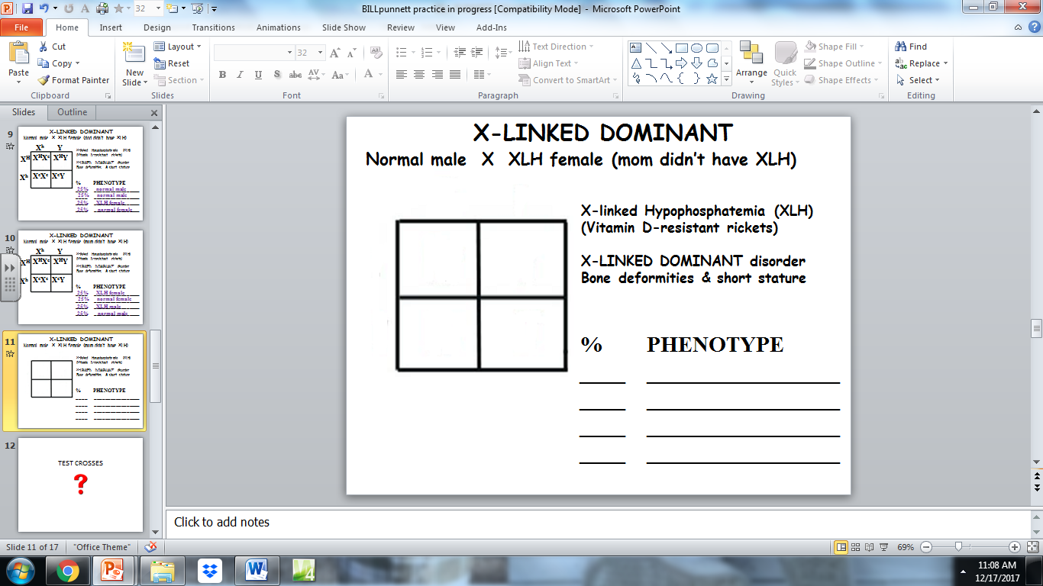**____________________________________________________________________________________________**

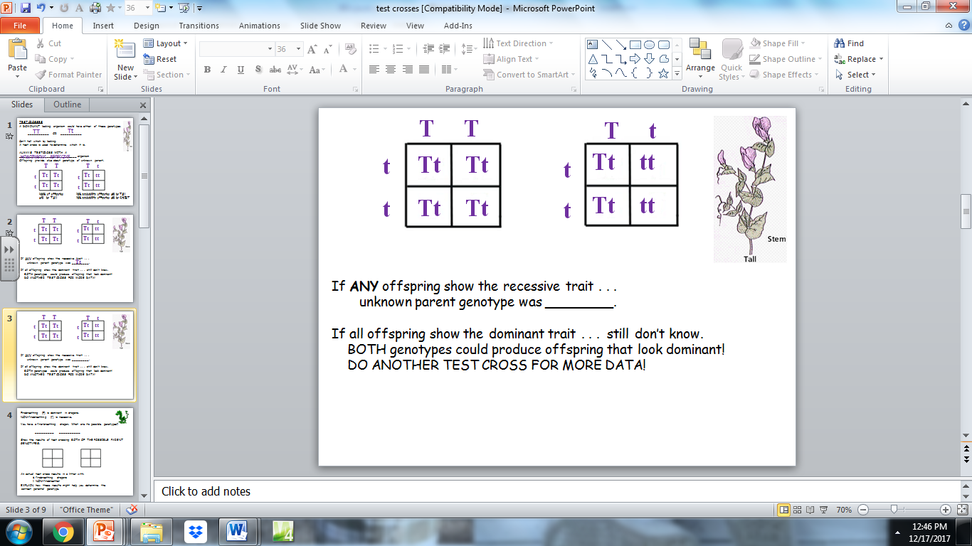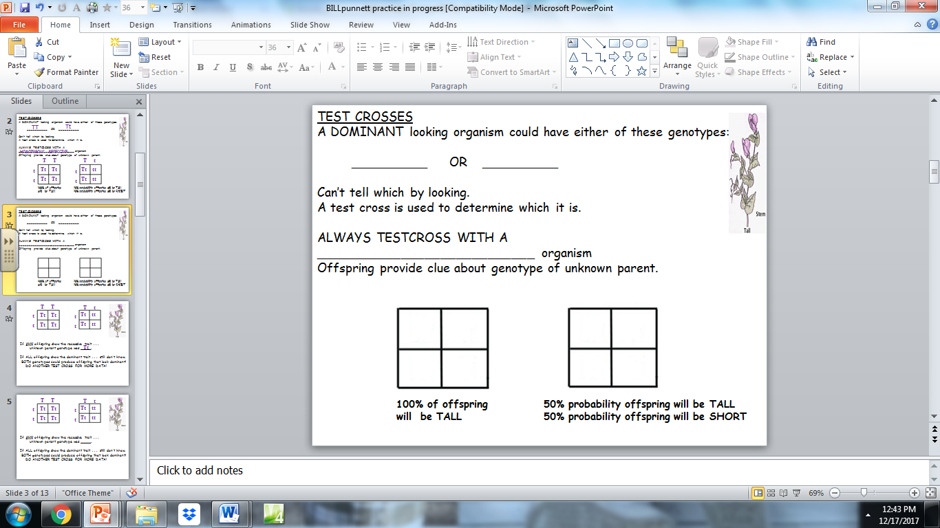

******************************************************************

TEST CROSS PRACTICE:  
Firebreathing (F) is dominant in dragons.   
NON-firebreathing (f) is recessive.

You have a fire-breathing dragon.  
 What are its possible genotypes? ________ OR ________

Show the results of test crossing BOTH of the possible parent genotypes:

|  |  |
| --- | --- |
|  |  |
|  |  |

|  |  |
| --- | --- |
|  |  |
|  |  |

An actual test cross results in a litter with:

6 firebreathing dragons   
 2 NON-firebreathers

What can you conclude about the unknown parent’s genotype?

_____________________________________________________________________  
  
Deafness in dogs is caused by a recessive allele.  
  
Deaf dogs have the genotype dd. You have a hearing dog.   
  
What are its possible genotypes? ________ OR _______  
  
Show the possibilities of a test cross to determine its genotype.

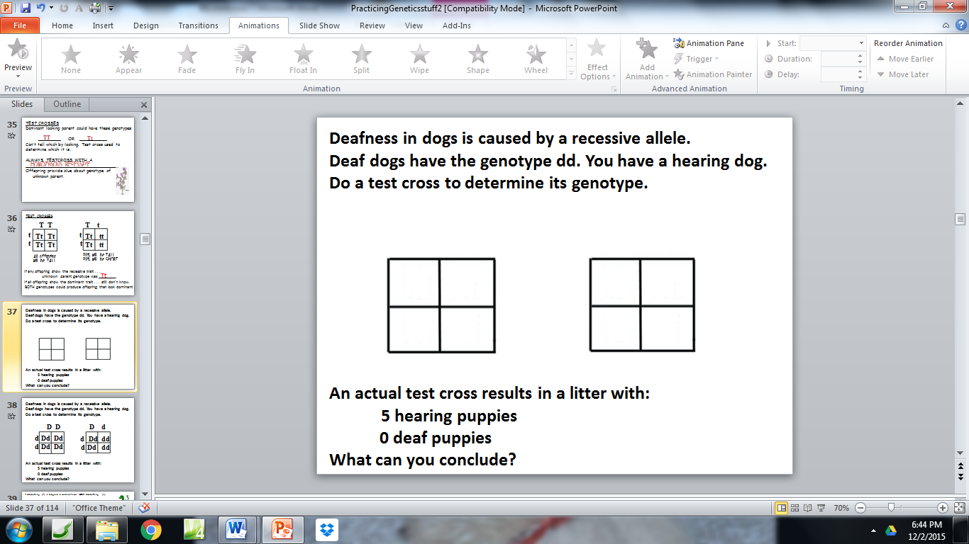

An actual test cross results in a litter with:  
 5 hearing puppies  
 0 deaf puppies  
What can you conclude about the unknown parent’s genotype?