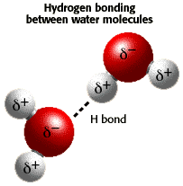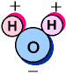**PROPERTIES OF WATER LAB   
  
BEFORE YOU START: Introduction:** • Chemical formula is H2O (one oxygen and 2 hydrogen atoms)   
 • Oxygen has more electrons orbiting it than hydrogens.  
 • Overall charge on water molecule is neutral but . . .   
 water molecule has slight positive charge on the side with H atoms  
 and slight negative charge on the side with oxygen.   
 • **Molecules with** **uneven distribution of charge** = **POLAR**

• **INTRA**-molecular bonds = **COVALENT BONDS**  
   
 **HOLD THE HYDROGEN & OXYGEN ATOMS TOGETHER**  
• **INTER**-molecular bonds = **HYDROGEN BONDS**  
   
 **HOLD WATER MOLECULES TO EACH OTHER   
  
• Attraction BETWEEN water molecules = COHESION.**

Look at the picture below:

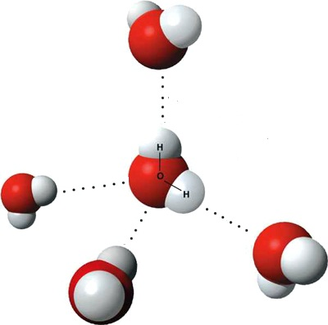

1. Add **+ AND – SIGNS** to the H and O atoms  
 in the water molecules to indicate the partially   
charged regions of *each* molecule.   
  
  
2. ***COLOR ALL*** the hydrogen bonds shown  
   
 in **RED**.  
  
  
3. ***COLOR ALL*** the covalent bonds in each water   
   
 molecule **BLUE**

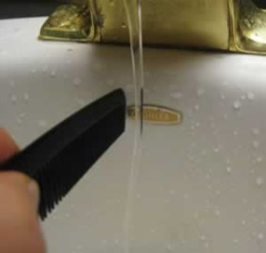**STATION #1   
   
IF** water is polar and its parts have a slight electric charge , , ,  
   
**THEN** it should be attracted to another object with a charge.   
  
 Use the rod and fur provided to **TEST THIS HYPOTHESIS**.   
   
Rub the rod on the fur to build up an electric charge and hold   
   
the rod near a stream of running water.   
   
 (Be careful not to touch the rod to the water.)  
   
  
4) What happens? EXPLAIN YOUR ANSWER.   
 This video may help you. <https://www.youtube.com/watch?v=VhWQ-r1LYXY>

**STATION #2**• **POLARITY** of water makes it a good a “dissolver” of ions/other polar substances.   
• “Like dissolves like”.   
• Water is **"universal solvent"** because it dissolves more substances than any other liquid.   
• Substances that **DON’T dissolve** in water are called **NONPOLAR.**

5) Sometimes **nonpolar substances are called hydrophobic**. Breaking the word down  
 into its root words, what do you think hydrophobic means?

6) The opposite of hydrophobic is hydrophilic. What do you think this term   
 hydrophilic means?

Look at the salad dressing container filled with oil and vinegar. Gently swirl the mixture   
and allow it to sit for 1 minute.  
   
 7) Do you think oil is hydrophilic or hydrophobic? EXPLAIN YOUR ANSWER.   
 **(Claim, Evidence, Reasoning CER)**

8). Oil is a type of lipid and all lipids will have the same reaction with water as oil.   
 THINK ABOUT IT: What would happen if phospholipids that make cell membranes  
 dissolved in water like other macromolecules?

*******************************************************************************

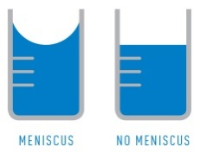**STATION #3**Because water molecules are polar they are not only attracted to each other, but they  
 are also be attracted to other substances and surfaces around them that have a slight  
 charge. This **attraction to other surfaces** is called **ADHESION.**

Fill BOTH the graduated cylinders (GLASS & PLASTIC) with water.   
Notice the surface of the water at the top of each cylinder.  
  
  
When the water molecules are attracted to the surface they stick to the sides of the   
cylinder causing it to dip down in the center, this is called a **MENISCUS.** When reading a  
 graduated cylinder, always read the number at the **BOTTOM** of the meniscus.

9) Which surface (glass or plastic) shows the greatest ADHESION to water molecules?

10) EXPLAIN why the water “climbs up” the sides of the glass cylinder.

.

*****************************************************************************

**STATION #4**

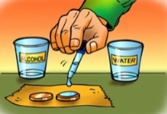• **SURFACE TENSION** property of water due to **COHESION**

• Water molecules in a drop are attracted to surrounding molecules

• Middle molecules surrounded by/attracted to molecules on all sides   
• Surface molecules only attracted by molecules on water side  
• Tension created as surface molecules pulled toward molecules below

• Surface tension causes water to **bead up** on surfaces.

You can see surface tension at work by placing a drop of water onto a penny.   
The drop will hold its shape and round up into a dome.

• Add tap water one drop at a time to the penny until the water falls over the edge.   
 • Record how many drops it takes before the water falls off edge.   
 • Dry off the penny, and then try again. Collect data 3 times.

• Repeat the procedure using **ISOPROPYL** (**RUBBING) ALCOHOL.**

|  |  |  |
| --- | --- | --- |
| Trials | Water Drops | Alcohol Drops |
| 1 |  |  |
| 2 |  |  |
| 3 |  |  |
| Average |  |  |

11). DRAW A PICTURE of what the water drop looks like on the penny just before   
it falls over the edge. ADD ARROWS to show attraction between water molecules   
at the surface of the drop and molecules in the middle of the drop.

12) Which liquid (alcohol or water) do you think has the highest surface tension?   
 Provide evidence to support your conclusion.

13) How are hydrogen bonds and cohesion related?  
  
  
  
14) Surface tension creates a “skin” on the water’s surface that allows animals like   
the “water strider” to walk on the surface of water. EXPLAIN what is happening   
when insects can walk on the water.

**STATION #5**Explore surface tension further.   
 • Add enough water to cover the bottom of the glass bowl.   
 • Sprinkle enough pepper to cover the surface of the water.   
 • Insert a **PLAIN** toothpick vertically into the water in the bowl through the pepper  
   
 15) Describe what happens.

Repeat the procedure using one of the “**SPECIAL”** toothpicks from the labeled cup.   
 16) Describe what happens.

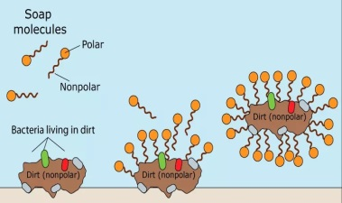  
  
• “SPECIAL” toothpicks are soaked in DISH SOAP.   
• Soap has both a POLAR part and a NON-POLAR part.  
 = **AMPHIPATHIC**  
• POLAR end has an affinity for water and the   
• NON-POLAR end has an affinity for “greasy dirt”  
By attaching to both water and dirt at the same time,   
the soap can wash the dirt away from your hands and clothes.

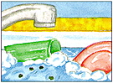• To clean clothes or wash dirty dishes/hands, **surface tension   
  
 must be REDUCED so water can spread and wet surfaces.**   
  
• Chemicals that do this = surface active agents (surfactants)  
   
 • Make water "wetter."

17). EXPLAIN how soap affects surface tension and WHY.  
 <https://www.youtube.com/watch?v=2suY9h7xnKg>

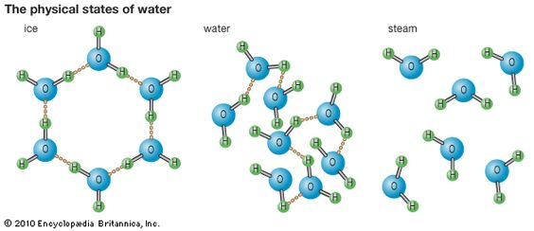**STATION #6**  
Observe the ice in the water.  
Most substances are more dense in solid form than as liquids.   
 EX: Frozen ethanol cubes would sink in a glass of ethanol.  
Water: one of few substances that is **LESS DENSE** as a solid than liquid

Water molecules are farther apart in solid ice than in   
liquid water.   
  
18). How do you think this affects the amount of   
space water takes up when frozen as opposed to as a liquid?

19) How would life in a lake be affected if water acted like other substances and   
ice sank as it froze so that lakes froze from the bottom up?

20) How do you think this property of water is responsible for all the potholed   
roads in South Dakota?

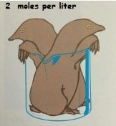**STATION #7**

**WHAT IS A MOLE?** • Molecules are measured in units called moles.  
 • 1 mole of substance contains 6.02 X1023 molecules (AVAGADRO’s NUMBER)   
 and is equal to the atomic mass of that substance in grams/Liter of solution.   
  
**IONIZATION OF WATER**

Water molecules can ionize to form :  
 a H3O+ ion (HYDRONIUM ION) and an OH- ion (HYDROXIDE ION).

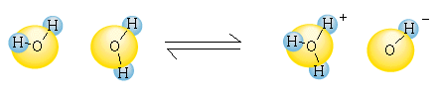

In PURE WATER the concentration of the [H3O+] and [OH-] ions are EQUAL.

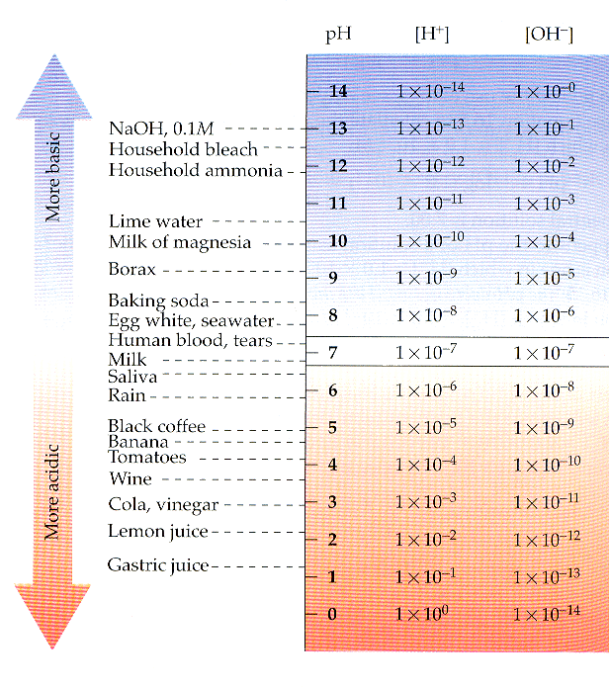~ The concentration of each is 1 X 10-7 M (0.0000001 M)   
That means there is 1/10,000,000th of a mole of hydronium ions per liter of pure water  
 and an equal number of hydroxide ions.

**pH (potential of hydrogen)** **SCALE**  
  
• Scale used to specify the acidity/basicity of a solution.

• NEUTRAL solutions have a pH = 7 (EX: pure water)

•. An ACID is a substance with a pH LESS THAN 7

• A BASE is a substance with a pH GREATER THAN 7  
  
• In any aqueous solution at 25° C, [H+] X [OH-] = 10 -14

**-Exponents for [H+] and [OH-] always add up to 14.**

Ex: If H+ concentration = 1 X 10 -2 ; OH- concentration = 10 -12.

**IMPORTANT THINGS TO REMEMBER ABOUT pH:  
  
•SMALLER** numbers means **MORE** H+ ions**.**  
• Each pH unit represents a **10 fold** difference in H+ and OH-   
  
 concentrations.

**• pH of 3** is **NOT THREE TIMES** more acidic than a **pH of 6**!   
 It’s **1000 TIMES** more acidic!

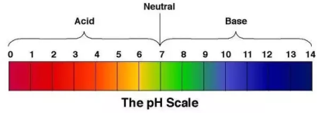

Use the pH paper provided to test the pH of the liquids listed below:

|  |  |  |
| --- | --- | --- |
| SUBSTANCE | pH | Is it an acid, base, or neutral? |
| Milk |  |  |
| Pop |  |  |
| Vinegar |  |  |
| Maalox |  |  |
| Baking soda |  |  |
| Ammonia cleaner (Windex) |  |  |
| Rubbing (isopropyl) alcohol |  |  |
| Orange juice |  |  |
| Distilled water |  |  |

21) Which solution is the most acidic? _____________________________  
22) Which solution is the least acidic? __________________________

23) Which two substances have the greatest difference in pH?  
 _______________________ ________________________  
  
24) Which of these has the greatest concentration of H+ ions? __________________

25) Complete this sentence comparing the substances in #24.

______________ is ________ times _________ __________ than _____________.   
 number more or less acidic/basic  
  
*****************************************************************************

Calculating pH is more complicated if the pH is NOT A WHOLE NUMBER.   
There is an equation for calculating pH: pH= -log [H+]   
  
You will not have to calculate this on the AP Exam, but . . .  
 you should be able to convert pH to [H+] using **WHOLE** pH values.

26) pH of urine = 6.   
 What is the concentration of H+ ions in urine? ______________________

What is the concentration of OH- ions in urine? _____________________

27) Our stomachs produce hydrochloric acid to kill germs and help break down nutrients   
in the food we eat. Too much stomach acid can cause an upset stomach. Use what you   
learned about acids and bases at this station to explain why people take antacids   
(like Maalox, Tums, or Rolaids) when they get heartburn.   
(Hint: Maalox contains magnesium HYDROXIDE)

**STATION #8-**SP.1 – Students can use representations and models to communicate scientific   
phenomena and solve scientific problems.WATCH THIS VIDEO

Use the “cups of water” to MODEL some of the properties of water.   
Add pictures with labels to your BILL.  
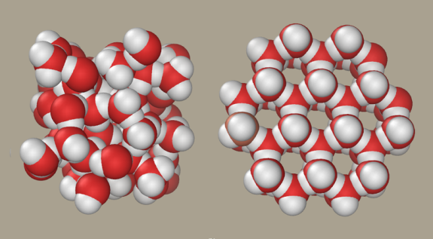  
Model and draw how one water molecule can “stick” to other water molecules.  
Model and draw the following: COHESION and ADHESION.  
  
Model how water could move up a straw or up a tree trunk.  
WATCH THIS VIDEO <https://www.youtube.com/watch?v=mc9gUm1mMzc>

[](https://www.youtube.com/watch?v=mc9gUm1mMzc)

28) EXPLAIN HOW cohesion and adhesion are involved in this upward movement?

Modified by Kelly Riedell from:   
http://sps.k12.ar.us/massengale/properties_of_water.htm AND D2L Learning Power AP BIOLOGY