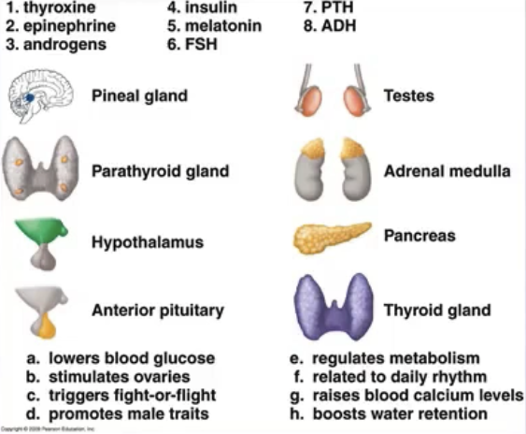

GLAND | HORMONE | FUNCTION
PINEAL
PARATHYROID
HYPOTHALMUS
ANTERIOR PITUITARY
TESTES
ADRENAL MEDULLA
PANCREAS
THYROID
Pineal gland 5. melatonin
b. related to daily rhythm (like sleep patterns)

Parathyroid 7. PTH (parathyroid hormone)
g. raises blood calcium levels
(more absorption from intestines and released from bones)

Hypothalamus 8. ADH (anti-diuretic hormone)
h. boosts water retention

Anterior pituitary 6. FSH (follicle stimulating hormone)
b. stimulates ovaries (to mature a oocyte in follicle of ovary)

Testes 3. androgens
d. promotes male traits

Adrenal medulla 2. epinephrine
c. triggers fight-or-flight

Pancreas 4. insulin
a. lowers blood glucose levels

Thyroid gland 1. thyroxine
e. regulates metabolism

GLAND | HORMONE | FUNCTION
PINEAL
PARATHYROID
HYPOTHALMUS
ANTERIOR PITUITARY
TESTES
ADRENAL MEDULLA
PANCREAS
THYROID

