BOZEMAN BIOLOGY NOTE TAKING GUIDE- NERVOUS SYSTEM

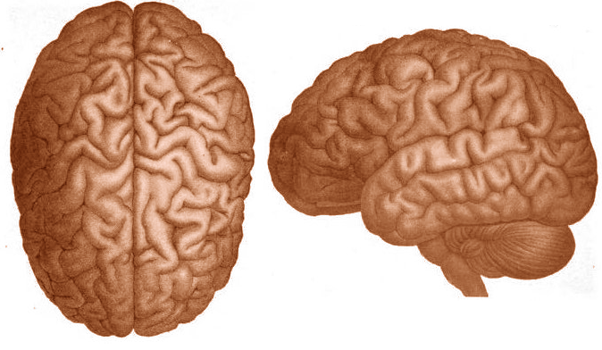

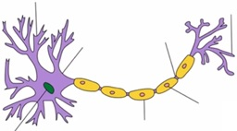

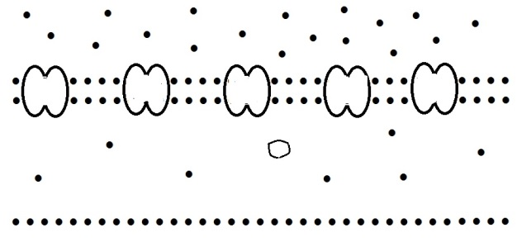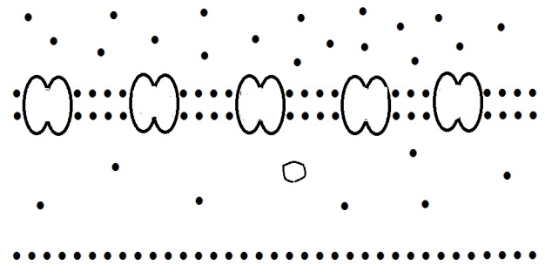http://www.clker.com/cliparts/a/3/4/8/1321341519333110575salt-shaker-jh.svg.hi.png





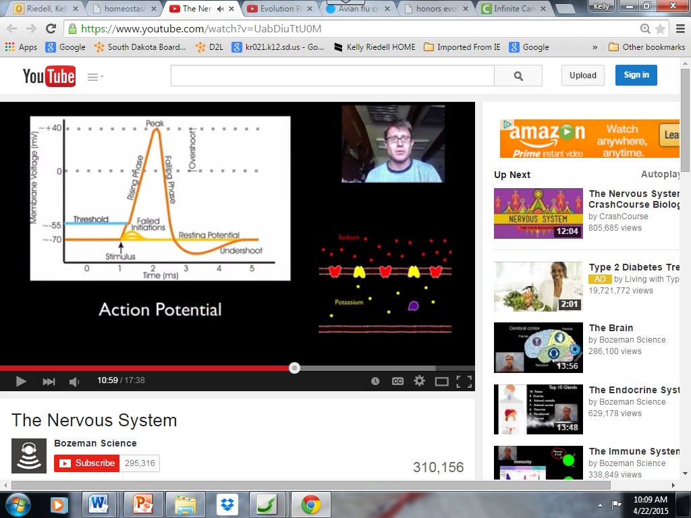

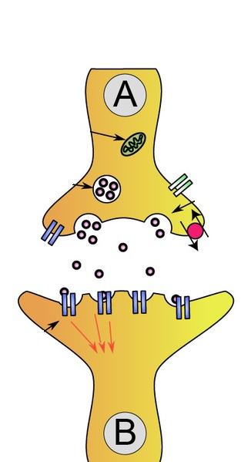

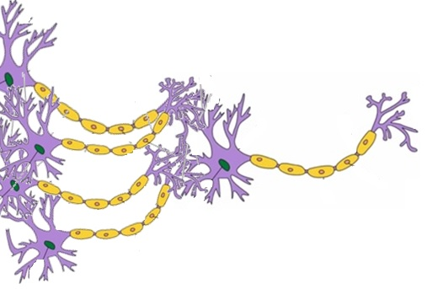

Created by Kelly Riedell Brookings Biology to go with Bozeman Biology Nervous system Vide