TYPES OF MUTATIONS = change in the genetic code
Can be due to :
____________________________________________________________
____________________________________________________________
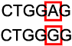 |  | One letter is replaced by a different letter
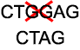 |  | Piece of DNA is deleted and lost
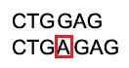 |  | Piece of DNA is added
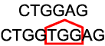 |  | Extra copies of a section of DNA are  Added
GENE MUTATIONS= change in a single gene
__________________- Change in just a few nucleotides in DNA sequence

If change codes for same amino acid = ______________________ mutation
GGC and GGA BOTH code for glycine = ”WOBBLE”
If change codes for a different amino acid = _____________________ mutation
May change function of protein
EX: Sickle cell mutation: A → T
If change codes for a STOP instead of an amino acid = _____________________ mutation
Protein sequence will be terminated early (shorter) and NONFUNCTIONAL.
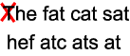
Because messages are read in groups of 3 letters (CODON)
insertions/deletions can cause a ______________________________.
A shift in the reading frame changes every codon after the mutation.
Can result in NONSENSE or MISSENSE mutations.
Frameshift mutations at beginning of a gene change more of the code than at the end.

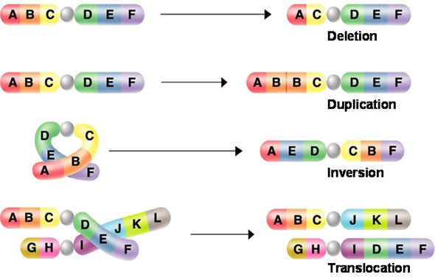
CHROMOSOMAL MUTATIONS –changes in number or structure of chromosomes

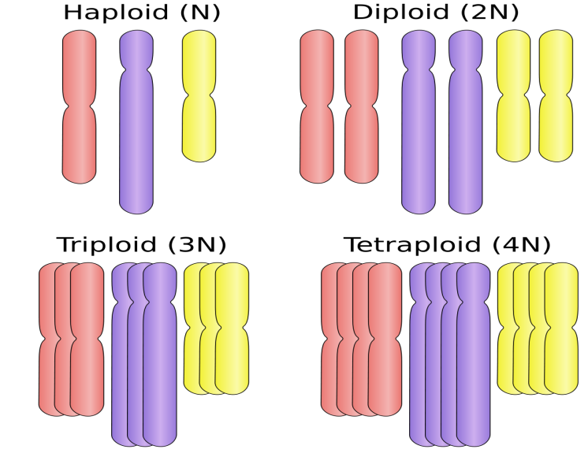
_____________________
LETHAL in mammals
rare in most animals
Beneficial in plants

