**When You Want to Add an Image to a Test Question**

**For example, we wanted to know if the students could recognize the cell phase seen.**

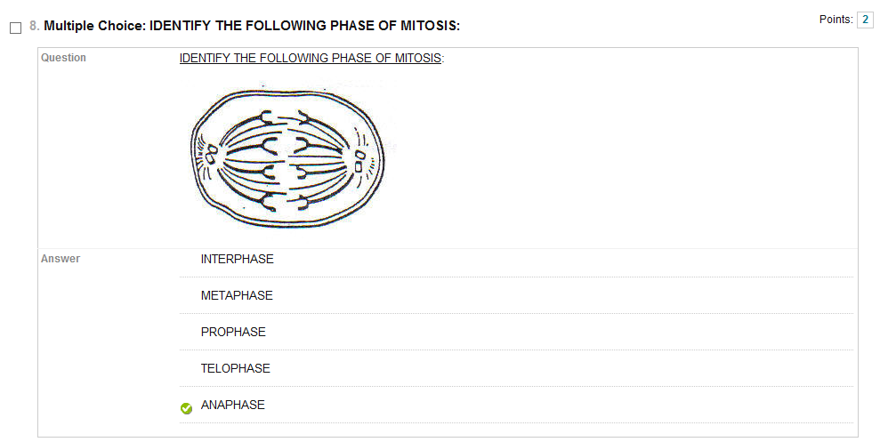

**Let’s say you are just beginning to make a new test:**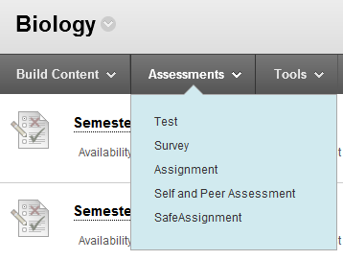



**You would first choose ASSESSMENTS and then TEST.**

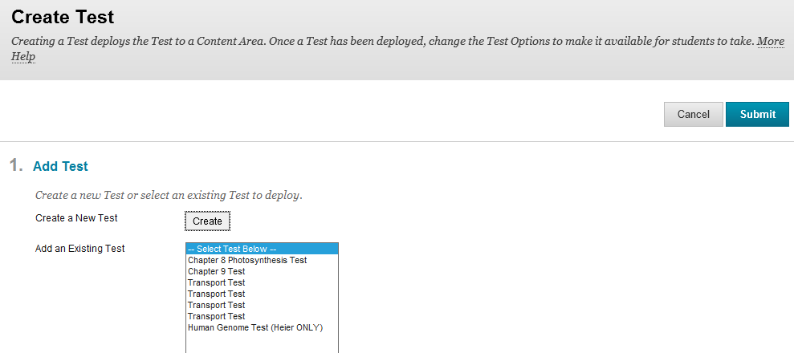



**Now select CREATE and you do NOT have to click on SUBMIT.**

**You get to name your test. I will choose Chapter 7 Cell Test and click on SUBMIT. You can put in a description if you want before submitting.**

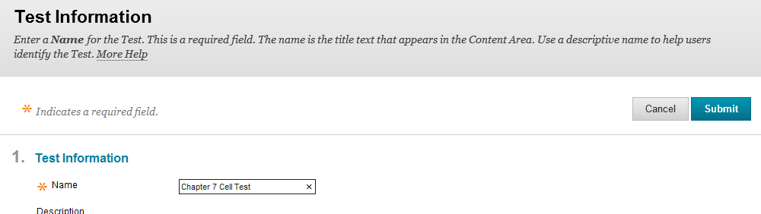



**Type in the name of what you want your test title to be and click on SUBMIT.**

**Now you can choose what type of question you want to build your test.**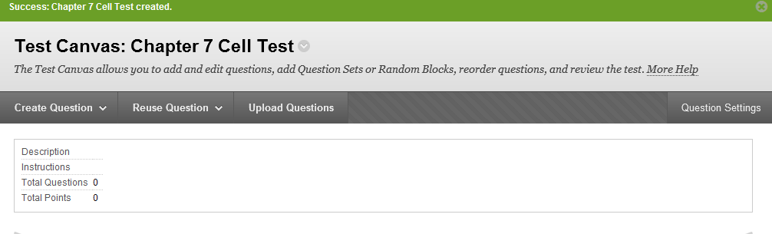



**You have many choices to pick from to build your test. I am going to choose MULTIPLE CHOICE.**

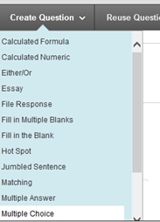

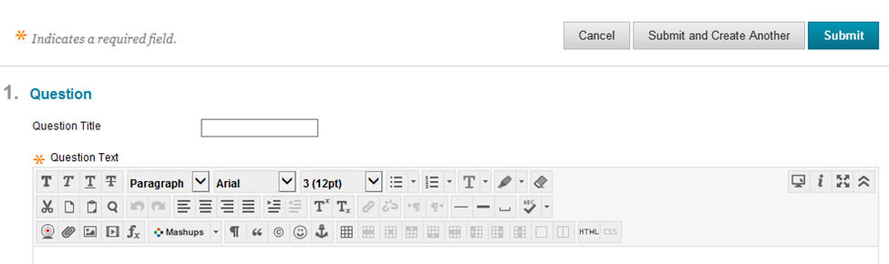



**You can type a question title if you would like. I am just going to write my statement/question in the Question Text.**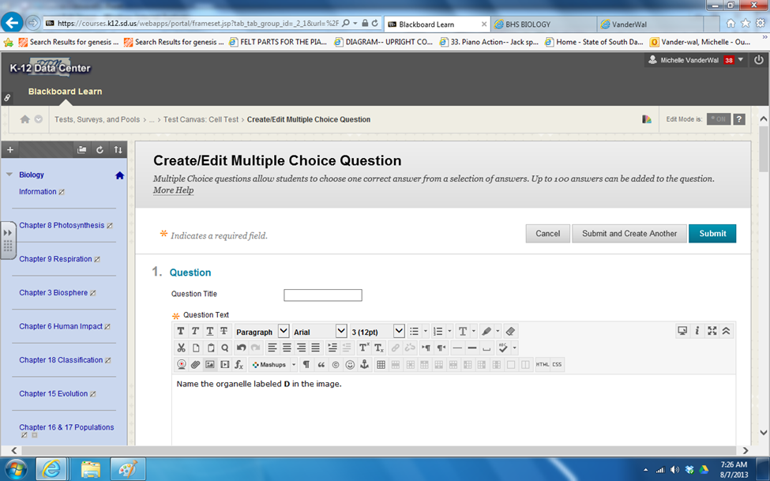



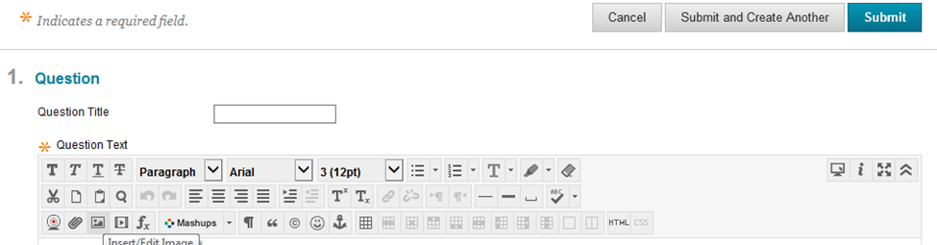



**Sometimes you want to add an image to your question like we did in the above example. You first select this INSERT/EDIT IMAGE button.**



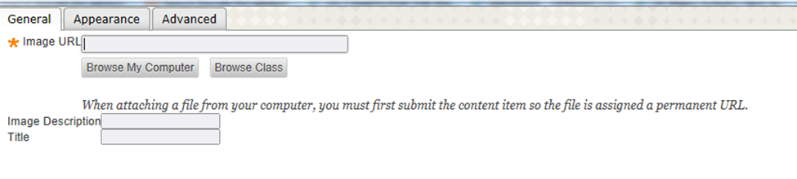



**I select BROWSE MY COMPUTER and go to PICTURES on my computer.**

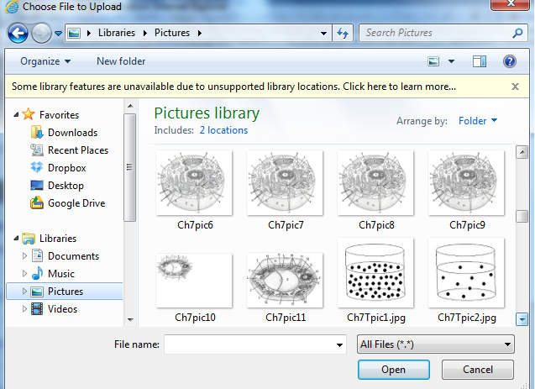



**I can see my options that I have placed into my Pictures. When I hover over the pictures I am also looking for jpg files. These do not take up as much space on the computer and internet.**

**NOTE: When you save your image in pictures on your computer, be careful how you save the title. For example if I had a picture of the Calvin Cycle for Photosynthesis, I do not want to save it as CalvinCycle.jpg and then ask a question of what the name of the cycle is called. The students will see CalvinCycle.jpg and hopefully answer the test question correctly. We found pictures saved should be Ch9pic1.jpg then the students would not have the answer listed in their question.**

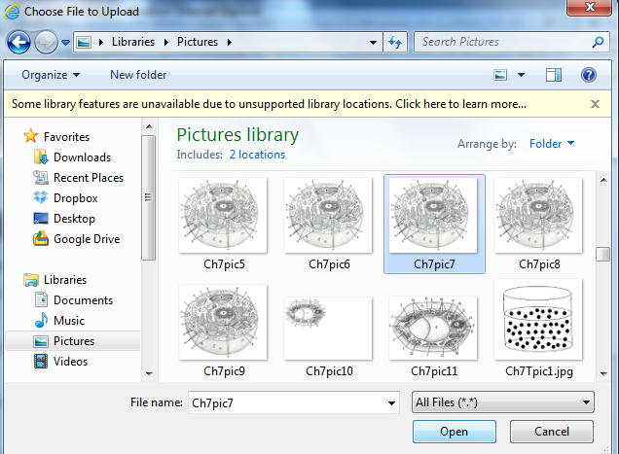



**I am going to select my Ch7pic7 picture and then click OPEN.**



**I then completed IMAGE DESCRIPTION and TITLE and then clicked INSERT. I found it would not let me INSERT without completing IMAGE DESCRIPTION and TITLE.**

**NOTE: I did NOT put anything in the IMAGE URL window.**

**After you clicked INSERT, the program fills in this window for you.**



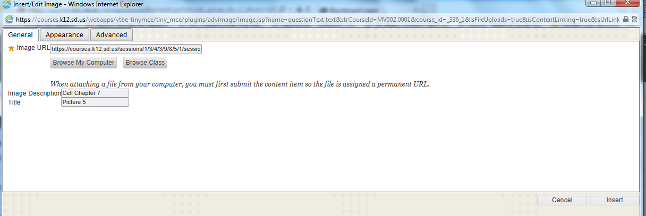



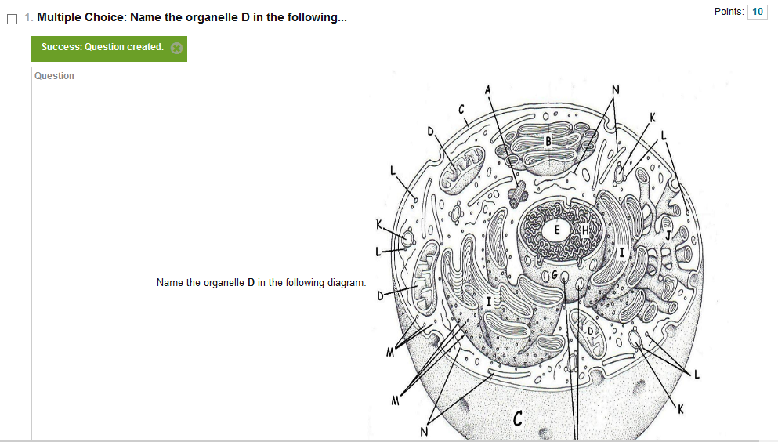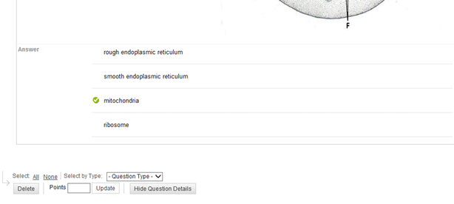



**NOTICE: in the above question the point total is 10 points. I want the point total to be only worth 2 points.**

**I hover over the point total.**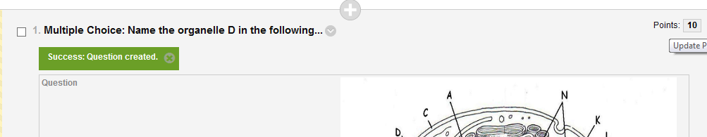



**This window now appears. You just change the points total to what you want and click SUBMIT.**

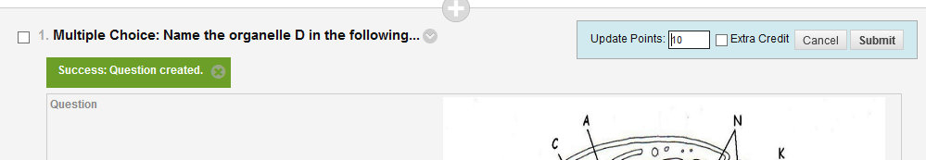

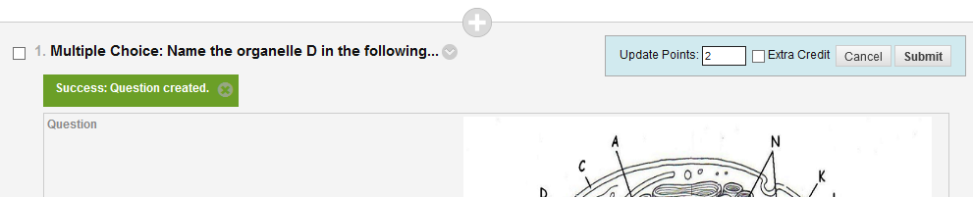

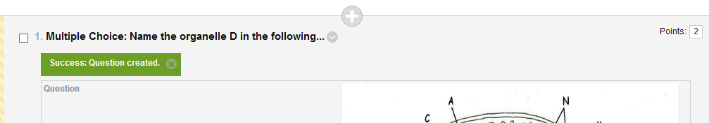

**Do you want your test to generate questions that are worth two points? This is how you can save a bunch of steps while making a new test. This can be done when you first start a test or any place while you are typing a test. You will select QUESTION SETTINGS.**





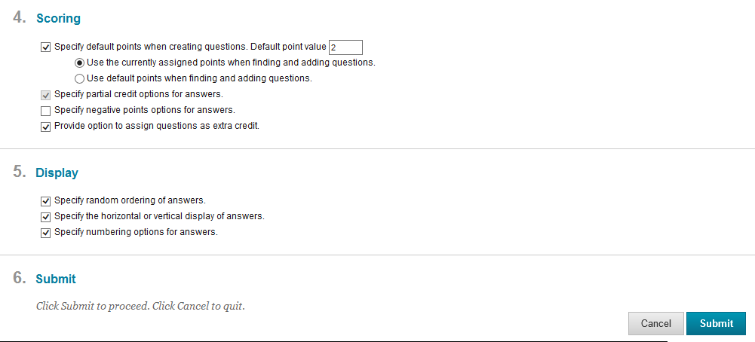



**Scroll down until you see #4 and change the point total to what you want your questions to be generated as and then click SUBMIT.**