**When You Want to Add an Image to a Test Answer**

**I first show you an example of how the students would see an example of this on a test.**

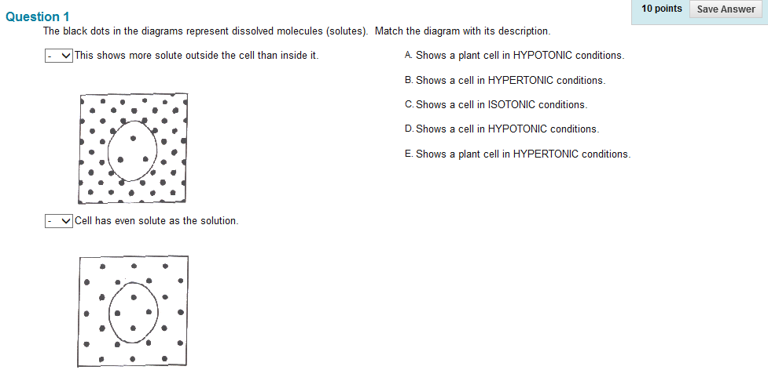

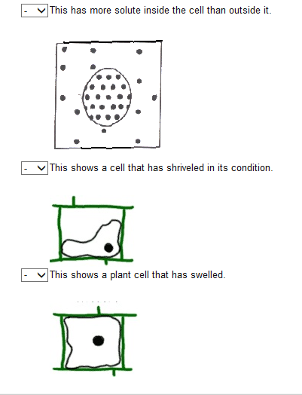

**The students will use a drop down arrow that is by the description/question. It looks like this.**

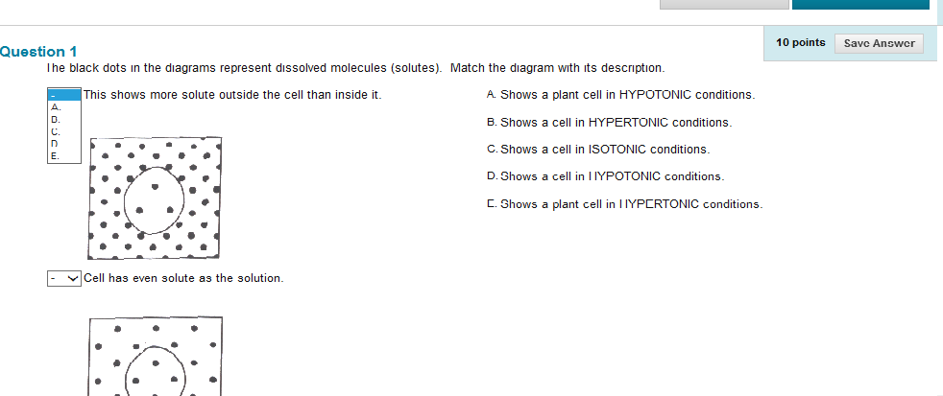



**After the student has answered all five drop down they will click SAVE ANSWER.**

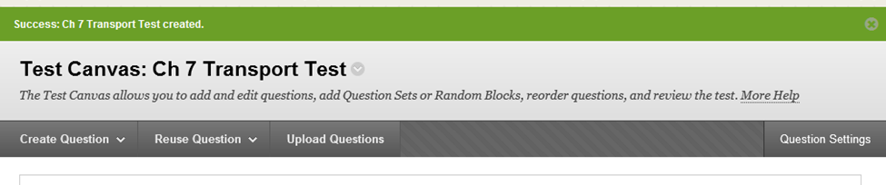



**So let us being when you want to add an image to the answer choices, you will have to make changes in QUESTION SETTINGS.**



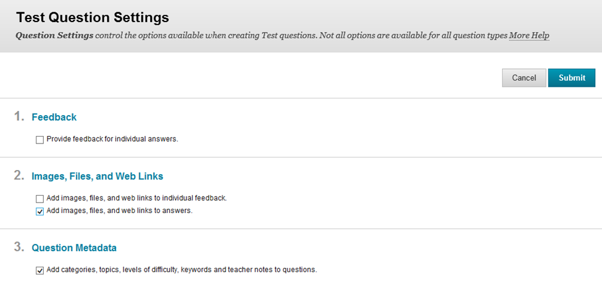



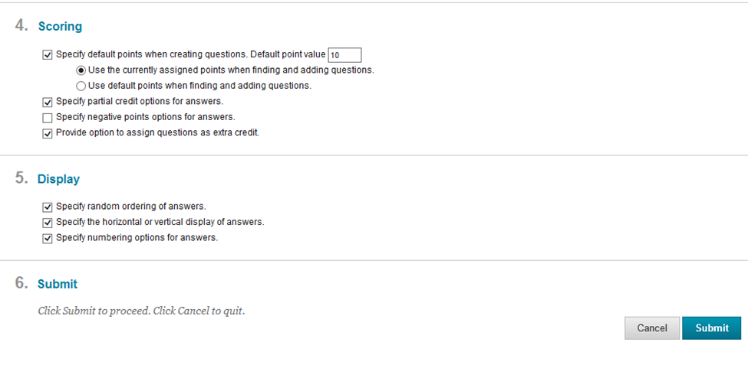



**Now click on CREATE QUESTION and choose MATCHING.**

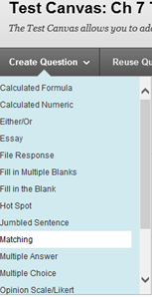



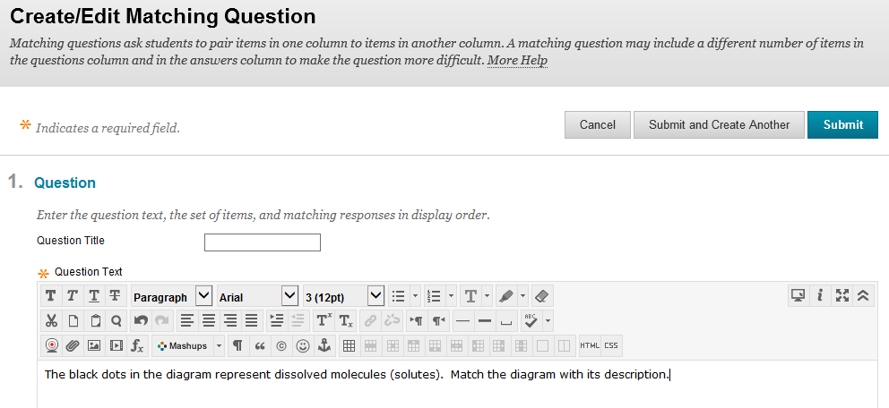



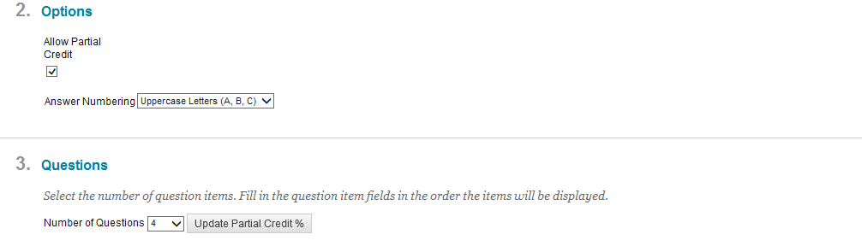



**Note: There is no way anymore to override the program and have less than four choices. Four and Five choices work the best. If you have six choices and click on UPDATE PARTIAL CREDIT you will get students results that have a decimal and that really confuses your students.**



**There is a formula that you should know about. When you click on UPDATE PARTIAL CREDIT % each of the windows must add up to 100 % EVENLY. So when you have four questions and click on UPDATE PARTIAL CREDIT % each of the windows would have 25 % and that works!! Your total points for the question should be 8 if you want each matching to be worth 2 points.**

**If you choose five questions and click on UPDATE PARTIAL CREDIT % each of the windows would have 20 % and that works!! Your total points for the question should be 10 if you want each matching to be worth 2 points.**



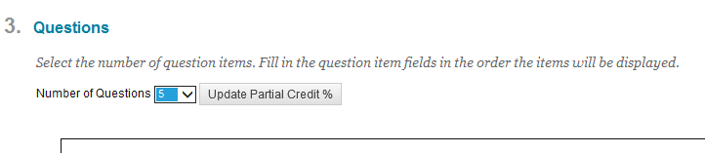



**So I changed to 5 and clicked on UPDATE PARTIAL CREDIT % and clicked on SUBMIT.**

**Now wait just a moment, the computer has to submit your request and the program has to give you another question.**

**After your computer blinks, you are ready to begin with the first pair of question with answer.**

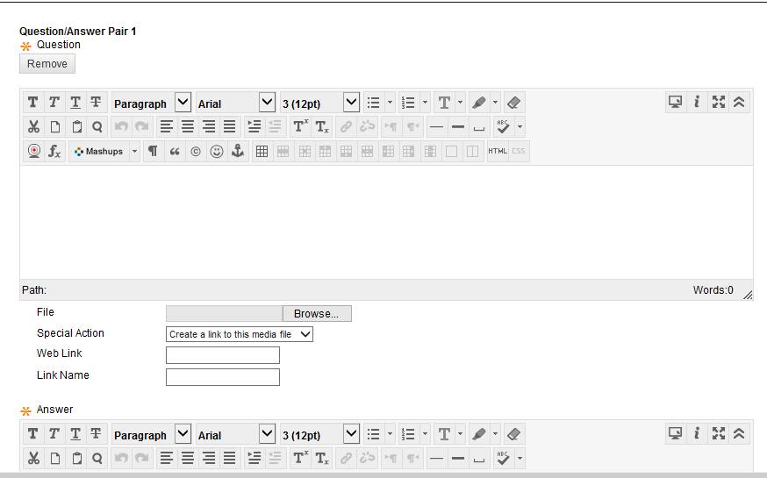

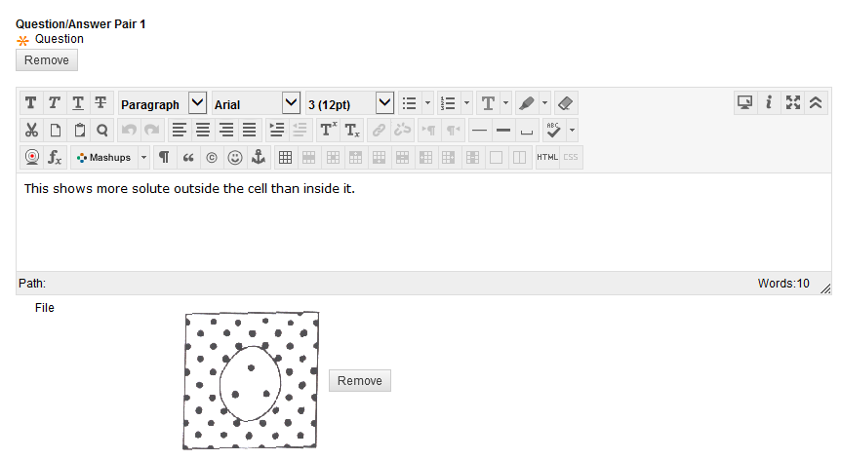



**I typed the statement or you could type a question in this region.**

**You are given many icons to explore how you want this to look. The icon for help can explain what each of these do for you.**

**I typed the answer for the above question in the answer region. Don’t worry you will mix up the choices for the students later.**

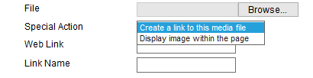



**I select BROWSE.**

**Then I opened my PICTURES.**

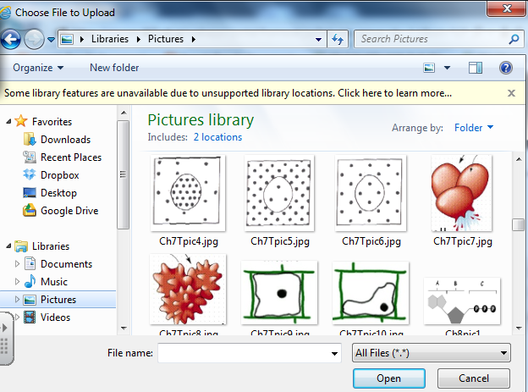



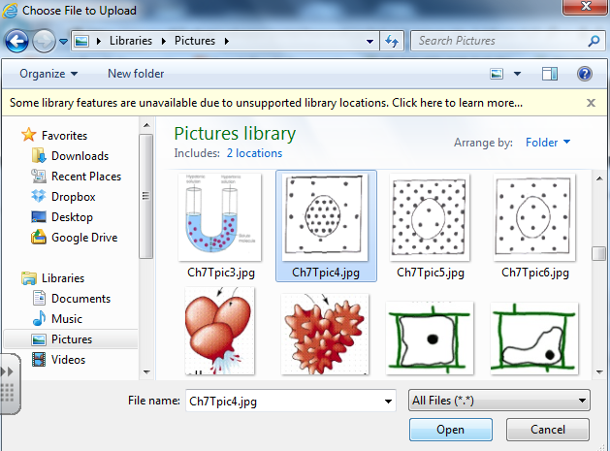

**I highlighted the picture I wanted and then clicked OPEN. Make sure the picture is a jpg file.**







**I prefer to select DISPLAY IMAGE WITHIN THE PAGE.**

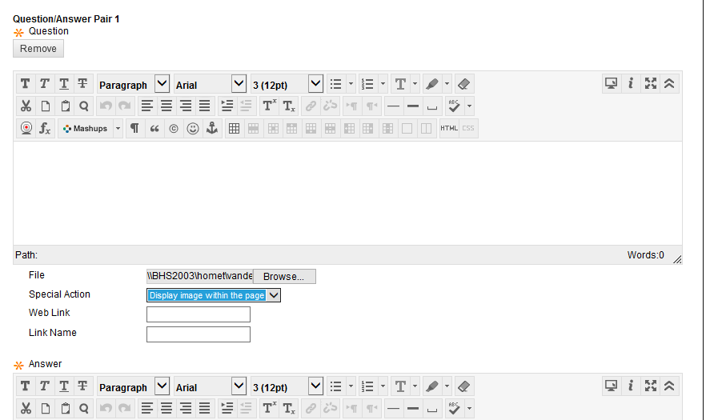



**Don’t worry when you see the file switch to this.**

**Eventually the computer will display the picture for you instead.**





**You will complete all the other questions doing the same procedure as we just did.**

**When you scroll down you will find this choice:**

**I always choose MANUALLY for matching questions. I did not always like how this program generated answers randomly.**

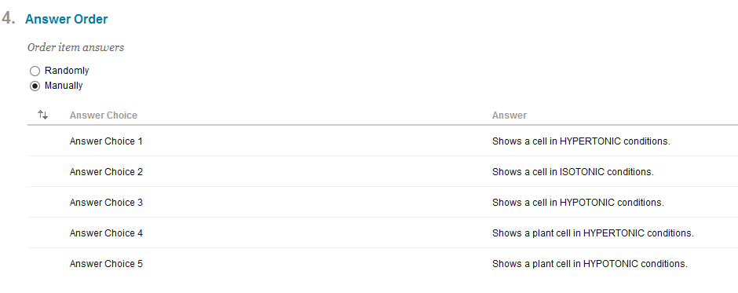



**When you hover to the left of your answers an up and down arrow appears. Now have fun mixing up the answers in a different order. This will be the order that your students will see.**

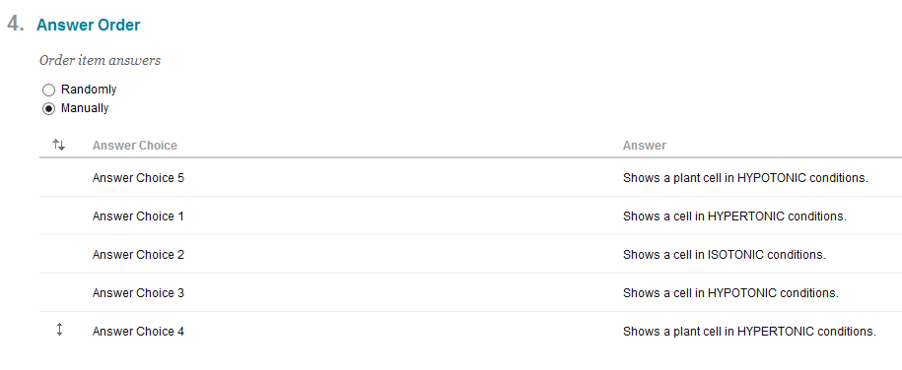



**This is the up and down arrow. Here is an example of how I mixed my answers. All students will get these choices in the same order since I selected MANUALLY.**

**This is how it is going to look from the teachers editing screen.**

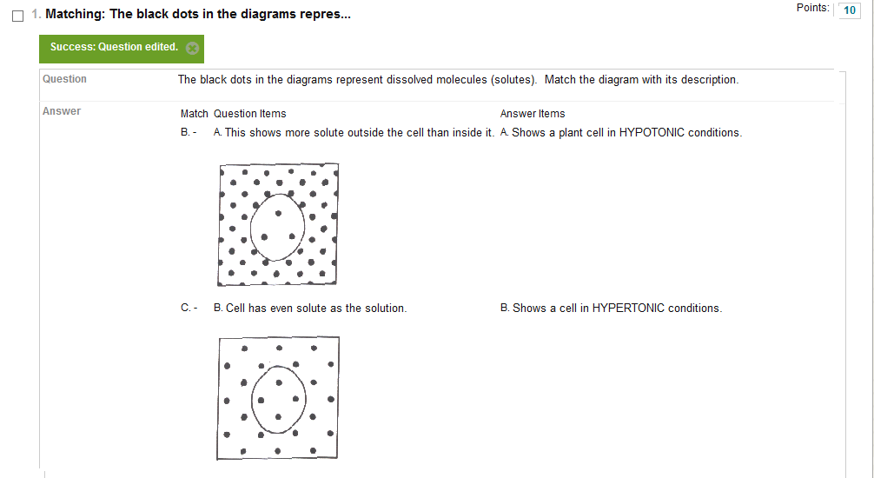



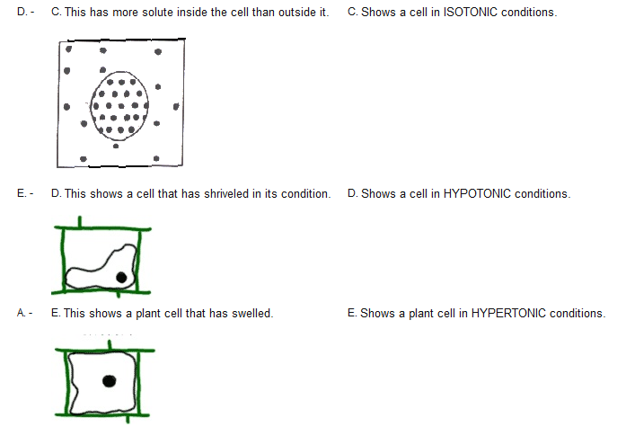

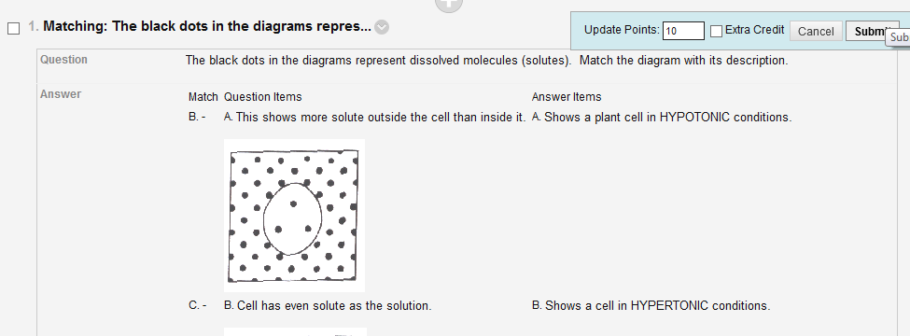



**When you get all done with a matching question, make sure you are happy with the point total. If you need to make changes to the UPDATE POINTS just click on it, make changes, and click SUBMIT.**

**Don’t be afraid of matching questions. They are a little time consuming to enter. Sometimes I have had to begin over again when entering them because for some reason the program found an error. Just try again and save often and eventually it works!!**

