**When the Students Can See Their Results BUT YOU CAN NOT**

After you click on the class title that you want to see your results, the Control Panel will appear in the lower left hand corner of the screen.



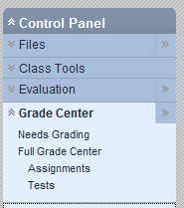



You select Control Panel🡪Grade Center🡪 Tests🡪Manage

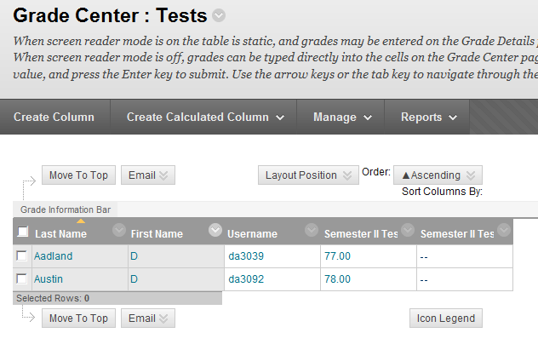



Click on the down arrow on the right hand side of MANAGE.

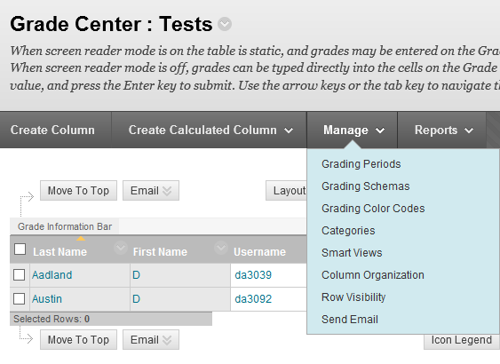



This drop down menu will appear. You now want to select COLUMN ORGANIZATION.

Notice below if I wanted to see the results of Chapter 3 &4-2 Biosphere Test in parentheses it shows the word hidden.

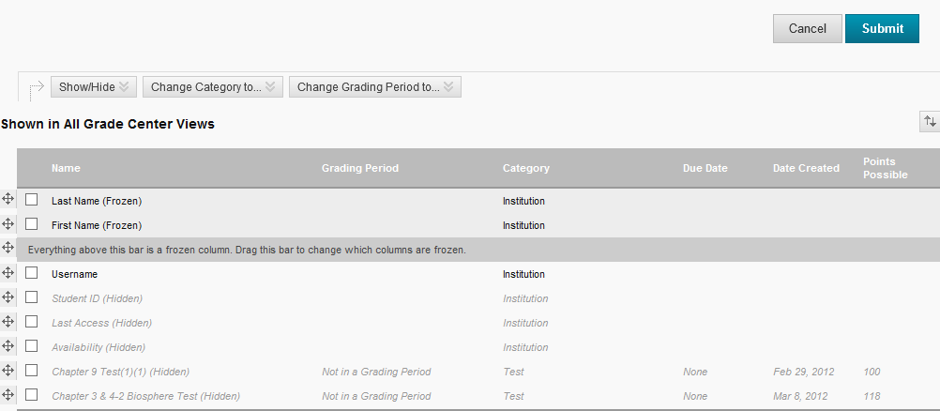



You will need to click on the box and an **X** will appear.

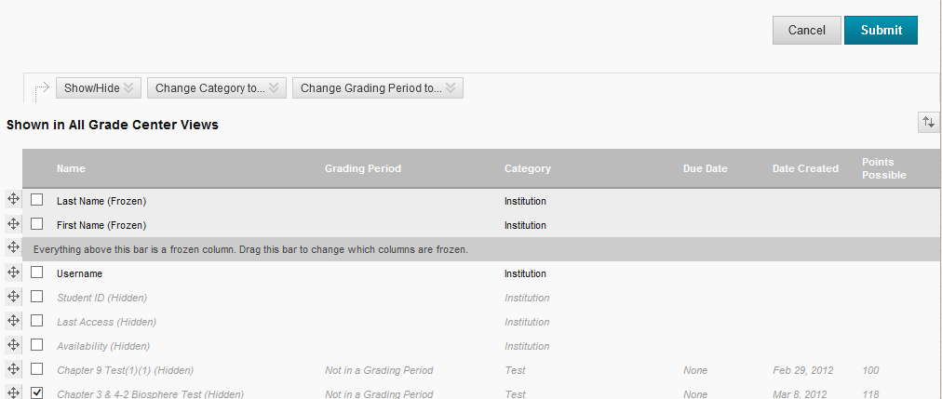



Now scroll down to the bottem and you will see SHOW/HIDE.

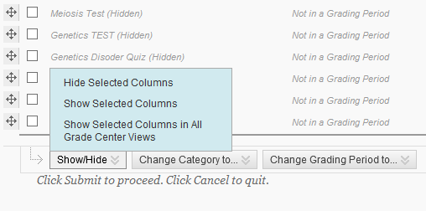



When you click on SHOW/HIDE this drop down menu appears. You need to select SHOW SELECTED COLUMNS.

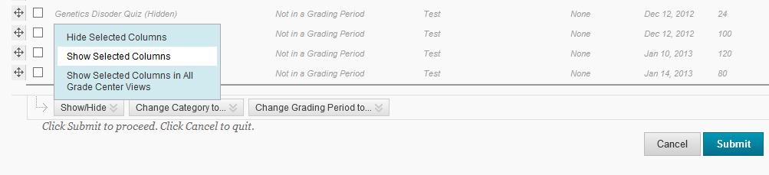



When you click on SHOW SELECTED COLUMNS it becomes highlighted and then click on SUBMIT.

The screen will automatically take you back to viewing their grades. It will tell you it was successful. If it wasn’t successful repeat the above instructions until it is a success.



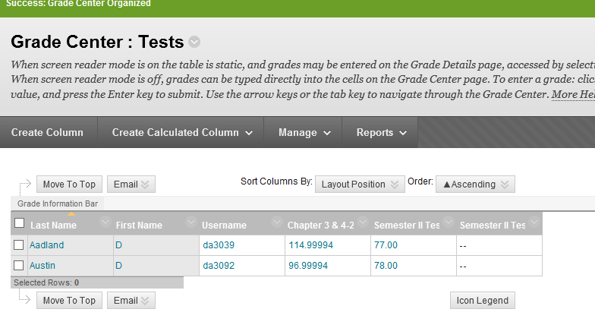



Now you can view the grades of the chapter test you wanted to see. This procedure works great when you have columns that you no longer need to see. If you want them hidden then you select HIDE SELECTED COLUMNS.