**Penalty Points for Multiple Answer Questions**

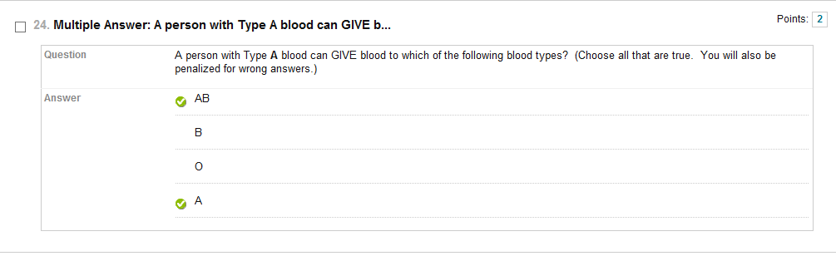

When you have a student answer a question like the above, we found that if we did NOT assess penalty points students would select all four answers and technically get the full credit for this type of question.

When you want to add penalty points you first must go into QUESTION SETTING.

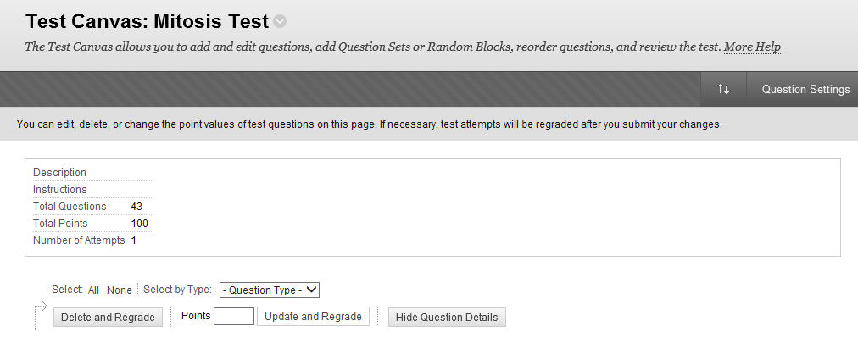



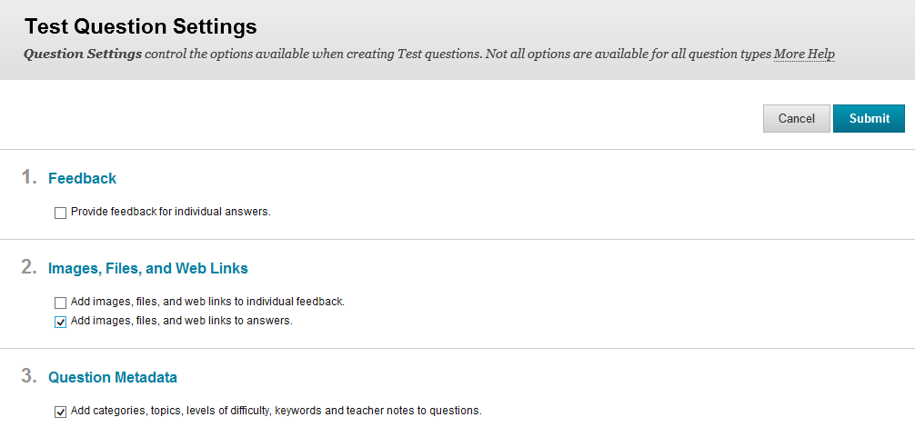

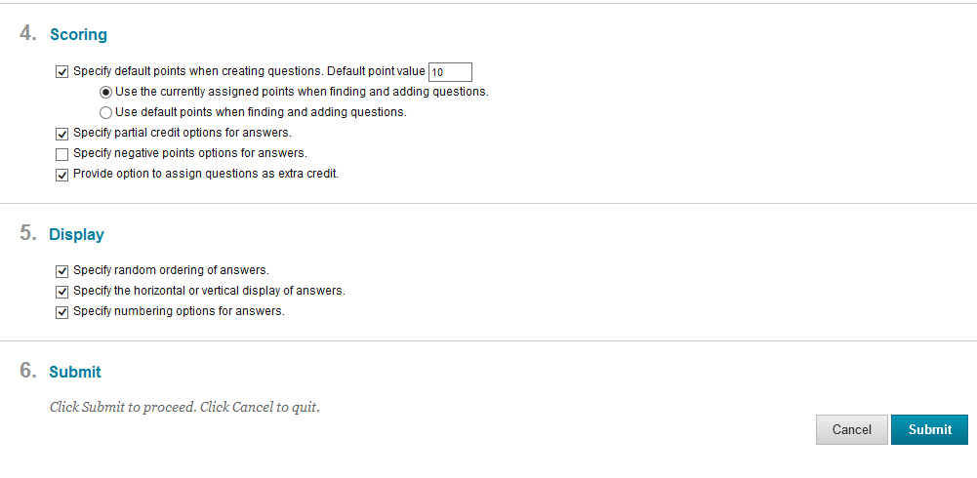



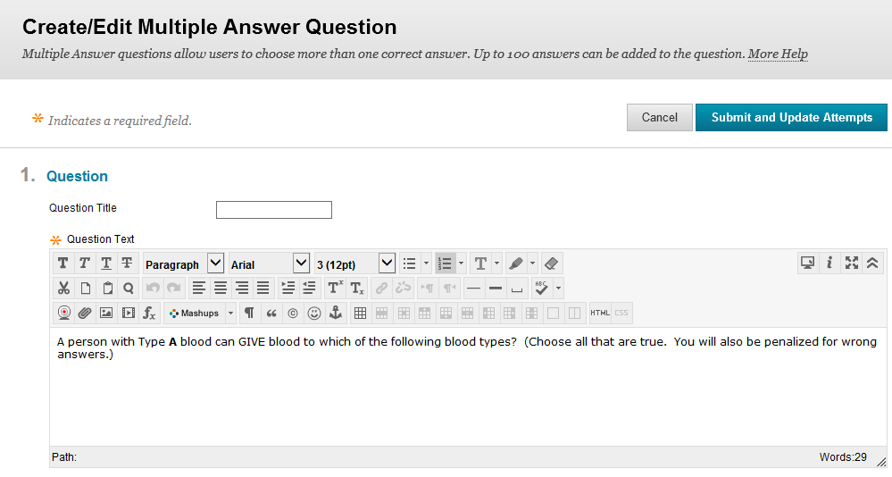 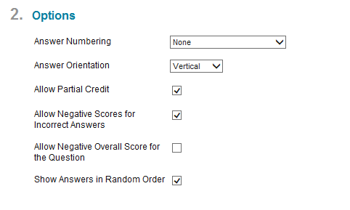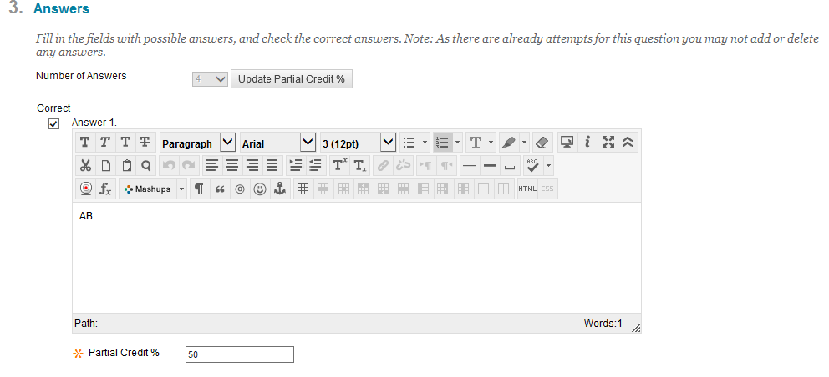

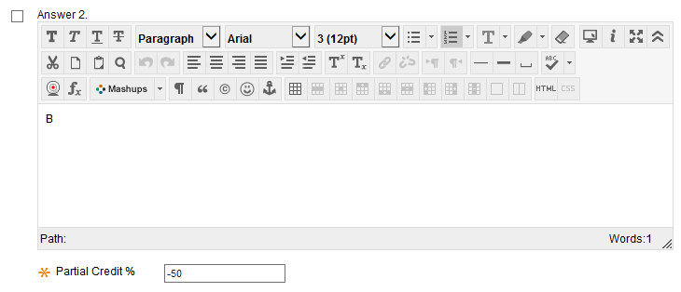



Notice that we put a negative in front of the number to create the penalty of choosing this answer.

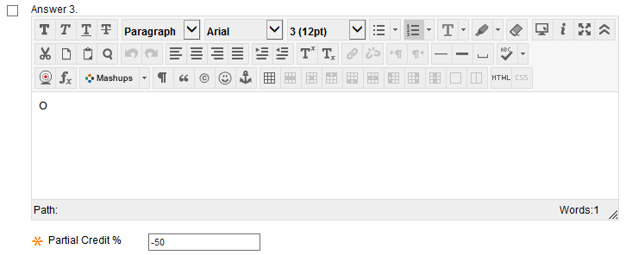

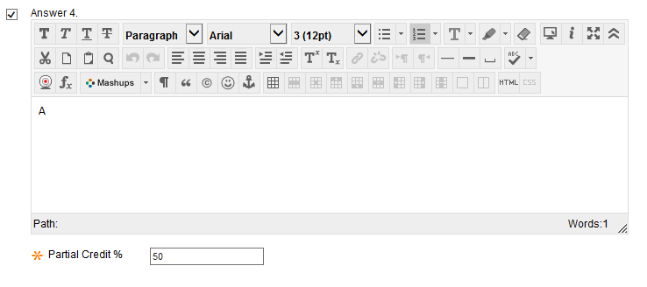

Now scroll down and at #7 select SUBMIT AND UPDATE ATTEMPTS.

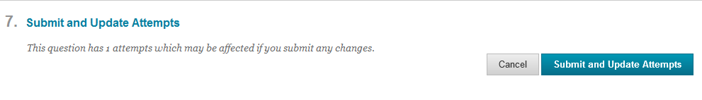

NOTE: The Partial Credit % all correct answers must add up to 100.

The wrong answer Partial Credit % must add up to -100.