**How to Copy a Test and Make it Available to Other Classes:**

After you click on your test, a control panel appears in the lower left hand corner.

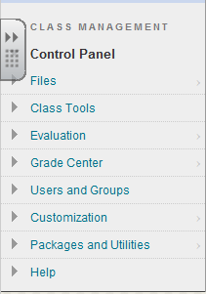



Select CLASS TOOLS and then select TESTS, SURVEYS, AND POOLS.

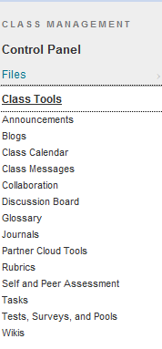



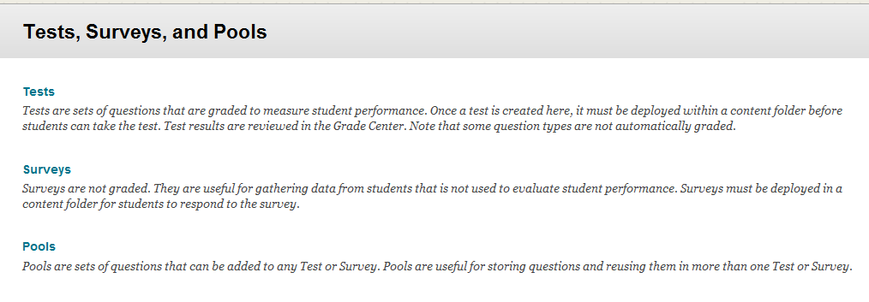



You will need to select TESTS.

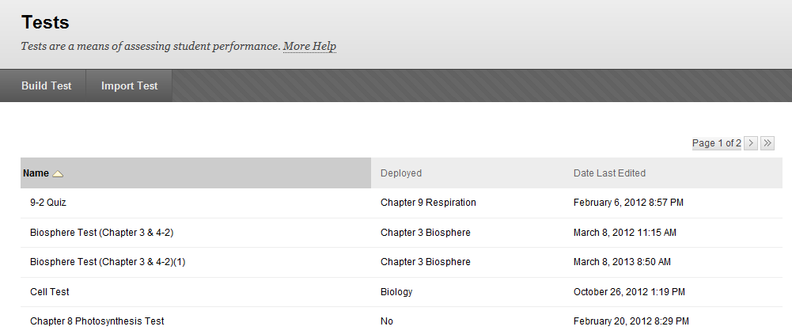

Above you see that I have Biosphere Test (Chapter 3 & 4-2) and then there is another Biosphere Test (Chapter 3 & 4-2)(1), what happened is that I made a change from the first test to the second test and the computer renames them with an additional (1). I can delete the old test by hovering over it and selecting the arrow that appears and choosing delete.

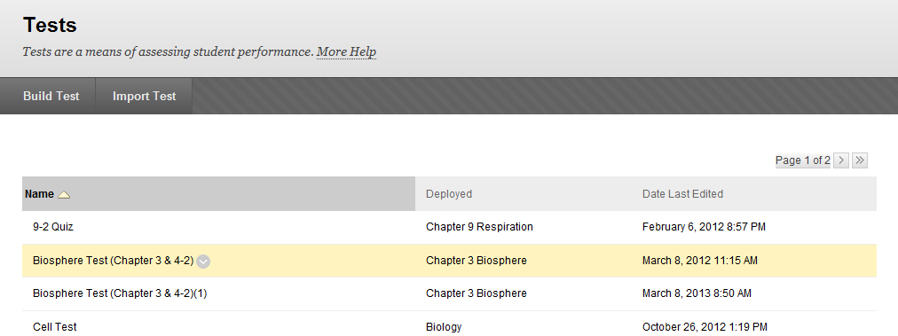



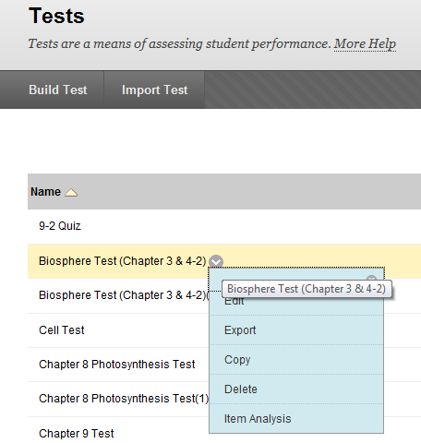



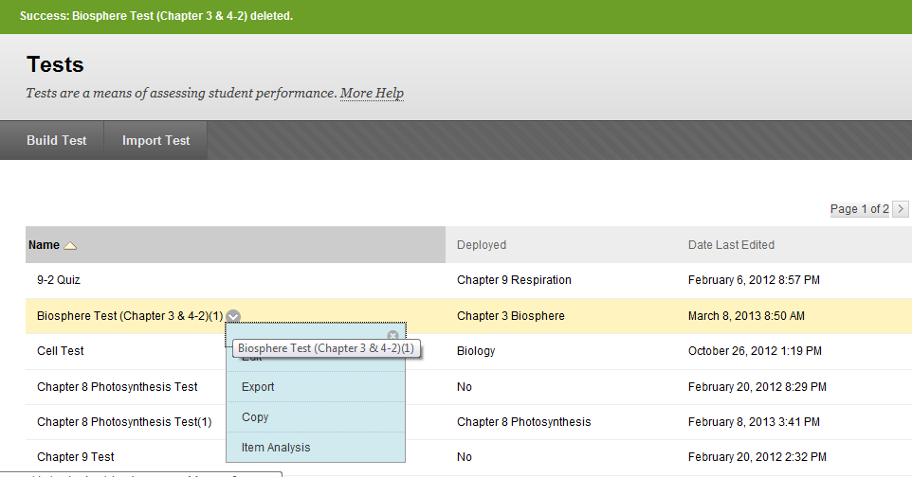

If you didn’t want to leave the test names Biosphere Test (Chapter 3 & 4-2)(1), you can choose EDIT and then select the arrow.

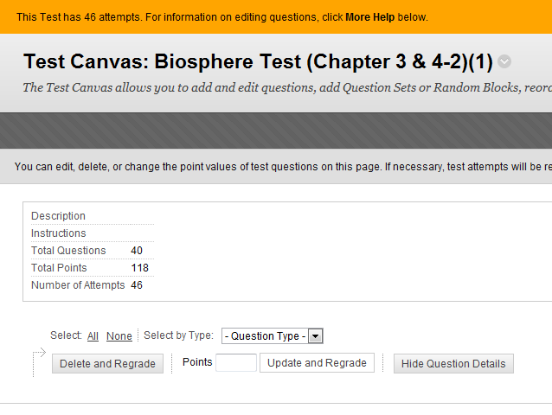



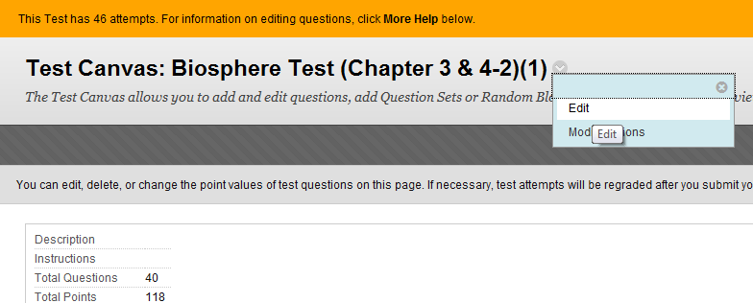

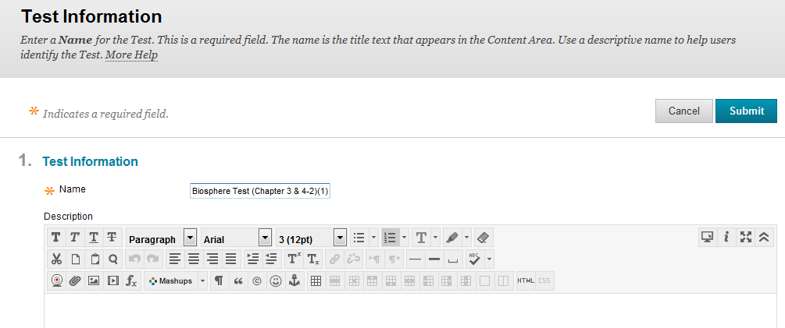



You can then change the title to something else if you like.

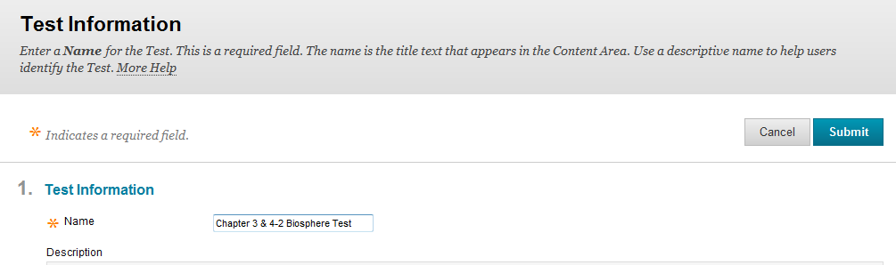



Change the name and select SUBMIT.

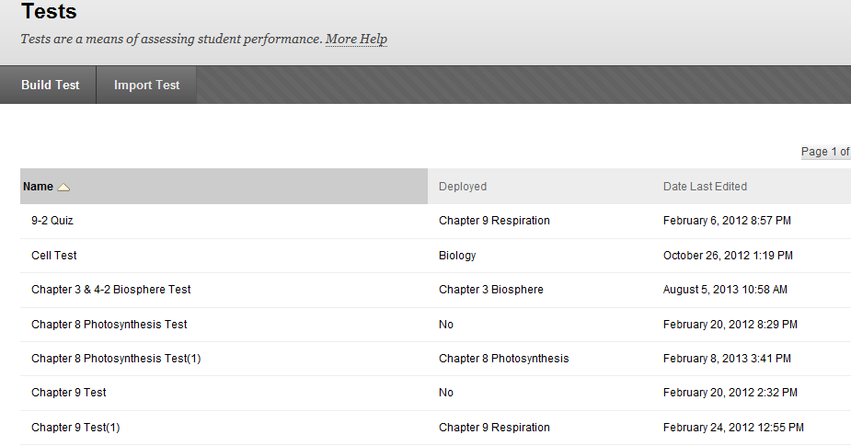

When you hover over the test that you want to copy, the arrow in the right hand side has an option of copying the test.



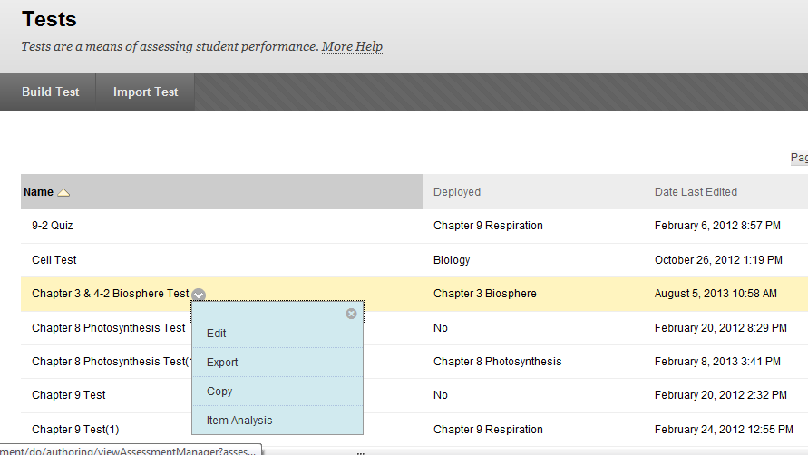



Now this is where it gets a little confusing. In Biology we have a Biology I class and a Honors Biology Class. Maybe we want to start with the Biology I test but we want to add some harder questions for the Honors Biology students to answer. I don’t want to retype the test. I can copy the test by EXPORT .

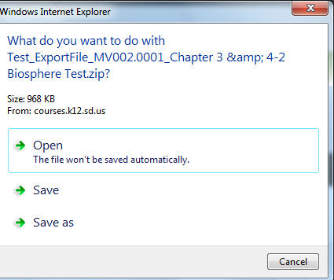

I find it less confusing if I choose the SAVE AS and be alert as to where the file is being saved to.

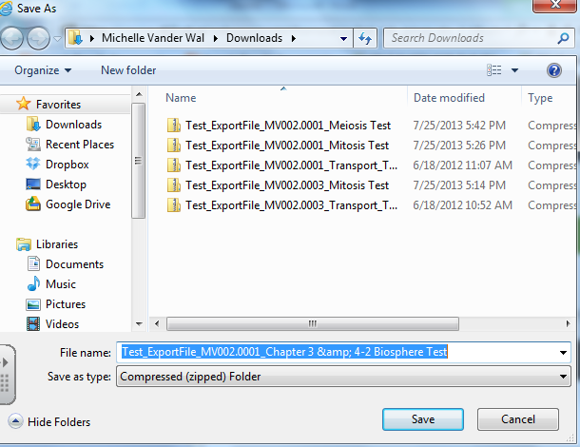



Do you see that it put it in my DOWNLOADS when I saved it? You can also understand which test it is in the title of how the computer saved it.

All you have to do now is to go to the class you want to bring this into. For us, it would be the Honors Biology class. Click on the Honors Biology class, then you selected the Control Panel, followed by CLASS TOOLS, then you selected TESTS, SURVEYS, & POOLS, and next you selected TESTS. Look back to the top of this document as to how you did this.

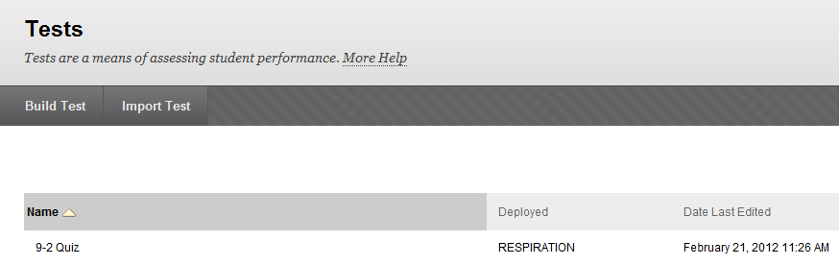



Now you will select IMPORT TEST from the location that you chose to store your test at.

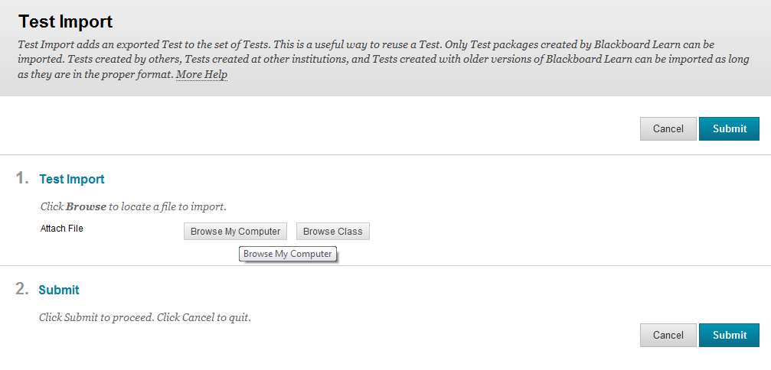

This screen above now appears. Select BROWSE MY COMPUTER to find your saved file and select one of the SUBMIT buttons when you are done (it doesn’t matter which one you select).

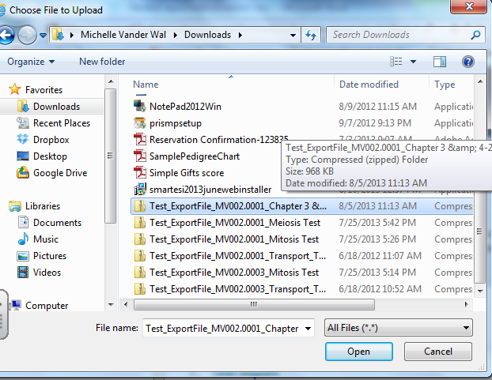

Remember I placed my export file in DOWNLOADS and now you just have to locate it and OPEN it and it will put this copy into your other class.

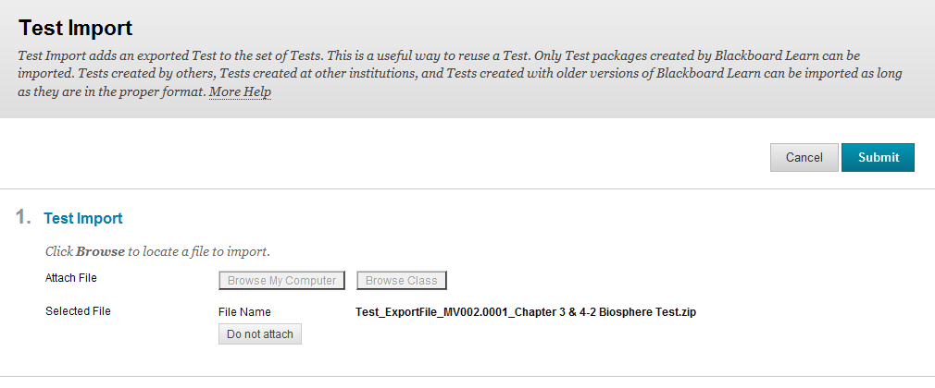



Now click SUBMIT.

You will get a message that looks like this:

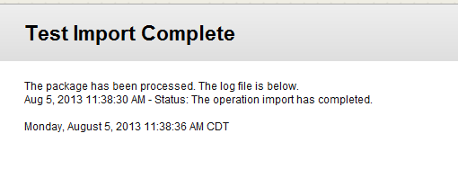

You will need to go back to your other class. Just click on BLACKBOARD LEARN and you can get there easily.

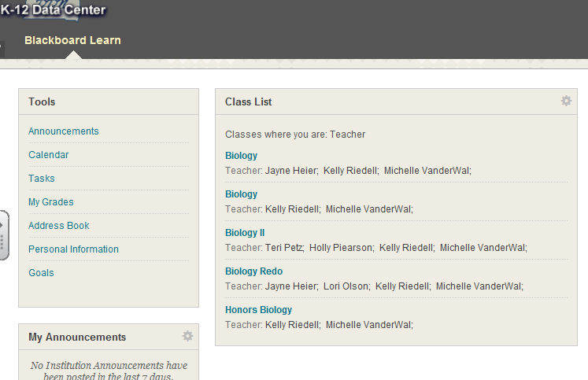



We wanted to place this imported test into HONORS BIOLOGY so you will need to select the class you want your test to go in and then . . . .

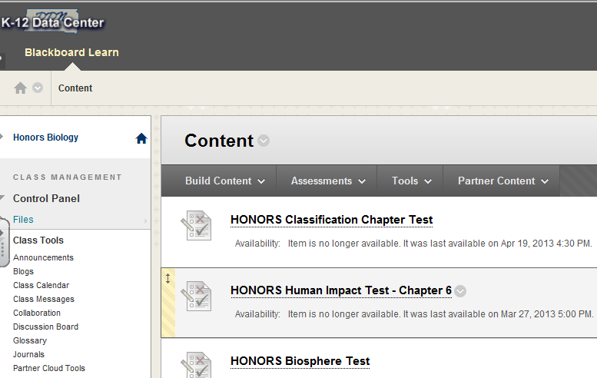



Now select ASSESSMENTS.

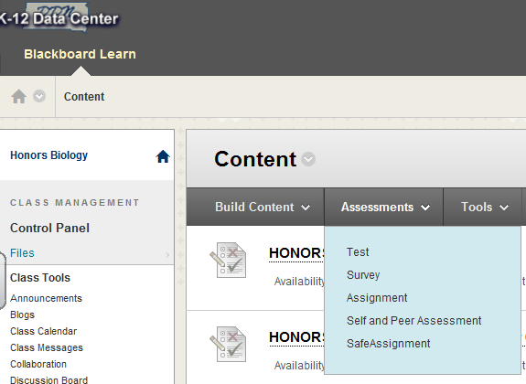



Now select TEST

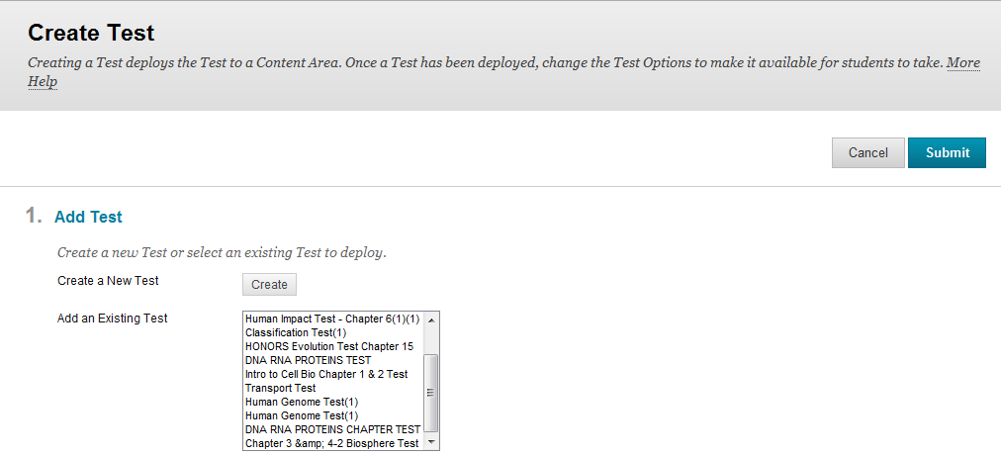



Find your test that you imported and then SUBMIT.

You will still need to activate when you want to give the test. For directions on how to do that, look at our file on SETTINGS.