How do you get students into your roster?

First you sign in to <https://courses.k12.sd.us>

Click onto your class list name.

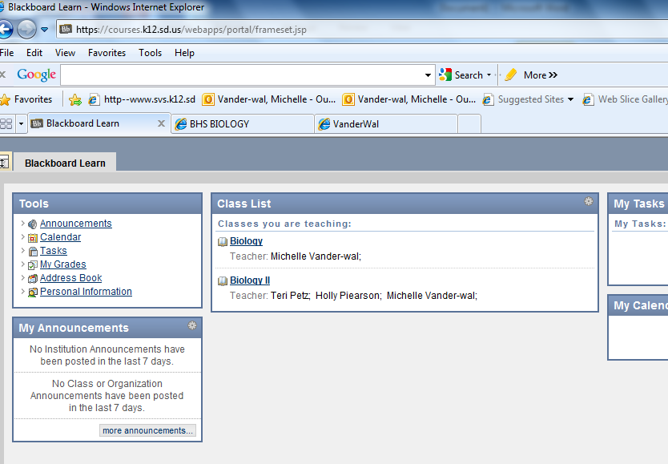



For example: I will click on Biology.

Scroll your screen down until you see on the lower left the Control Panel.

You next will need to click on Users and Groups

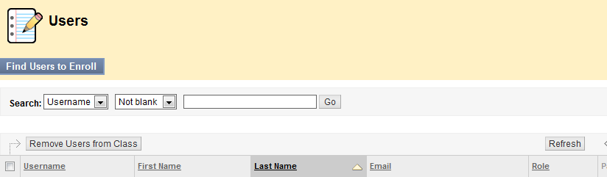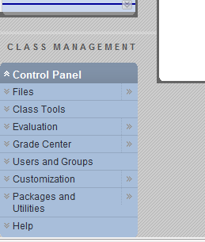



Click on Find Users to Enroll.







You either can look up students by the document I will forward you from Deb Ulvestad OR you can look in infinite campus under roster and look for your students access code individually.

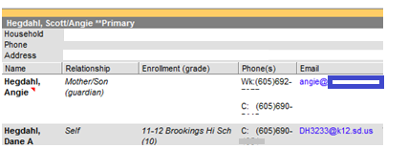



Now click on Browse in Blackboard Learning.

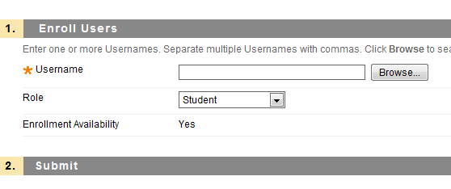



Type the code in for your student.



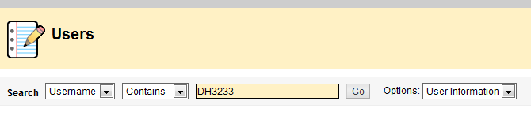



You will need to click on the box in front of the students name and then click on submit.

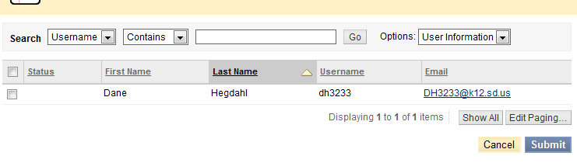



This student’s name will be added to your list of students and it will begin to lengthen. If you have multiple classes, all classes will merge into the same spreadsheet.

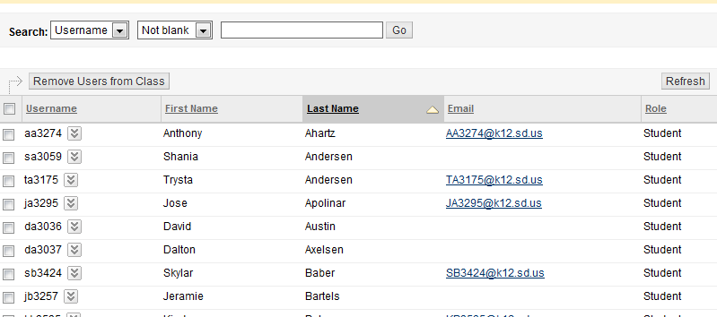

Your spreadsheet will begin to look something like this. If you have a collaborator in any of your classes, they can be added the same way except under role they should be listed as teacher.

Notice this spreadsheet still does not have their password listed. The Deb Ulvestad documents list their current passwords. If you have trouble with any student’s password, consult Deb Ulvestad.

Mrs. Riedell had no difficulty telling her honor students their usernames and passcodes once. I found with lower level students that typing their usernames and passcodes onto business cards works well. As soon as students are logged on, I take the business card back and hold them for the students.