Xcel unveils new phase of wind power construction, with huge plant in South Dakota

The site in eastern South Dakota will produce as much energy as Xcel's giant wind farm in Colorado.
By Mike Hughlett Star Tribune MARCH 16, 2017 — 5:41PM
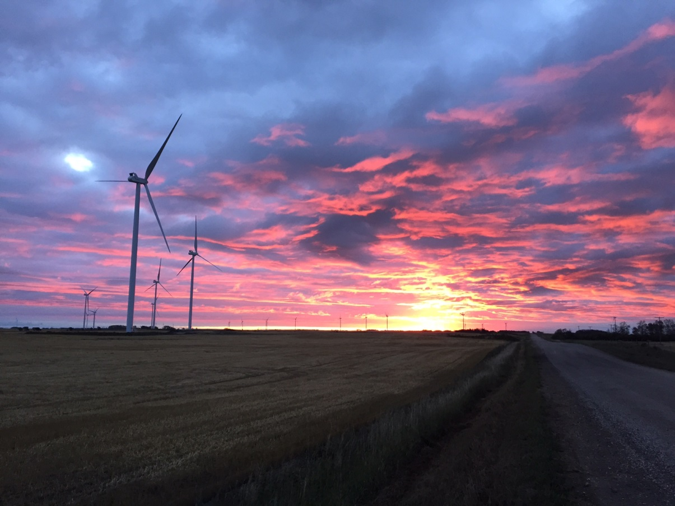

XcelXcel Energy announced in September that it would increase its Upper Midwest wind generation capacity by about 60 percent. Xcel Energy Inc. will build its largest Upper Midwest wind project ever in eastern South Dakota, the latest phase of a huge new wind power investment in Minnesota and the Dakotas. The Minneapolis-based utility unveiled new details of the wind plan Thursday, which include three new projects, one each in Minnesota, South Dakota and western North Dakota.
The company's planned Crowned Ridge Wind project in Codington County and two adjacent South Dakota counties would have a power production capacity of 600 megawatts, the same amount as Xcel's planned Rush Creek development in Colorado. Rush Creek, which has already been approved by Colorado regulators, is currently Xcel's largest single wind project.
The new South Dakota wind plant "will be our biggest [wind] investment in the Upper Midwest," said Chris Clark, Xcel's president for Minnesota.
Last September, Xcel announced it would increase its Upper Midwest wind generation capacity by about 60 percent, adding at least 1,500 megawatts of capacity, enough to power 800,000 homes. In October, the company announced it would build three new wind farms in Minnesota and one in North Dakota with a total of 750 megawatts of capacity.
A megawatt is a million watts, and to put Xcel's wind projects in perspective, the company's Sherco coal-fired generators in Becker each produce 680 megawatts, though they pump out energy constantly, not intermittently like renewable energy facilities.
The wind farms announced Thursday will add another 800 megawatts of capacity. They will be owned — at least initially — by their developers, with Xcel buying the power. All of the projects together constitute a $2.5 billion investment.
Xcel, already the nation's largest wind-producing utility, has been on a wind spree of late, taking full advantage of federal tax credits for wind power before they are phased out.
"This is some of the best priced wind power, and it's a great value for our customers," Clark said. Xcel's new wind installations would produce energy at a cost of 1.5 to 2.5 cents per kilowatt hour, which compares favorably to the 2.3 to 2.4 cents per kilowatt hour costs of Xcel's Sherco coal generators, Clark said.
Xcel's announcement Thursday includes a 100 megawatt project in North Dakota's Mercer and Morton counties and a new 100 megawatt wind farm near Lake Benton, Minn., which will replace an aging facility there. That new wind plant will have bigger turbines, which can produce more power.
The Lake Benton and South Dakota projects will be developed by Florida-based NextEra Energy. The North Dakota project will be developed by Allete Clean Energy, a subsidiary of Duluth-based Allete, the owner of Minnesota Power.
The three projects unveiled Thursday will operate under either a "power purchase agreement" or a "build-to-own" structure. With the former, Xcel buys power from an independent owner over a 20- to 25-year contract. Under the latter, the project is developed and owned independently, but with the aim that Xcel will eventually own it.
The four new wind plants announced in October would be built and owned by Xcel itself, though the utility would contract out the engineering and construction work. Plants that are owned directly by Xcel can be built into the utility's rate base.
All planned projects are subject to regulatory approval and are expected to be producing power by 2020. By then, Xcel expects to get over 20 percent of its electricity production from wind, up from around 15 percent now.
mike.hughlett@startribune.com 612-673-7003

