Add Voiceover to Power Point

- Once your Power Point is complete for edits, you are ready to create the video with voice over.
- Select Slide Show on the top menu and then select Set Up Slide Show

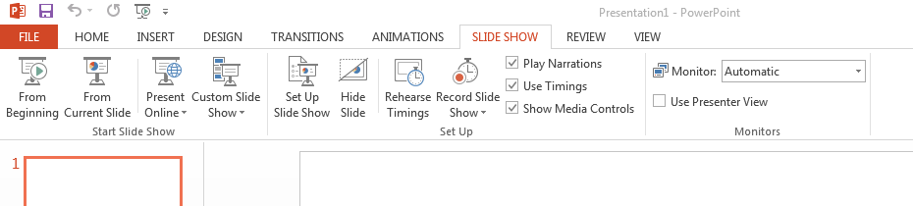

- Under Set Up Slide Show, select options as shown below and then select ok
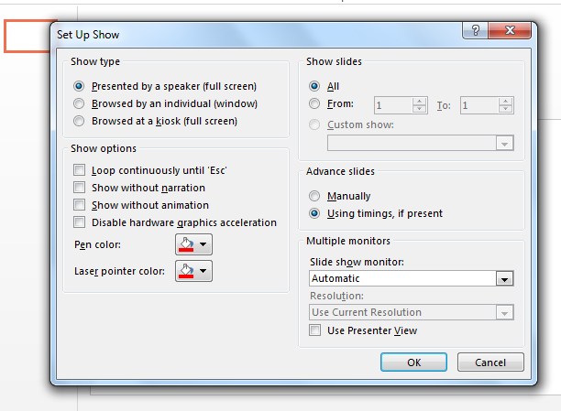

- To start recording, select Record Slide Show- this will allow you to start recording from the beginning or from a selected slide.
  - Be sure to speak clear and slow
  - Leave a couple seconds before and after voice to create an easy-to-follow video
  - Use arrow keys to move on to next slide to continue recording
- Once recording is complete, hit the esc button to exit.
- Save
- To Edit, go to the slide on which you want to edit sound and select Record Slide Show. Then select Clear on Current Slide
- To record new voiceover, select Record Slide Show on the slide you want to add sound and select Start Recording from Current Slide. Esc. When completed on that slide and save.

Export Power Point as Video

- Under file, select Export then Create a Video. Select Internet Quality and Use Recorded Timing and Narratives for your options
- Select Create Video Button
- Save video as a .MP4 to your Google Drive. Do not exit Power Point until the video is created. This can take some time so be sure to watch the loading bar at the bottom of the screen.
